**Math 1201**

**Mealy Mountain Collegiate**

**Midterm Exam**

**January 2012**

**Student: ____________________**

**Teacher: ____________________**

**Value 100% Time: 3 hours**

**General Instructions**

1. Students are required to do ALL items**.**

2. The examinationconsists of the following parts:

Section A**:** 40 Selected Response *Value: 40 marks*

Section B: 11 Constructed Response *Value: 40 marks*

3. For section A items, place the letter corresponding to the correct answer on the answer sheet provided.

4. For section B items, students are reminded to show all necessary steps and calculations as credit may be given for incomplete or partially correct solutions. Correct answers without proper calculations may not merit full marks.

**DO NOT OPEN THIS EXAMINATION PAPER UNTIL YOU ARE TOLD BY THE SUPERVISOR TO BEGIN**



**Conversions**

|  |
| --- |
| **Imperial to SI units** |
| 1 in. = 2.54 cm ≈ 2.5 cm |
| 1 ft ≈ 0.3 m |
| 1 mi. ≈ 1.6 km |

|  |
| --- |
| **Imperial** |
| 1 ft. = 12 in. |
| 1 yd. = 3 ft. |
| 1 mi. = 1760 yd. |

**Formulae**

|  |  |  |
| --- | --- | --- |
| **Object** | **Surface Area** | **Volume** |
| Cylinder |  |  |
| Cone |  |  |
| Pyramid |  |  |
| Sphere |  |  |
| Hemisphere |  |  |

**Section A - Selected Response (50%)**

**Directions:** Place the letter corresponding to the correct answer on the answer sheet provided.

1. What SI unit is most appropriate in measuring the length of Mealy Mountain Collegiate?

(A) mm

(B) cm

(C) m

(D) km

2. George has 20 yards of string that he wants to cut into pieces 15 inches long. How many

pieces can George make?

(A) 1

(B) 16

(C) 48

(D) 720

3. Paul plans to replace 974 inches of baseboard in his home. Baseboard is sold in 8 foot

lengths. How many pieces of baseboard does Paul need to purchase?

(A) 10

(B) 11

(C) 82

(D) 122

4. Which referent could be used for an inch?

(A) The distance from where you are to Tim Horton’s.

(B) The length of your calculator.

(C) The width of your largest toe.

(D) The width of your desk top.

5. The distance Jim walked each day last week is shown in the table below.

|  |  |  |  |  |  |  |  |
| --- | --- | --- | --- | --- | --- | --- | --- |
| **Day of**  **Week** | Monday | Tuesday | Wednesday | Thursday | Friday | Saturday | Sunday |
| **Distance Walked in Miles** | 6 | 7 | 8 | 4 | 5 | 6 | 4 |

What was the approximate distance Jim walked to the nearest kilometre?

(A) 25 km

(B) 40 km

(C) 64 km

(D) 80 km

6. A janitor measures the height of a window in Mealy Mountain Collegiate to be 4 feet

10 inches high. What is the approximate height of the window to the nearest centimetre?

(A) 23 cm

(B) 35 cm

(C) 120 cm

(D) 145 cm

7. Jerry is building a fence around his rectangular garden. His garden measures 18 ft. 6 in. by 8 ft. 5 in. The fencing material is sold by the yard. It costs $4.15/yd. What is the cost of material before taxes?

(A) $37.35

(B) $70.55

(C) $73.32

(D) $74.70

8. A block is in the shape of a regular tetrahedron as shown below. What is its surface area?

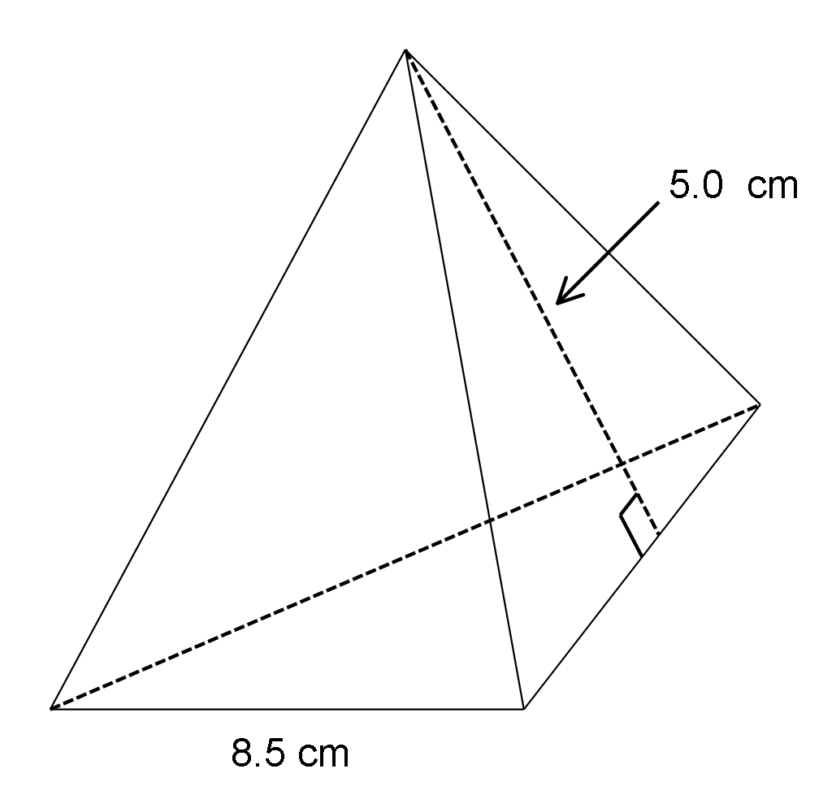

(A) 21.25 cm2

(B) 42.5 cm2

(C) 63.75 cm2

(D) 85.0 cm2

9. The lateral area of a cone is 200.12 cm2. If the diameter of the cone is 12.2 cm, what is the slant height of the cone to the nearest tenth of a centimeter?

(A) 5.2 cm

(B) 10.4 cm

(C) 12.0 cm

(D) 16.4 cm

10. An Egyptian right square pyramid is shown below. What is the height, h, to the nearest

tenth of a metre?

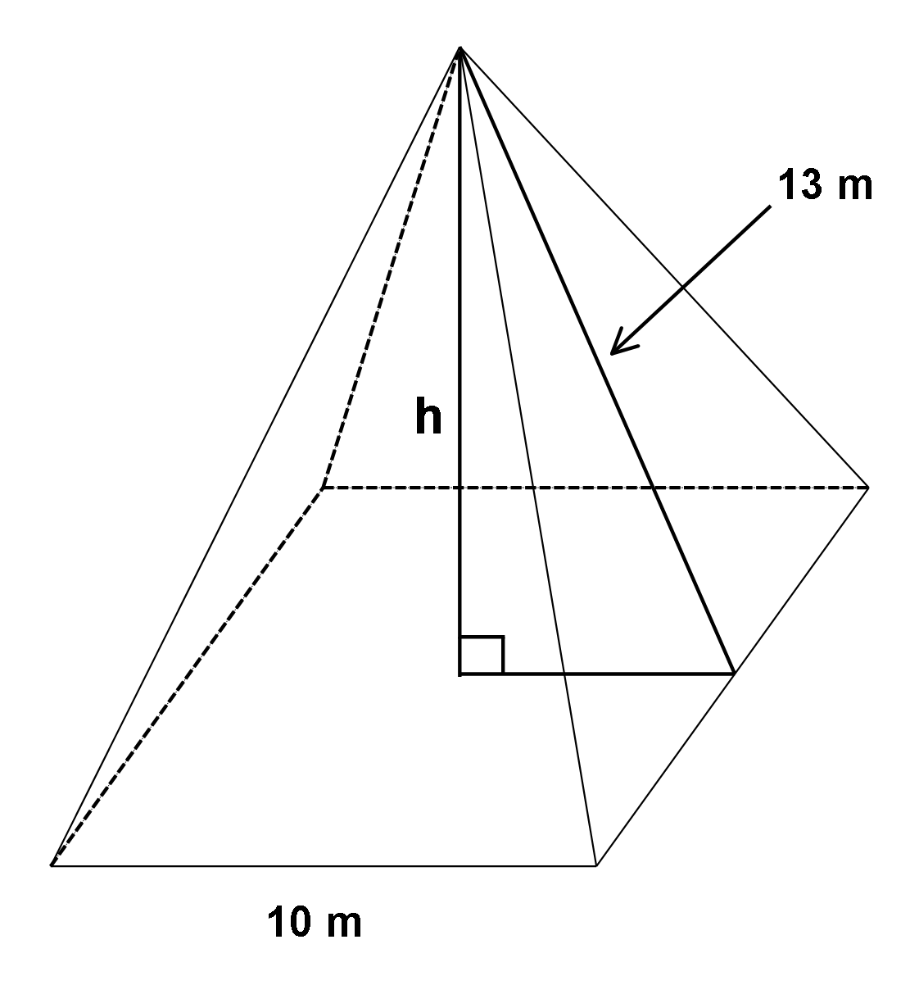

(A) 5.0 m

(B) 8.3 m

(C) 10.0 m

(D) 12.0 m

11. The surface area of a tennis ball is 803.84 cm2. What is its diameter?

(A) 4 cm

(B) 8 cm

(C) 16 cm

(D) 64 cm

12. An oil tank is in the shape of cylinder with a diameter of 52 m and a height of 15 m. How much oil is needed to fill the tank?

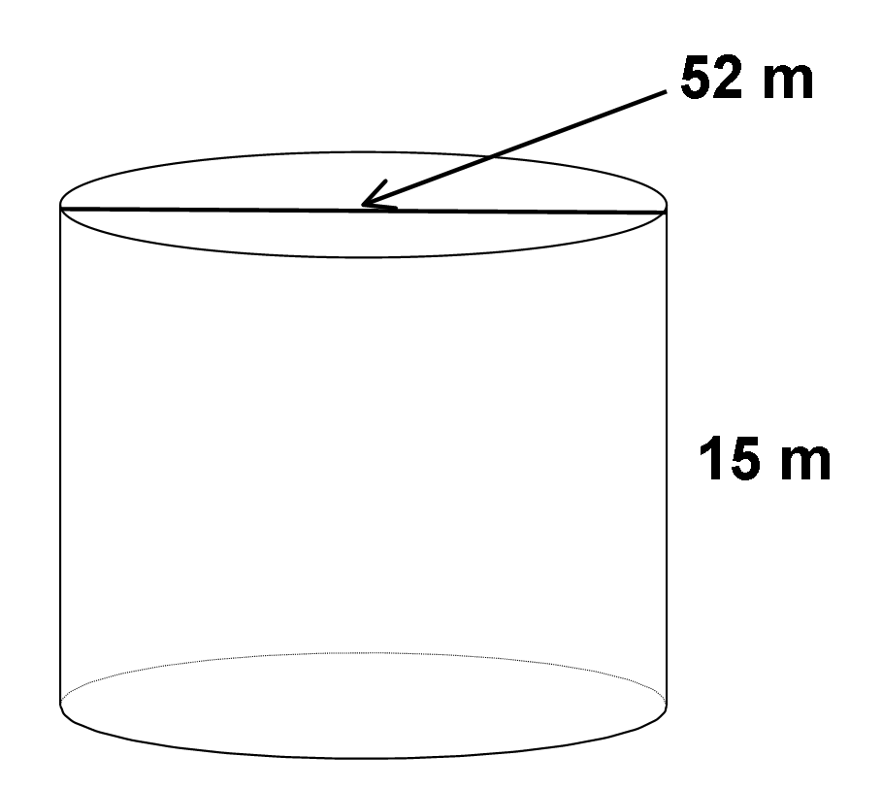

(A) 4408.56 m3

(B) 17307.68 m3

(C) 31839.6 m3

(D) 127 358.4 m3

13. Which of the following is the ratio for **tangent** of an acute angle in a right triangle?

A) 

B) 

C) 

D) 

14. A ladder 12.0 m long is leaning against a wall. The angle of inclination is . To the

nearest tenth of a metre, how far up the wall does the ladder reach?

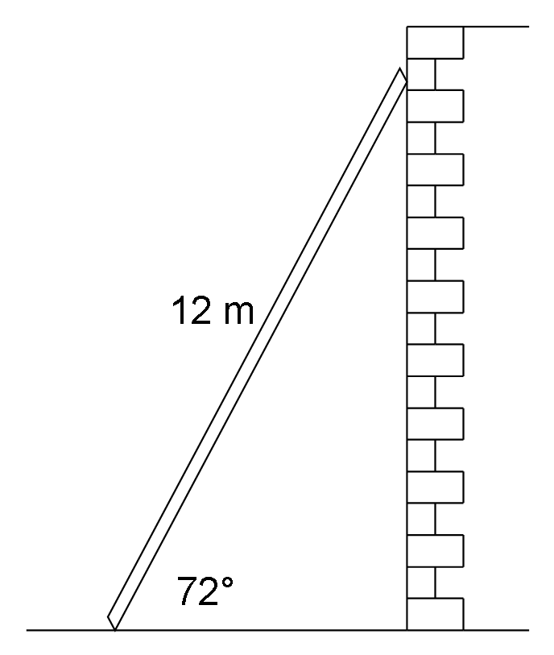

(A) 0.8 m

(B) 3.7 m

(C) 11.4 m

(D) 36.9 m

15. What is the measure of  to the nearest tenth of a degree?

(A) 18.4˚

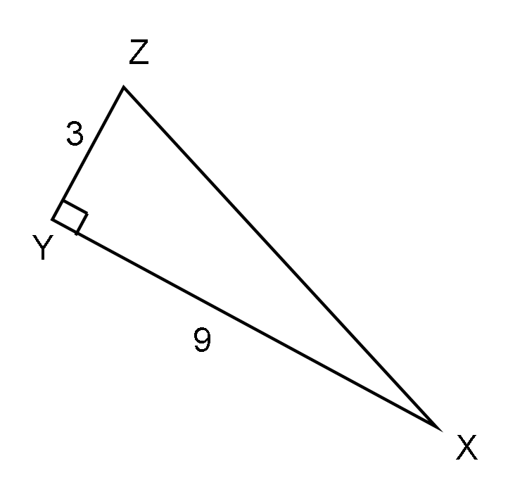

(B) 19.5˚

(C) 70.5˚

(D) 71.6˚

16. Which of the following is the ratio for  in ?

(A) 

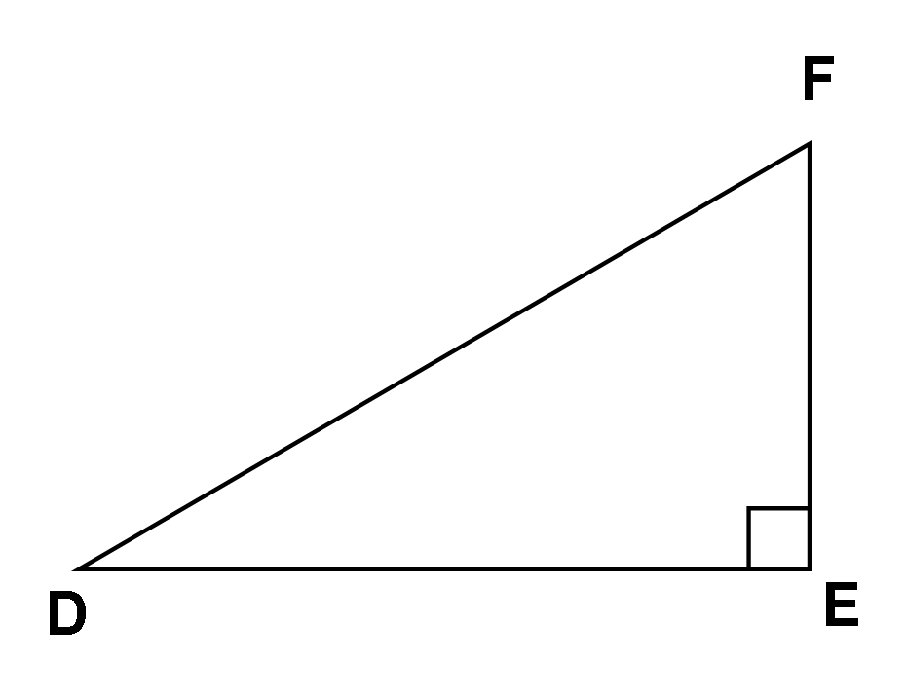

(B) 

(C) 

(D) 

17. A surveyor made the measurements shown in the diagram. What is the distance from

R to S, to the nearest hundredth of a metre?

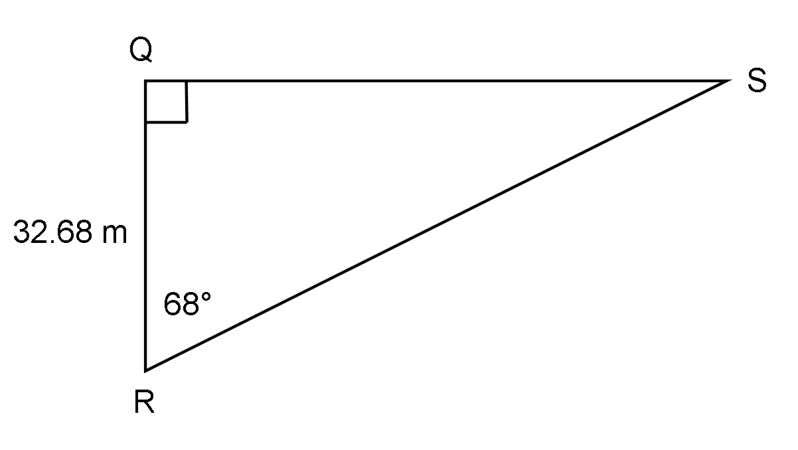

(A) 12.34 m

(B) 13.20 m

(C) 35.25 m

(D) 87.24 m

18. A 6 metre cable is attached to a pole. The cable is anchored to the ground 2.5 metres from

the base of the pole. What is the angle of inclination of the cable to the nearest tenth

of a degree?

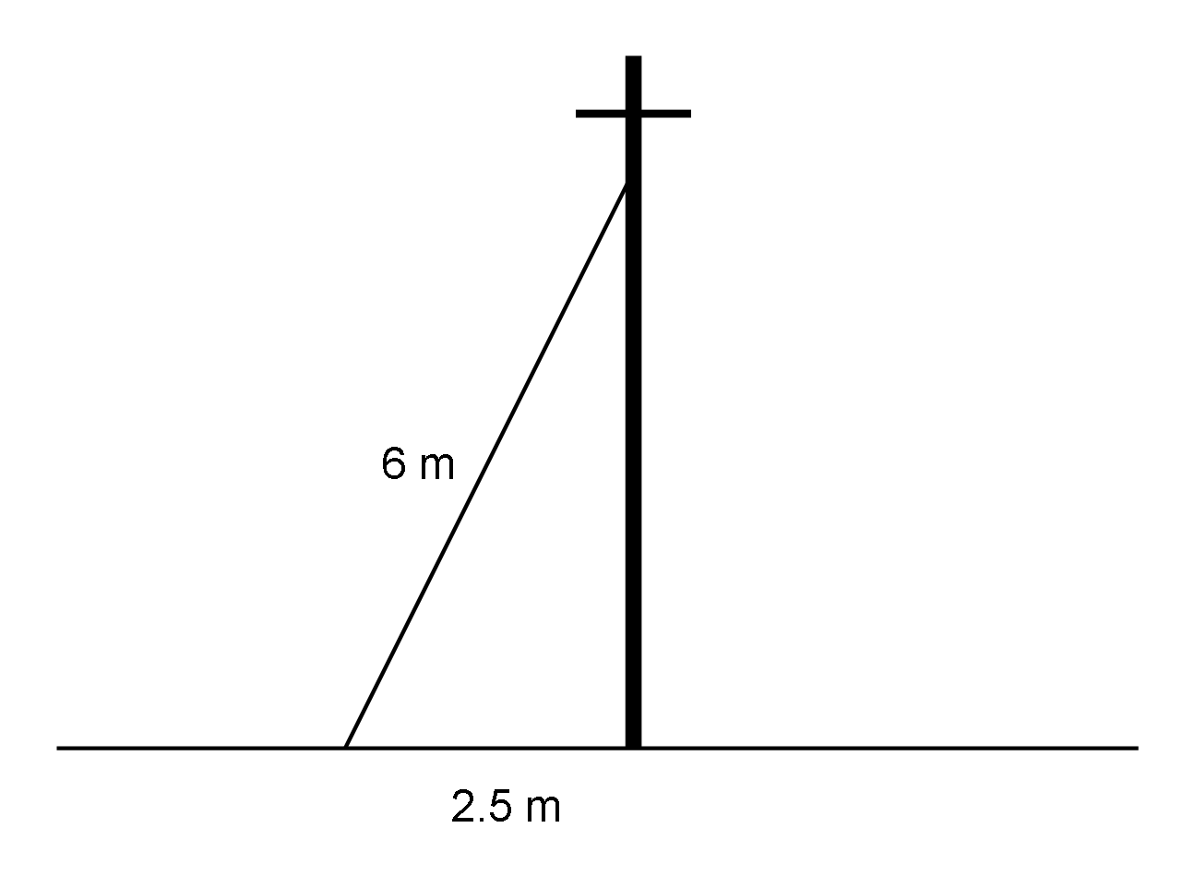

(A) 1.1˚

(B) 22.6˚

(C) 24.6˚

(D) 65.4˚

19. Rhonda walked diagonally across a rectangular playground with dimensions

60 m by 45 m. If she started at point C, what is the angle, to the nearest degree, between her path and the longest side of the playground?

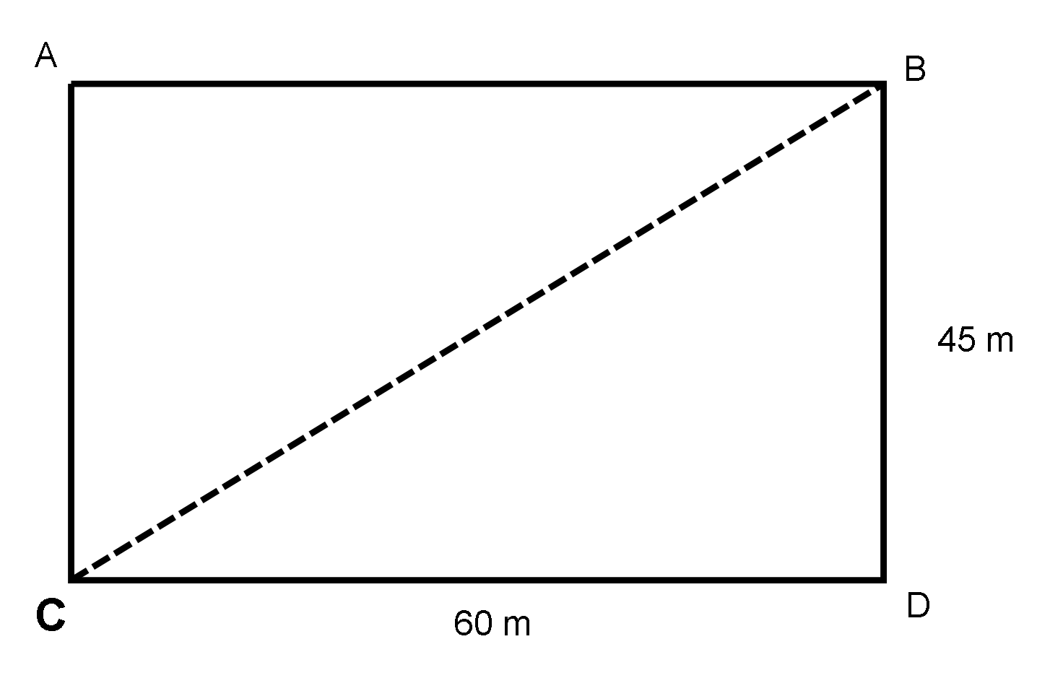

(A) 

(B) 

(C) 

(D) 

20. The front of a tent has the shape of an isosceles triangle with equal sides 8 m long. The

measure of the angle at the peak of the tent is 130o. What is the maximum headroom

in the tent to the nearest metre?

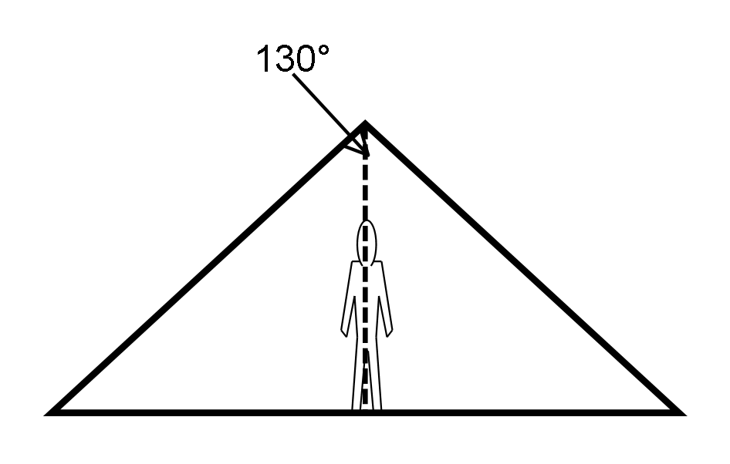

(A) 3.4 m

(B) 3.7 m

(C) 6.9 m

(D) 7.3 m

21. A forest technician 1.68 m tall is collecting data about the height of trees. He walks 7 m

from the base of a tree and measures the angle of elevation to the top of the tree as illustrated in the diagram below. What is the height of the tree?

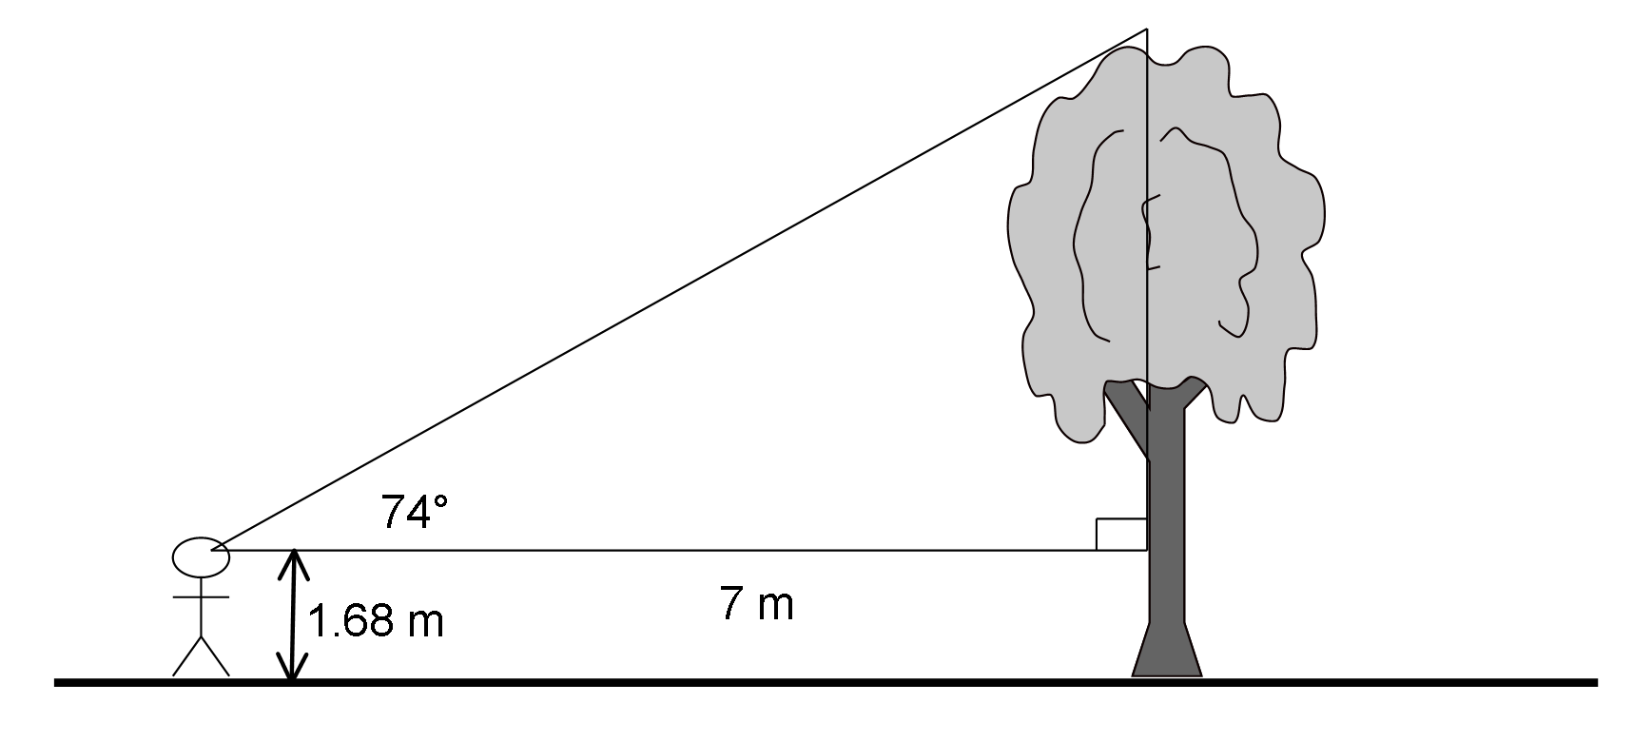

(A) 3.7 m

(B) 8.4 m

(C) 24.4 m

(D) 26.1 m

22. Which statement is true?

(A) 

(B) 

(C) 

(D) 

23. Grain is stored in a cone- shaped pile. The dimensions of the cone are shown. Which

equation could be used to find x, the angle of inclination?

(A) 

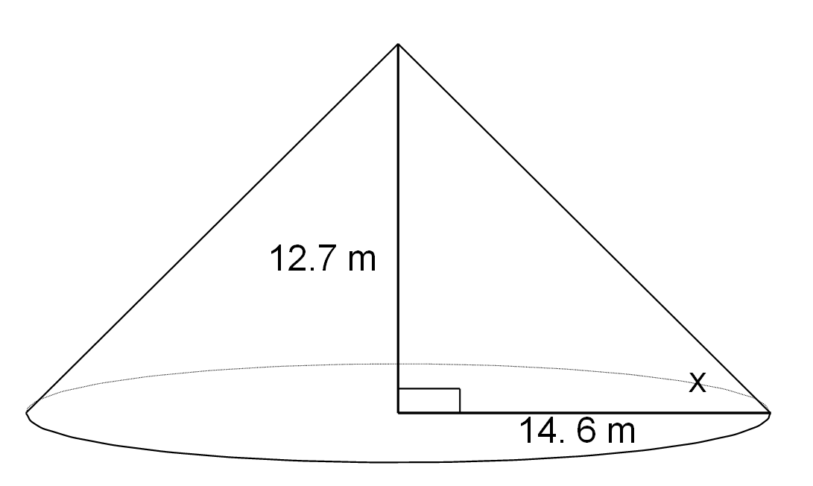

(B) 

(C) 

(D) 

24. What is the least common multiple of 18 and 24?

(A) 2 × 3

(B) 22 × 33

(C) 23 × 32

(D) 24 × 33

25. What is the side length of the smallest possible square that can be tiled using a 6 cm by

15 cm tile, assuming the tiles cannot be cut?

(A) 3 cm

(B) 21 cm

(C) 30 cm

(D) 90 cm

26. Which of the following numbers is both a perfect square and a perfect cube?

(A) 8

(B) 16

(C) 32

(D) 64

27. Which two numbers have the following properties?

* Their GCF is 12.
* Their LCM is 72.

(A) 2 and 3

(B) 24 and 36

(C) 48 and 72

(D) 72 and 864

28. Which power would have the largest index when written in radical form?

(A) 

(B) 

(C) 

(D) 

29. What is the edge length of a cube in the diagram below?



(A) 7.35 cm

(B) 54 cm

(C) 396.82 cm

(D) 5832 cm

30. What is  as an entire radical?

(A) 

(B) 

(C) 

(D) 

31. Which set of numbers is ordered from smallest value to greatest value?

(A) 

(B) 

(C) 

(D) 

32. Which of the following is a natural number?

(A) 

(B) 

(C) 0

(D) -8

33. Which of the following sets of numbers contain only rational numbers?

(A) 

(B) 

(C) 

(D) 

34. Simplify: 

(A) 

(B) 

(C) 

(D) 

35. Which of the following statements are true?

|  |  |
| --- | --- |
| I | The factors of 24 are 2, 3, 4, 6, 8, and 12 |
| II | The prime factorization of 24 is 23 × 3 |
| III | The prime factors of 24 are 2 and 3 |
| IV | is an irrational number |

(A) I and IV only

(B) II and III only

(C) II, III and IV only

(D) I, II, III and IV

36. Evaluate: 

(A) 

(B) 

(C) 

(D) 

37. Which of the following number lines best represents the placement of X, Y and Z given:

X = 

Y = cube root of 68

Z = 

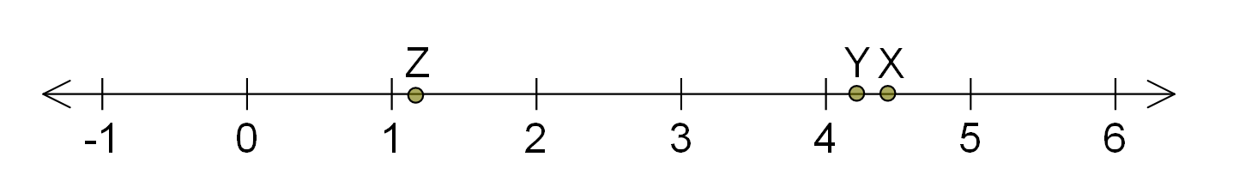

(A)

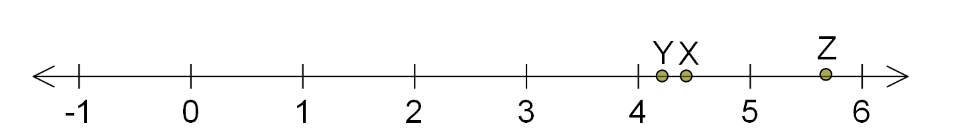

(B)

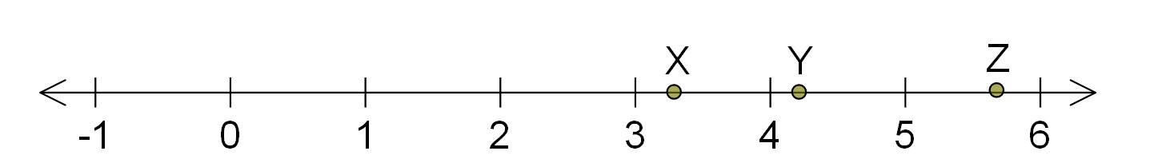

(C)

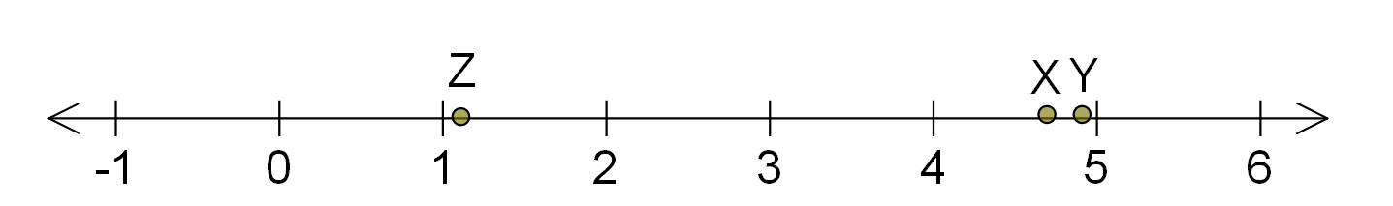

(D)

38. The area of a square is 27 square inches. Which of the following statements is true?

(A) Both the square’s side length and its perimeter are irrational.

(B) Both the square’s side length and its perimeter are rational.

(C) The square’s side length is irrational and the perimeter is rational.

(D) The square’s side length is rational and the perimeter is irrational

39. What is  as a power?

(A) 

(B) 

(C) 

(D) 

40. Evaluate: 

(A) 

(B) 0.201 224…

(C) 

(D) 

**Part 2- Constructed Response**:

**Directions:** Answer all questions in the space provided. Show **ALL** workings to ensure full marks. (50%)

41. George is 6 ft. 3 in. tall and wants to enter a door opening that is 2 m high. Algebraically

determine whether George can enter the opening without bending over. If so, what is the

distance between George’s head and the top of the door opening? (4 marks)

42. Ice cream is sold in a cylindrical container with a height of 15 cm and a radius of

8 cm. If a scoop of ice cream is in the shape of a hemisphere with a diameter of 5.0 cm,

how many scoops of ice cream are in the container? (4 marks)

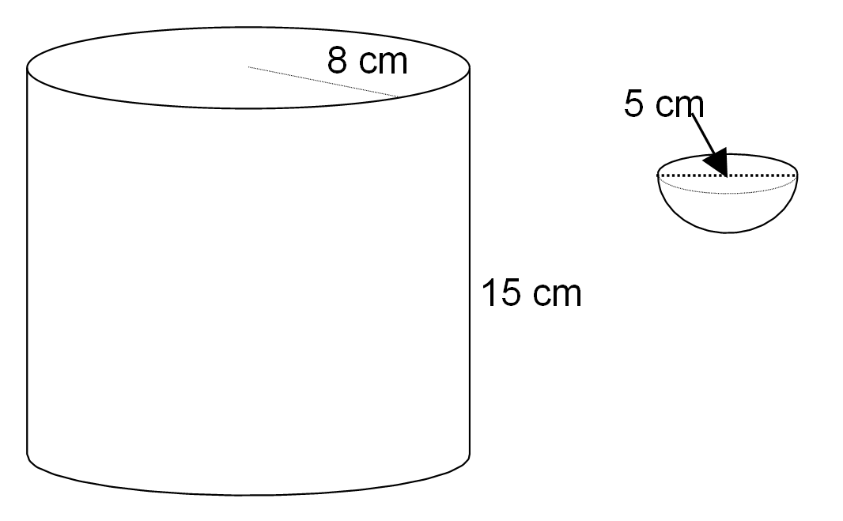

43. A solid ball in the shape of a sphere fits inside a cube that has edge lengths equal to the diameter of the sphere. If the ball has a diameter of 4.6 cm, what is the volume of the air in the cube? (3 marks)





44. Determine how much paint is needed to paint the outside of the following composite

3-D object. (4 marks)

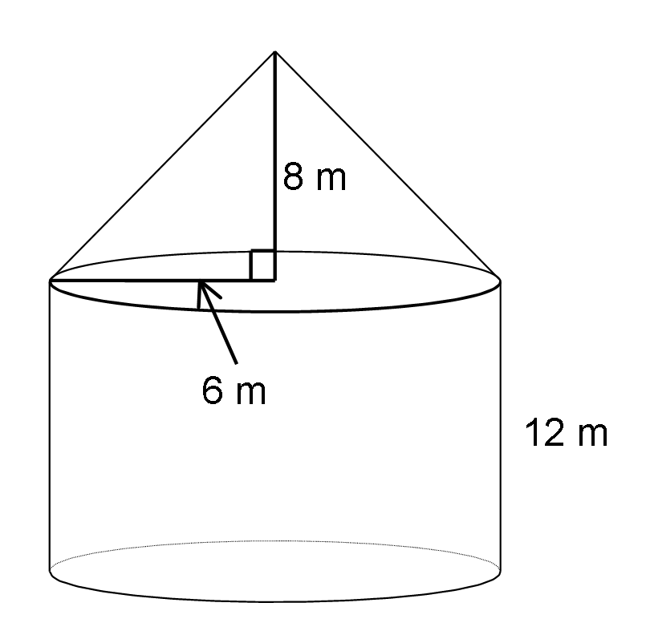

45. Solve , given  (4 marks)

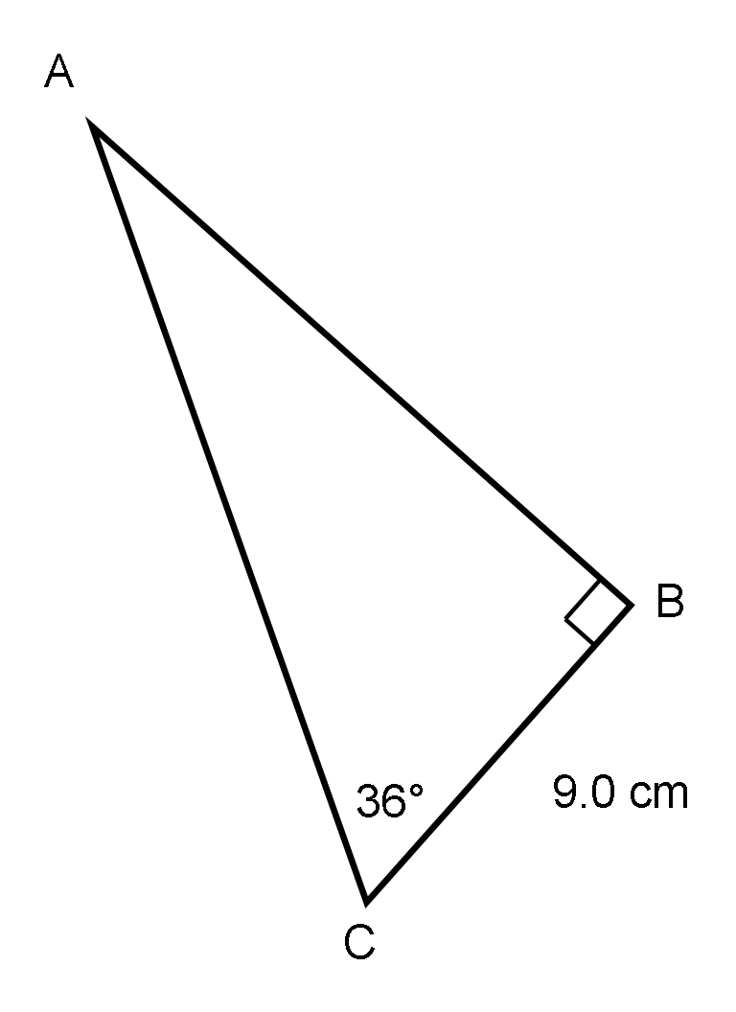

46. A tower is support by two guy wires as shown in the diagram below. The two wires are

are fixed in the ground 7.0 metres from the base of the tower. If the angle of elevation of the wires are 39o and 51o , how far apart are the wires attached on the tower? (4 marks)

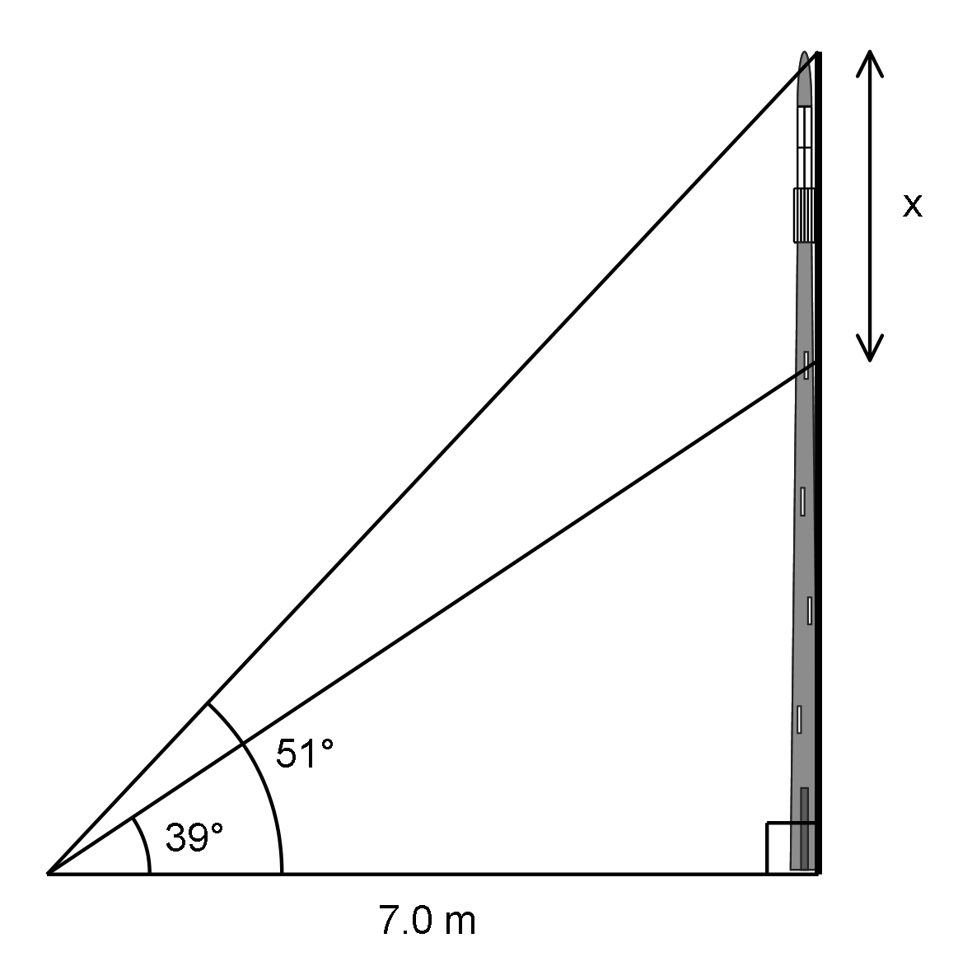

47. Calculate the length of side x in the diagram below to the nearest centimeter. (3 marks)

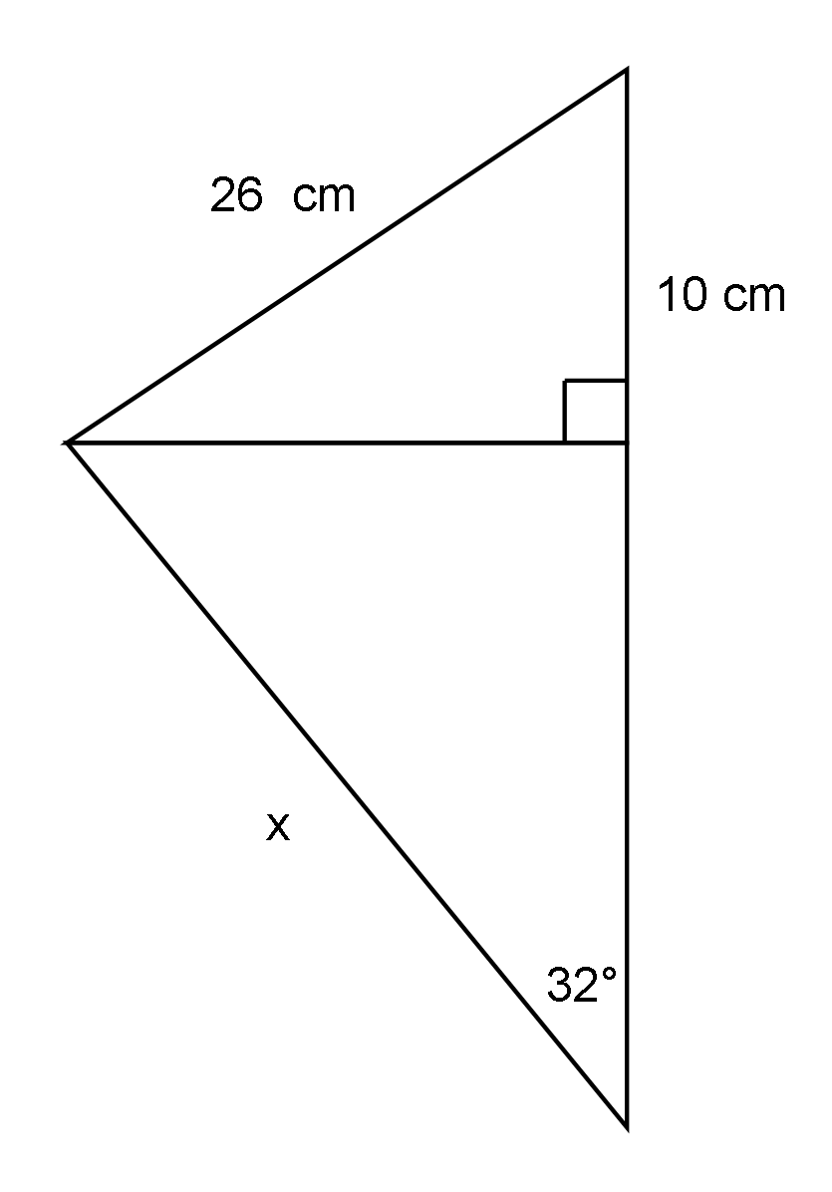

48. Two office towers are 31.7 m apart. From the shorter tower, the angle of elevation to the top of the taller tower is 27.5o. The angle of depression to the base of the taller tower is 48.2o. Using the diagram below calculate the height of each building. (4 marks)

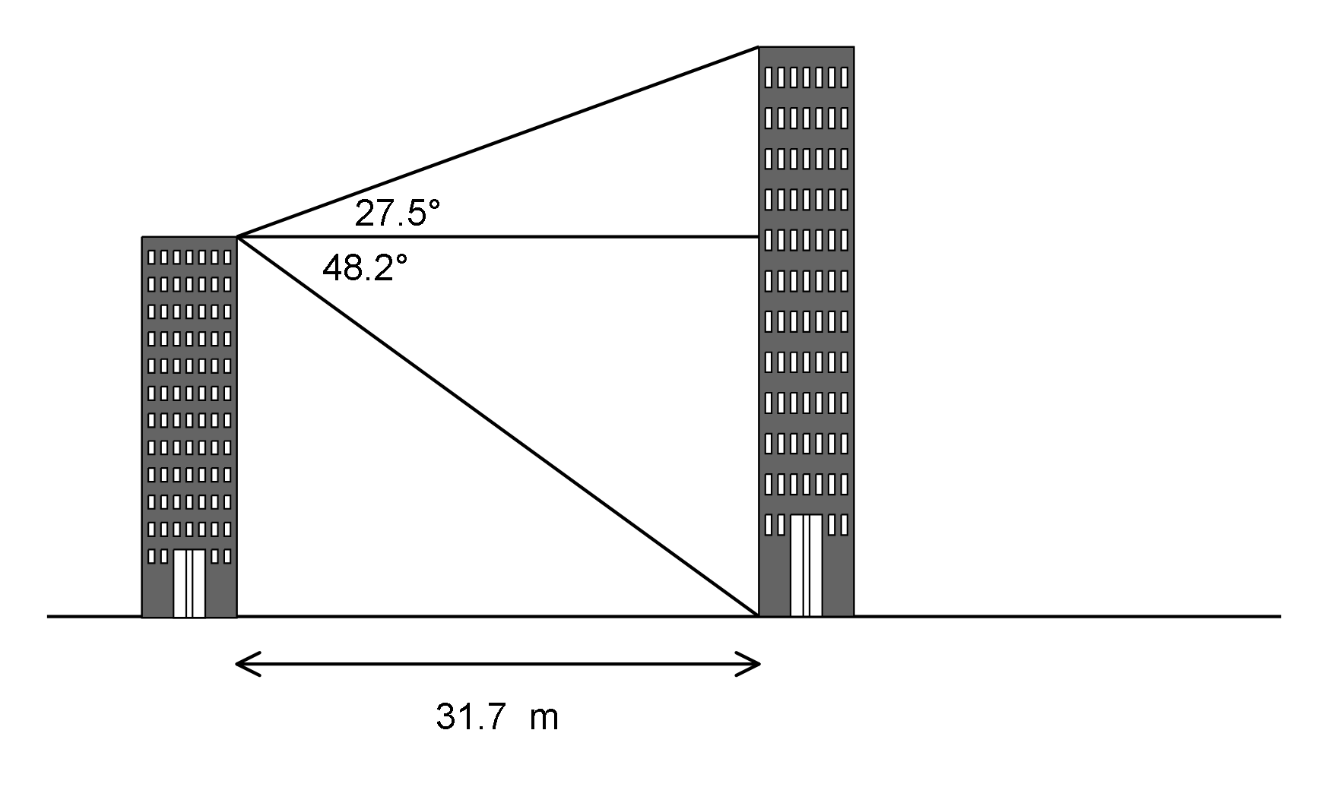

49. A local grocery store is celebrating their 10th anniversary. Every 6th person receives a free hat. Every 10th person receives a free T-shirt. Every 12th person will receive free jacket. Which person will receive all three items? (3 marks)

50. Jackson wants to paint a cube with a volume of 2144 m3. Each can of paint covers 79 m2. How many cans of paint will he need to paint the cube? (3 marks)



51. A student’s solution for evaluating a power is shown below. Identify and explain the error the student made. Write the correct solution. (4 marks)



**Math 1201**

**Answer Sheet - Part I Name :___________________**

**Directions:** Place answers for part I in the space provided.

|  |  |  |  |
| --- | --- | --- | --- |
| **1.** | **11.** | **21.** | **31.** |
| **2.** | **12.** | **22.** | **32.** |
| **3.** | **13.** | **23.** | **33.** |
| **4.** | **14.** | **24.** | **34.** |
| **5.** | **15.** | **25.** | **35.** |
| **6.** | **16.** | **26.** | **36.** |
| **7.** | **17.** | **27.** | **37.** |
| **8.** | **18.** | **28.** | **38.** |
| **9.** | **19.** | **29.** | **39.** |
| **10.** | **20.** | **30.** | **40.** |