Part 1: Multiple Choice (10 marks)
Circle the letter of the correct answer.
1. A set of all the elements under consideration for a particular context is known as a(n)

- Empty set
- Subset
- Union set
- Universal set

2. If $A=\left\{1, 3, 5, 7, 9\right\}$ and $B=\left\{2, 4, 6, 8\right\}$, then the intersection of set $A$ and set $B, A$ B, is

- $A∩B=\{1, 2, 3, 4, 5, 6, 7, 8, 9\}$
- $A∩B=∅$
- Too large to count
- None of the above
3. There are 42 guests at a golf resort. Of these guests, 25 plan to go golfing and 22 plan to play beach volleyball. There are 10 guests who do not plan to golf or play beach volleyball. How many guests plan to golf and play beach volleyball?

- 15
- 22
- 37
D) 42

4. How many elements are in the union of set and set B if $A=\left\{1, 9, 25, 49, 81\right\}$ and $B=\left\{1, 4, 9, 16, 25\right\}$?

A) 3
B) 5
C) 7
D) 10

5. If set A and set B are part of the universal set, U, then $n\left(A∪B\right)$ is equal to

- $n\left(A∪B\right)$’
- $n\left(U\right)-n\left(A∪B\right)$’
- $n\left(U\right)$
- $n\left(A\right)+n\left(B\right)$

6. What is the value of $n\left((S∪T)\backslash J\right)$ in the following diagram?

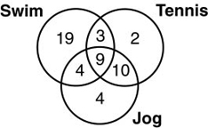

A) 24
B) 32
C) 47
D) 51

7. If Set $A=\left\{-2, 0, 2, 4, 6, 8, 10\right\}, which represents set notation?$

- $A=2x, \{x|x∈R\}$
- $A=2x, \{x|-1≤x≤5, x∈W\}$
- $A=2x, \{x|-1≤x≤5, x∈N\}$
- $A=2x, \left\{x\right|-1≤x≤5, x∈I\}$

8. Let $A=\{-4, 0, 7, 12, 14\}$, $B=\left\{all real numbers\right\}$, and $C=\left\{5, 6, 7, 8\right\}$. Then

- $\left(A∩B∩C\right)=∅$
- $\left(A∩B∩C\right)=\{7\}$
- $\left(A∪B∪C\right)=∅$
- $\left(A∪B∪C\right)=\{-4, 0, 5, 6, 7, 8, 12, 14\}$

9. Which of the following represents the shaded area in the Venn diagram below?
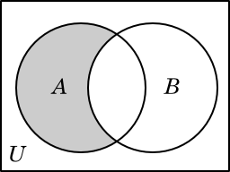
- $B'$
- $A$
- $B\backslash A$
- $A\backslash B$

10. Given the universal set U = {q, r, s, t, u, v, w, x, y, z}, and subsets A = {q, s, u, w, y}, B = {q, s, y, z}, and C = {v, w, x, y, z}, what is A U (B ∩ C)?

A) {q, s, u, w, y, z}
B) {q, y, z}
C) {q, r, w, y, z}
D) {q, w, y}
Part 2: Constructed Response.
Students are to answer ALL questions and show ALL necessary workings to obtain full credit
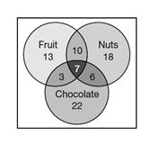
11. The Venn diagram below shows the three types of food ingredients students picked as things they like in dessert: nuts, fruit, and chocolate. [5]
- How many students like desserts with nuts and chocolate?

- How many students would like a combination of all three ingredients in a dessert?

- How many students like desserts with nuts only?

- How many students like desserts with fruit and nuts but no chocolate?

- How many students were polled in the survey?

12. The diagrams below represent the activities chosen by youth club members. They can choose to play tennis (T), baseball (B), or go swimming (S). Decide which diagram has the shading which represents the following descriptions: [3]

- Those who play all 3 sports. ________________

- Those who play tennis and baseball, but do not go swimming. _______________
- Those who play only tennis. __________________
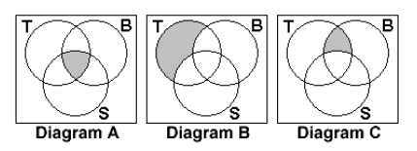

13. Consider the following sets: [3]

$A=\{-2, 0, 2, 4, 6, 8, 10\}$
$B=\left\{-5, -4, -3, -2, -1, 0, 1, 2, 3, 4, 5\right\}$
$C=\left\{1, 2, 3, 4, 5\right\}$
$D=\{-100, -90, -80, -70, -60, -50\}$

- Which of these sets are subsets of the other?

- List the disjoint sets if there are any.

14. In a class of 32 pupils: [5]
- 5 pupils live in New Town, travel to school by bus and eat school dinners
- 3 pupils live in New Town, travel to school by bus but do not eat school dinners
- 9 pupils do not live in New Town, do not travel to school by bus and do not eat school dinners
- 11 pupils live in New Town and have school dinners
- 16 pupils live in New Town
- 9 pupils travel by bus and eat school dinners
- 13 pupils travel by bus
How many pupils eat school dinners? (Use a Venn diagram in your solution.)

15. A survey of 120 first-graders was conducted concerning the types of animals that were in the last book each of them read. The following results were obtained: [5]
- 48 read about an elephant
- 56 read about a monkey
- 44 read about a tiger
- 7 read about an elephant and a tiger but not a monkey
- 13 read about an elephant and a monkey but not a tiger
- 14 read about a monkey and a tiger but not an elephant
- 18 students did not read about any of these animals.
How many students read a book about all three animals? (Use a Venn diagram in your solution.)

