**Test #2 Trigonometry Name:__________**

Part I : Place the correct response in the space provided to the right. [15]

1. Which represents standard position for $-\frac{9π}{5}$ radians? 1.___



(A) (B)



(C) (D)

2. Which represents 195° expressed in radian measure? 2.___

(A) (B) (C) (D)

3. Which pair of angles is coterminal? 3.___

(A) $\frac{2π}{3}$ and $\frac{5π}{3}$ (B) $-\frac{5π}{4}$ and $\frac{3π}{4}$

(C) $\frac{2π}{5}$ and (D) and

4. What is the length of the arc cut by a 240° sector in a circle

having diameter 10 cm? 4.___

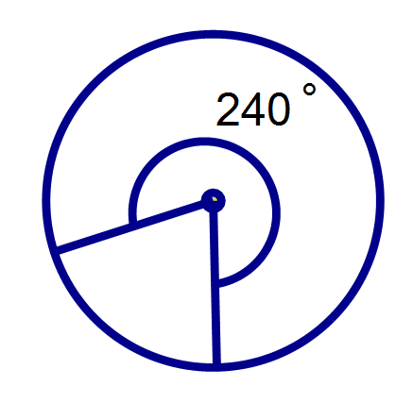

(A)

(B)

(C)

(D)

5. Which represents the equation of a circle with centre at the origin

and radius ? 5.___

(A) x2 + y2 = (B) x2 + y2 = 6

(C) x2 + y2 = 12 (D) x2 + y2 = 36

6. If P(Ө) is the point of intersection on the terminal arm of Ө and the

unit circle, then which represents the exact coordinates for ? 6.___

(A) (B)

(C) (D)

7. Which represents the measure of the central angle Ө if the point

$P\left(θ\right)=\left(-\frac{\sqrt{3}}{2}, -\frac{1}{2}\right)$ lies on the terminal arm of Ө? 7.___

(A) (B) (C) (D)

8. Which represents the missing coordinate if the point $P\left(\frac{1}{5}, y\right)$

lies on the terminal arm in the fourth quadrant? 8.___

(A) (B) (C) (D)

9. If the point P(–8, 15) lies on the terminal arm of Ө, then which

represents the ratio for csc Ө ? 9.___

(A) (B) (C) (D)

10. Which represents the exact value of $\tan\left(\frac{2π}{3}\right)$? 10.__

(A) (B) (C) (D)

11. Which represents the exact value of tan 60° + cot 60° ? 11.__

(A) (B) (C) 1 (D)

12. Which represents the approximate measure in radians for Ө

if sec Ө = 3 ? 12.__

(A) 0.01 (B) 0.05 (C) 0.34 (D) 1.23

13. In which quadrant is csc Ө > 0 and cos Ө < 0 ? 13.__

(A) I (B) II (C) III (D) IV

14. Which represents a solution for tan Ө = –1.456

where 180° ≤ Ө ≤ 360° ? 14.__

(A) 55.5° (B) 214.5° (C) 235.5° (D) 304.5°

15. Which exact measures of Ө satisfy sin Ө = 0

where –360° ≤ Ө < 360°? 15.__

(A) Ө = –360°, –180°, 0°, 180°, 360°

(B) Ө = –270°, –90°, 0°, 90°, 270°

(C) Ө = –360°, –180°, 0°, 180°

(D) Ө = 0°

Part II: Answer each question in the space provided. Correct answers

without appropriate trigonometric justification will not receive full marks.

16. Determine the EXACT value, in simplest form, for: [6]

17. Determine the general solution to the equation below,

where x is in degrees. [6]

6 csc2x – csc x = 15

18. Solve for x, where –π ≤ x < 2π sec2x – 3 sec x +2 = 0 [5]

19. Determine the length of $\hat{AB}$, to the nearest tenth of a unit. [6]

