Math 3201 Test Name:___________________________ Chapter 1 /28
Formulas: n(A∪B) = n(A) + n(B) - n(A∩B)
n(A∪B∪C) = n(A) + n(B) + n(C) - n(A∩B) - n(A∩C) - n(B∩C) + n(A∩B∩C)
Part I: Place the letter of the correct answer in the space provided at the right. (9 Marks)
1. Consider the sets: A $=\left\{1, 3, 4, 7, 8, 9\right\}$ B $=\left\{1, 2, 3, 4, 5\right\}$ C $=\left\{1, 3\right\}$ What is 1.____ A∩B ?
A) $\left\{1, 3\right\}$ B) $\left\{1, 3, 4\right\}$ C) $\left\{1, 2, 3, 4, 5\right\}$ D) $\left\{1, 2, 3, 4, 5, 7, 8, 9\right\}$

2. Describe the shaded region: 2.____

A) B
B) B'
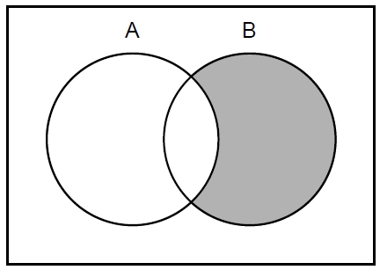
C) A'
D) B\A

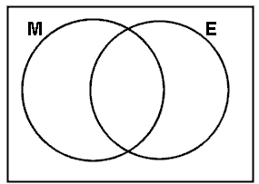3. In a class there are 30 students. 3.____
- 21 students like Math
- 16 students like English
- 6 students don't like Math or English
How many students like both Math and English?

A) 5 B) 7 C)13 D) 24

4. Consider the sets: U $=\left\{1, 2, 3, 4, 5, 6, 7, 8, 9\right\}$ A $=\left\{1, 3, 5, 7, 9\right\}$ B $=\left\{2, 4, 6\right\}$ 4.____ What is A' ?
A) $\left\{2, 4, 6\right\}$ B) $\left\{2, 4, 6, 8\right\}$ C) $\left\{1, 3, 5, 7, 9\right\}$ D) $\left\{1, 2, 3, 4, 5, 6, 7, 8, 9\right\}$

5. If you were doing an internet search on the eating habits of dogs, what search 5.____ would give the fewest results?
A) dogs B) dogs or eating habits
C) dogs and eating habits D) "dogs" and "eating habits"

6. The Grade 10 social studies students were surveyed to see whether they wanted to 6.____ visit the local museum or a nearby state park. They could choose the museum, the park, both, or neither. The results of the survey are shown in the Venn diagram below. If 96 students were surveyed, how many wanted to go to the state park only?
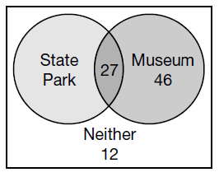
A) 11
B) 27
C) 38
D) 46

7. Consider the sets: P$=\left\{2, 4, 6, 8,\right\}$ Q$=\left\{Odd numbers between 0 and 10\right\}$ 7.____ R $=\left\{1, 3, 5, 7\right\}$ S$=\left\{1, 2, 3, 4\right\}$. Which of the following is true?
A) P ⊂ Q B) S ⊂ P C) Q ⊂ R D) R ⊂ Q

8. The diagrams below represent the activities chosen by youth club members. They 8.____ can choose to play Tennis (T), Badminton (B) or Squash (S). Which diagram represents the number of youth who play badminton and tennis but not squash?
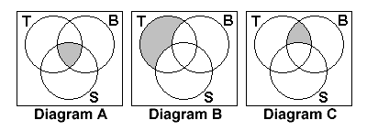
9. The following Venn diagram shows the number of students who like Surfing (S), 9.____ Hockey (H), Baseball (B), a combination of these sports or neither sport. What is n(S ∪ H)?
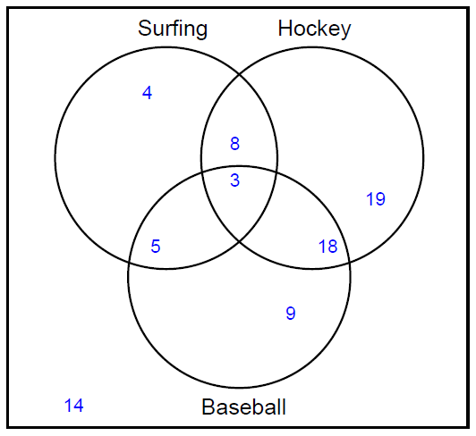
A) 8 B) 11 C) 31 D) 57
Part II: Answer all questions and show your workings in the space provided. (19 Marks)
1. The Venn diagram below shows the three types of food ingredients students picked as things they like in dessert: fruit, nuts and chocolate. (5 Marks)
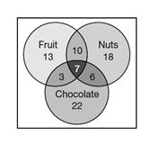
A) How many students like desserts with nuts and chocolate?
B) How many students like a combination of all three ingredients in a dessert?
C) How many students like desserts with only nuts?
D) How many students like desserts with fruit and nuts but no chocolate?
E) How many students were polled in the survey?

2. 66 students were surveyed to determine their travel interests. (7 Marks)
32 students wanted to go to Spain
27 students wanted to go to New York
44 students wanted to go to Paris
16 students wanted to go to New York and Paris
18 students wanted to go to Paris and Spain
10 students wanted to go to all three destinations
How many students wanted to go to New York and Spain but not Paris?
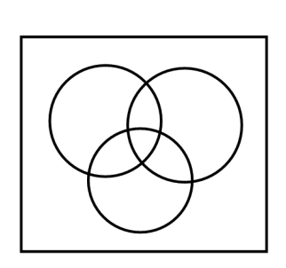

3. A survey of 120 first graders was conducted concerning the types of animals that were in the last book each of them read. The following results were obtained: (7 Marks)
48 read about an elephant
56 read about a monkey
44 read about a tiger
7 read about an elephant and a tiger but not a monkey
13 read about an elephant and a monkey but not a tiger
14 read about a monkey and a tiger but not an elephant
18 did not read about any of these animals.
How many students read a book about all three animals?

