Math 3200 Test Name:_____________________ Chapter 7 /32
Formula: $A=A_{0}{\left(1+i\right)}^{n}$
Part I: Multiple Choice: Shade the letter of the correct answer on the scantron form provided. (10 Marks)
1. What is the mapping rule that transforms $y=3^{x}$ to $y= -2{\left(3\right)}^{2x-4}+1$?
A) $\left(x,y\right)→\left(\frac{1}{2}x+4, -2y+1\right)$ B) $\left(x,y\right)→\left(\frac{1}{2}x+2, -2y+1\right)$
C) $\left(x,y\right)→\left(\frac{1}{2}x-4, -2y+1\right)$ D) $\left(x,y\right)→\left(\frac{1}{2}x-2, -2y+1\right)$

2. Write as a single power: $\frac{{\left(25\right)}^{n-1}{\left(125\right)}^{2n+3}}{5^{n-4}}$
A) $5^{2n+6}$ B) $5^{2n-2}$ C) $5^{7n-3}$ D) $5^{7n+11}$

3. A house is purchased for $240 000 and appreciates by 4% annually. Write an exponential function that can be used to determine the value, V of the house in t years.
A) $V=240 000{\left(0.4\right)}^{t}$ B) $V=240 000{\left(0.96\right)}^{t}$
C) $V=240 000{\left(1.04\right)}^{t}$ D) $V=240 000{\left(1.4\right)}^{t}$

4. Solve for x: $\sqrt{3}=9^{x-2}$
A) $-\frac{3}{4}$ B) $\frac{5}{4}$ C) $2$ D) $\frac{9}{4}$

5. What is the range of the function $=-\frac{1}{2}{\left(4\right)}^{x+3}-5$ ?
A) $\left\{y | y<-5\right\}$ B) $\left\{y | y<5\right\}$
C) $\left\{y | y>-5\right\}$ D) $\left\{y | y>5\right\}$

6. Describe the transformation of $y=2^{x}$ that produces $y-1= {\left(2\right)}^{4\left(x+2\right)}$
A) vertical translation 1 unit down, horizontal stretch $\frac{1}{4}$, horizontal translation 2 units left
B) vertical translation 1 unit down, horizontal stretch 4, horizontal translation 2 units left
C) vertical translation 1 unit up, horizontal stretch $\frac{1}{4}$, horizontal translation 2 units left
D) vertical translation 1 unit up, horizontal stretch 4, horizontal translation 2 units left

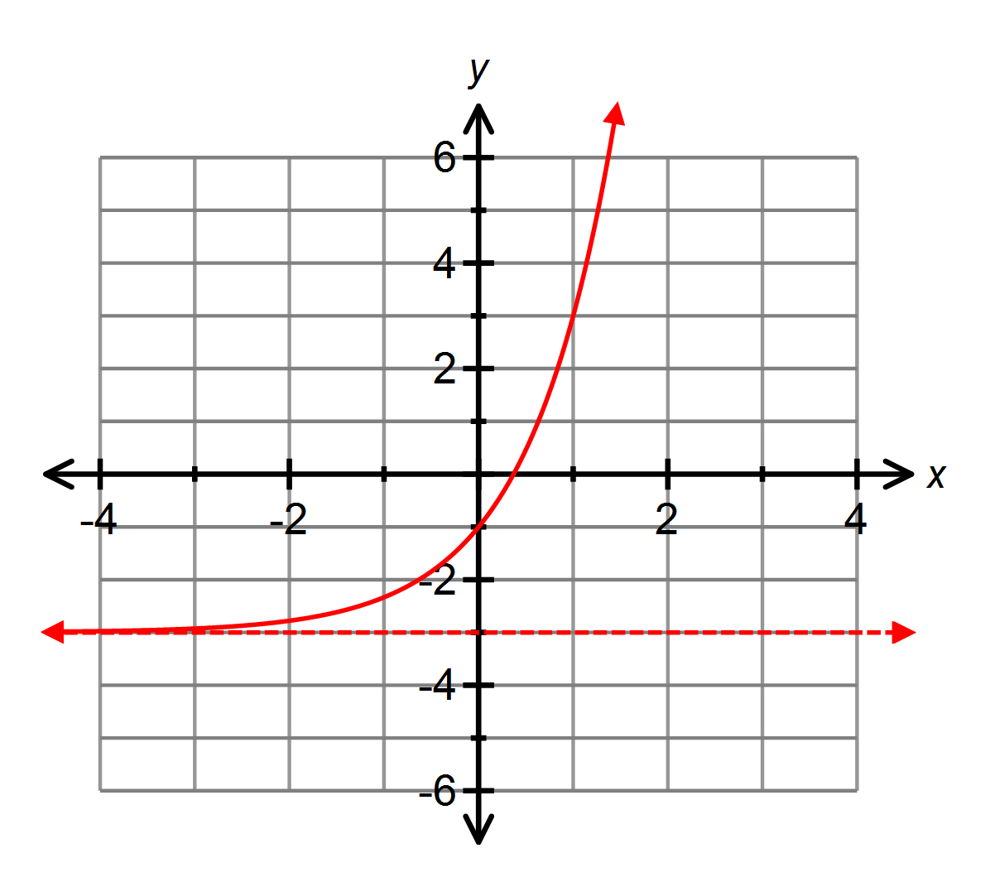7. Which equation best represents the graph below?
A) $y=2^{x}-3$
B) $y=3^{x}-3$
C) $y=3{\left(2\right)}^{x}-3$
D) $y=2{\left(3\right)}^{x}-3$

8. What is the equation of the horizontal asymptote of $-4\left(y+3\right)=2^{x-1}$
A) $y= -3$ B) $y= -\frac{1}{3}$ C) $y= \frac{1}{3}$ D) $y= 3$

9. A strain of bacteria doubles every 4 hours. If 20 bacteria are present initially, write an equation to represent the number of bacteria present at time t.
A) $y=20{\left(\frac{1}{2}\right)}^{t}$ B) $y=20{\left(2\right)}^{\frac{t}{4}}$
C) $y=20{\left(2\right)}^{t}$ D) $y=20{\left(2\right)}^{4t}$

10. Which best represents the transformation of $y=5^{x}$ by the mapping rule $\left(x,y\right)→\left(-\frac{1}{3}x-3,4y+2\right)$ ?
A) $\frac{1}{4}\left(y-2\right)=5^{-3\left(x+3\right)}$ B) $4\left(y-2\right)=5^{-3\left(x+3\right)}$
C) $\frac{1}{4}\left(y+2\right)=5^{-3\left(x+3\right)}$ D) $4\left(y+2\right)=5^{-3\left(x+3\right)}$

Part II: Show all workings in the space provided. (22 Marks)
1. A radioactive substance has a half-life of 23 years. If the function $A= A_{0}{\left(\frac{1}{2}\right)}^{\frac{t}{h}}$ models the decay of the substance and 384 grams are present initially, algebraically determine when 12 grams remain. (4 Mks)

2. Sketch the graph of: $y=2{\left(4\right)}^{-2x-6}-1$
State the mapping rule, tables of values, domain, range and equation of the horizontal asymptote. (6 Mks)
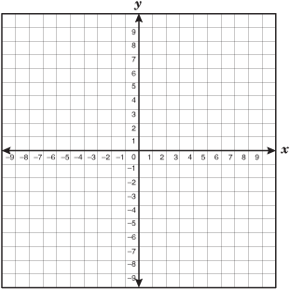

3. Solve for x algebraically: (9 Mks)
a) ${\left(\frac{1}{9}\right)}^{x-6}={\left(27\right)}^{2x-1}$ $\left[3\right]$ b) $4{\left(5\right)}^{3x+2}=2500$ $\left[2\right]$ c) $\sqrt[3]{{16}^{x}}={\left(\frac{1}{4}\right)}^{2x+4}\left[4\right]$

4. $4000 is invested in an account that earns 6% interest per year compounded semi-annually. Write an equation to model this situation and algebraically determine how much money will be in the account after 6 years. (3 Mks)

