**Mathematics 3201**

**Make-Up Test (Unit 3) Probability**

**Name: _____________________________________________**

|  |
| --- |
| **FORMULAES** |
|  |

**Part A :** Place the letter corresponding to the correct answer to each of the following in the appropriate

blank at the right.

1. The weather forecast is calling for a 30% chance of snow for Christmas. What are the odds in 1. ____

favor of **NOT** having snow for Christmas?

(A)  (B) 

(C)  (D) 

2. There are 12 candy in a bowl : **4 jelly beans, 3 candy canes,** and **5 jolly ranchers**. If 3 candy 2. ____

are selected, what is the probability selecting a jolly rancher, a candy cane and a jelly

bean in this order if the candy selected are not replaced?

(A)  (B) 

(C)  (D) 

3. The odds in favor of you passing this Math test is . As a percent what is the probability 3. ____

of you passing ?

(A)  (B) 

(C)  (D) 

4. A student has a four colored spinner and a six sided die with each side numbered one 4. ____

through six. What is the probability of rolling a number less than 4 and the color green

on the spinner?

(A)  (B) 

(C)  (D) 

5. Nick, Sarah and four other students are competing in a cross country race. What is the 5. ____

probability that Nick finishes first and Sarah finishes second in the race ?

(A)  (B) 

(C)  (D) 

6. Dan has a 40% probability of passing Math this year and a 70% probability of getting a job 6. ____

for the summer. What is his probability of him **NOT** passing Math and getting a job?

(A)  (B) 

(C)  (D) 

7. The Student Council at Mealy Mountain is having a Christmas contest. If a student spins the 7. ____

spinner twice and gets two 4’s, they win. What are the odds of a student winning ?

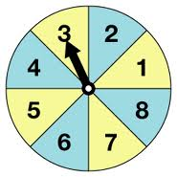

(A)  (B) 

(C)  (D) 

8. A deck of 40 cards consists of 4 different colored sets: red, blue, green and yellow. Each 8. ____

set is numbered from 0 to 9 as shown below. If two cards are randomly picked from the

deck, what is the probability that the first card is blue or green and the second card is a 5,

if the first card is replaced?

|  |  |  |  |
| --- | --- | --- | --- |
|  | Card Colour | Cards |  |
|  | red |  |  |
|  | blue |  |  |
|  | green |  |  |
|  | yellow |  |  |

(A)  (B) 

(C) (D)

8. At a traffic the red light is on for 30 seconds, amber for 5 seconds and green for 45 seconds. 8. ____

What is the probability of arriving at the light and the light is red?

(A)  (B) 

(C)  (D) 

9. There are 40 students in a class where 25 students surf the internet and 15 uses email. 9. ____

Of these 10 students do both. What is the probability that a randomly selected student

in the class do **NOT** surf the internet or use email?

(A) 25% (B) 37.5%

(C) 50% (D) 75%

10. In a bag there are 2 white marbles and 3 yellow marbles. In a second bag there are 2 green 10. ___

and 1 orange marble. What is the probability of drawing 1 white marble and 1 green marble?

(A)  (B) 

(C)  (D) 

11. A and B are mutually exclusive events. The probability of A, , is 25% and the 11. ___

probability of B, , is 60%. What is the probability of A or B,  not occurring?

(A) 15% (B) 35%

(C) 40% (D) 85%

**Part B** **:** Answer all questions and show your workings.

1. A golf bag contains 6 white balls and 8 yellow balls. What is the probability of each event if the balls

randomly selected are not placed back into the bag?

i) Choosing 3 yellow balls. **(2 marks)**

ii) Choosing 2 white balls and a yellow ball in this order. **(2 marks)**

2. Four people are randomly selected for a group of 8 boys and 6 girls. What is the probability of each

event ?

(A) All 4 people are boys. **(3 marks)**

(B) At least 3 people will be girls. **(3 marks)**

3. The probability of a student completing their Math assignment is . The odds that she will pass

her Math test is . What is the probability that she will complete her Math assignment and not

pass her Math test? **(3 marks)**

4. There are 100 boys and 120 girls in Grade 12. Twenty boys and thirty girls own a ski doo. If a

student is randomly selected:

i) What is the probability the student owns a ski doo? **(1.5 marks)**

ii) What is the probability that the student having their own ski doo is a girl? **(1.5 marks)**

5. Mr. Math is teaching Math 3201 this year and based on previous test scores there is a 70% chance a

student will pass a test if it rains the night before and a 20% chance if it’s sunny the night

before. For Friday’s test the forecast for Thursday night is a 70% chance of sunny weather. What is

the probability that a student will pass Friday’s test?

**(3 marks)**

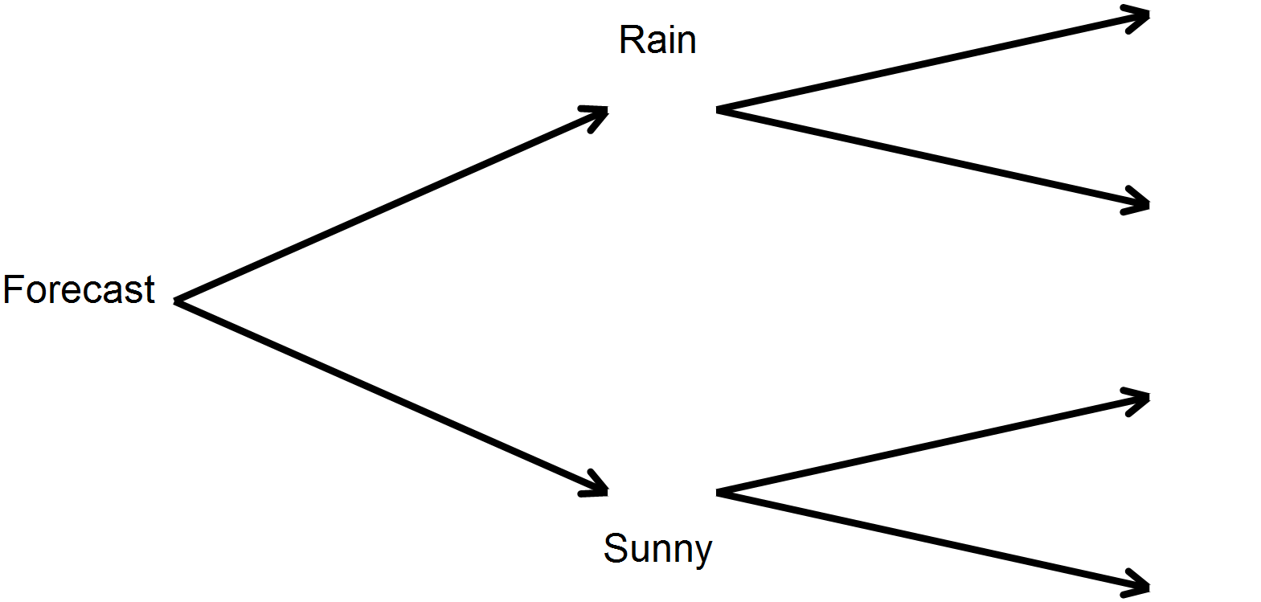

6. The music group at Mealy Mountain Collegiate is raising money for a trip to Nova Scotia. They sell

5000 tickets on two prizes:

**1st Prize $1500 Cash**

**2nd Prize A CD playing all their musical talent**

If Mr. Math has 150 tickets, what is the probability of him winning both prizes if the first ticket

drawn is **NOT** replaced? **(3 marks)**

7. A box contains the letters **A, B, G, H, M, N** and **T**. What is the probability of randomly selecting

4 letters and getting **M, A, T, H** in this order. **( 2 marks)**