**Section A - Selected Response**

**Directions:** Place the letter corresponding to the correct answer to each of the following on the

provided answer sheet.

1. Which referent could be used for 1 metre?

(A) The length of a dinner fork.

(B) The length of your stride.

(C) The width of a classroom in your school.

(D) The width of a computer keyboard.

2. A stack of 100 pieces of sheet music is 0.5 inches tall. How many pieces can fit in a storage box that

is 1 foot high?

(A) 200 pieces

(B) 400 pieces

(C) 1200 pieces

(D) 2400 pieces

3. What is 100 inches converted to yards, feet and inches?

(A ) 1 yd. 1 ft. 4 in.

(B) 2 yds. 2 ft. 2 in.

(C) 2 yds. 2 ft. 4 in.

(D) 4 yds. 0 ft 4 in.

4. A movie poster indicates that King Kong is 1500 cm tall. How tall is King Kong to the nearest foot?

(A) 17 ft.

(B) 29 ft.

(C) 50 ft

(D) 76 ft.

5. A car is travelling at 90 kilometres per hour. If the speed limit is 30 miles per hour, how many

miles per hour is the car over the speed limit?

(A) 26

(B) 38

(C) 56

(D) 60

6. Sam measured out four pieces of wood to build a bookcase. The measurements were:

Measurement I 500 mm

Measurement II 6.2 cm

Measurement III 16 inches

Measurement IV 2 feet

Which sequence places the measurements in order from ***smallest to largest*** ?

(A) II, I, III, IV

(B) II, III, I, IV

(C) IV, II, III, I

(D) IV, III, I, II

7. A picture measures 17 in. wide and 20 in. long. What is the approximate dimension of the picture

in SI units?

(A) 6.7 cm wide and 7.9 cm long

(B) 7.9 cm wide and 6.7 cm long

(C) 43 cm wide and 51 cm long

(D) 51 cm wide and 43 cm wide

8. A water tank is in the shape of a right cylinder 30 ft. high and 8 ft. diameter. How much sheet

metal was used in its construction?

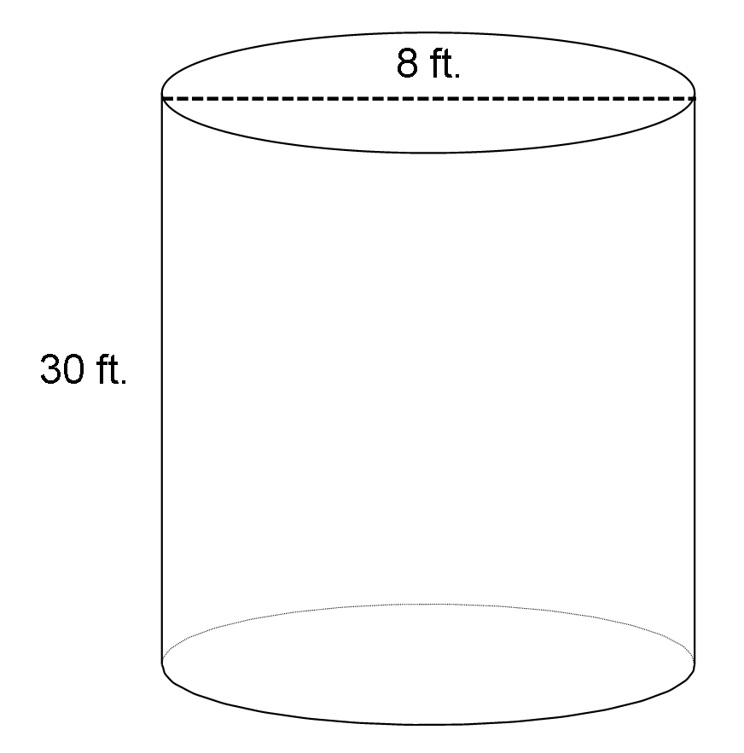

(A) 804.2 ft2

(B) 854.5 ft2

(C) 1608.5 ft2

(D) 1910.1 ft2

9. What is the surface area of the regular tetrahedron to the nearest square centimetre if AB = 5.0 cm

and CD = 5.8 cm?

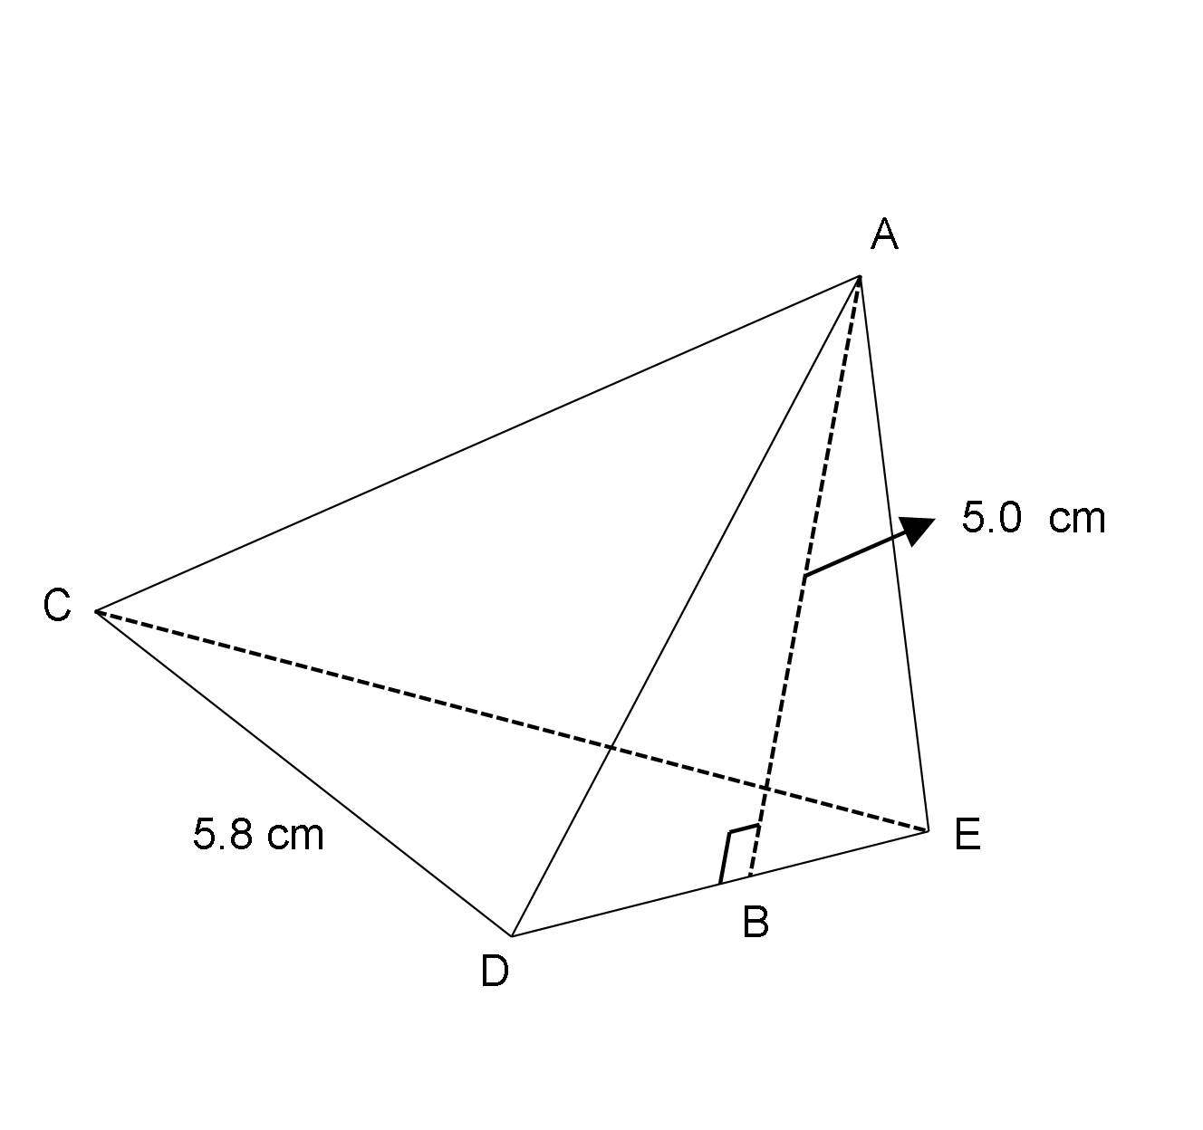

(A) 15 cm2

(B) 44 cm2

(C) 58 cm2

(D) 116 cm2

10. What is the lateral area of the cone to the nearest tenth?

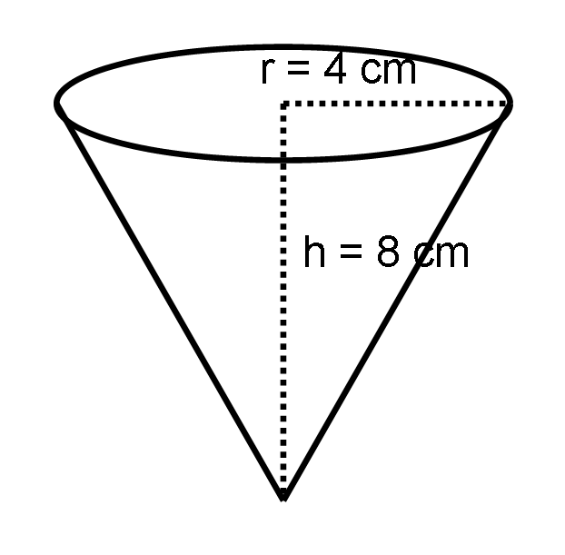

(A) 100.5 cm2

(B) 112.4 cm2

(C ) 150.8 cm2

(D) 162.7 cm2

11. An advertising model of an MP3 player has a height of 5 in. a width of 5 in. and a depth of 2 in.

What is the volume of the model MP3 player to the **nearest tenth of a *cm3***?

(A) 20.0 cm3

(B) 50.0 cm3

(C) 262.5 cm3

(D) 781.3 cm3

12. What is the volume of a square based pyramid with side length of 10 cm and height of 12 cm?

(A) 120 cm3

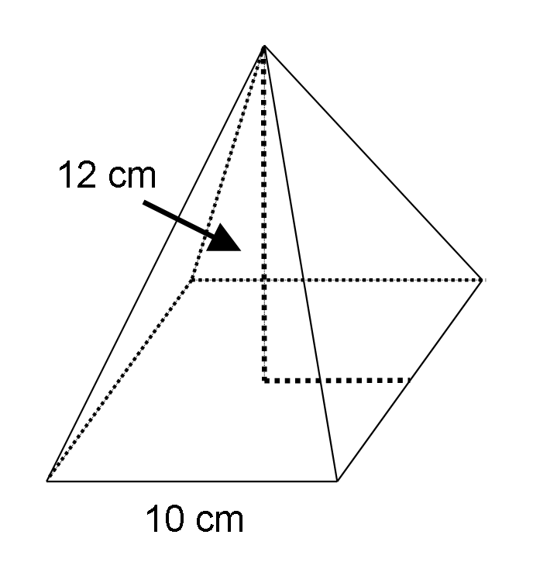

(B) 360 cm3

(C) 400 cm3

(D) 1200 cm3

13. A hemisphere has a radius of 11.4 cm. What is the volume of the hemisphere to the nearest tenth

of a cubic centimetre ?

(A) 1224. 2

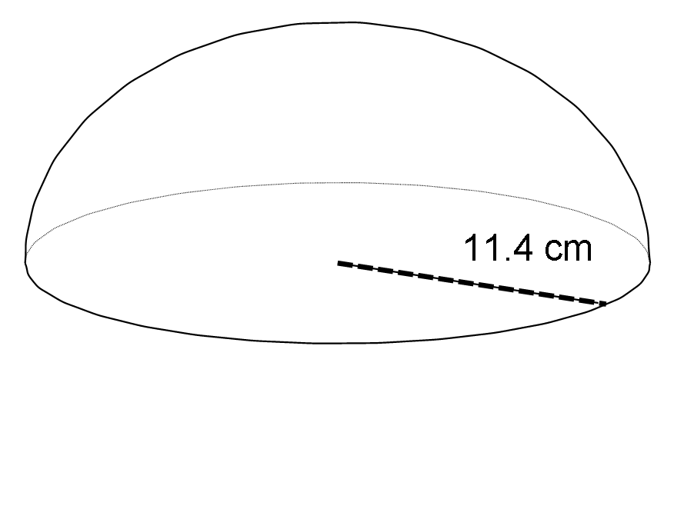

(B) 1550.7

(C) 3101.4

(D) 6202.7

14. An orange is peeled and the surface area is found to be 339.8 cm2. What is its radius?

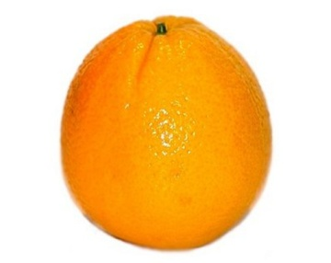 (A) 5.2 cm

(B) 7.4 cm

(C) 13.5 cm

(D) 16.3 cm

15. In which side is opposite  ?

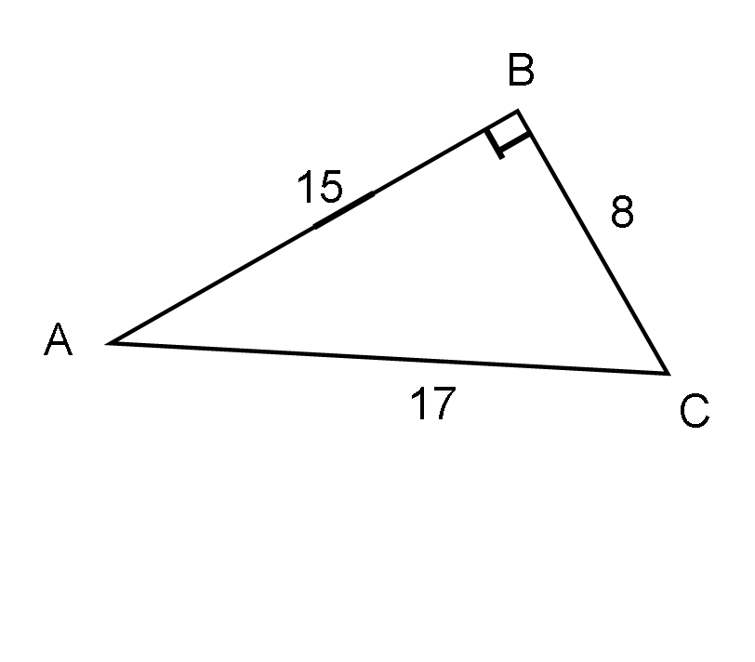

(A) AB

(B) AC

(C) BC

(D) 

16. What is the value of , to four decimal places?

(A) -1.1172

(B) 0.6427

(C) 0.8391

(D) 1.1918

17. In which trigonometric ratio is equal to  ?

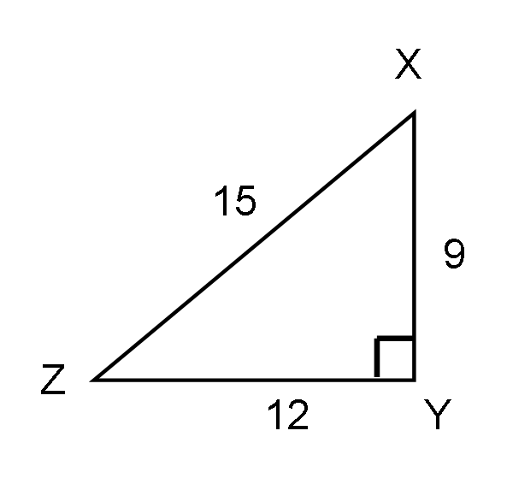

|  |  |
| --- | --- |
| I |  |
| II |  |
| III |  |

(A) I

(B) II

(C) I and II

(D) I and III

18. Which is the correct ratio for tangent?

(A) 

(B) 

(C) 

(D) 

19. Which equation should be used to solve for x in the triangle below?

(A) 

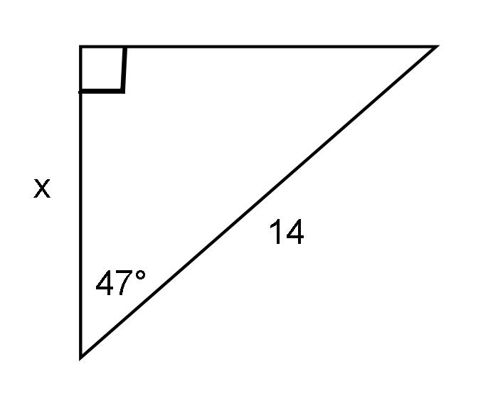

(B) 

(C) 

(D) 

20. What is the measure of to the nearest tenth of a degree?

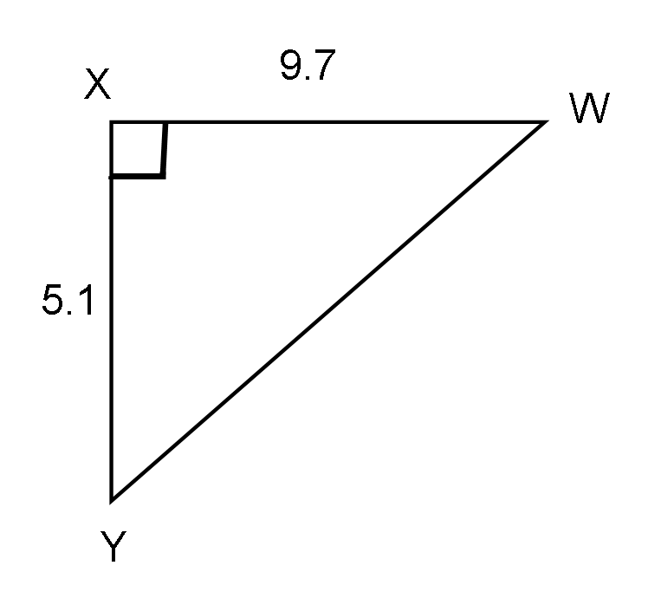

(A) 

(B) 

(C) 

(D) 

21. What is the length of side ***s*** to the nearest tenth of a millimeter?

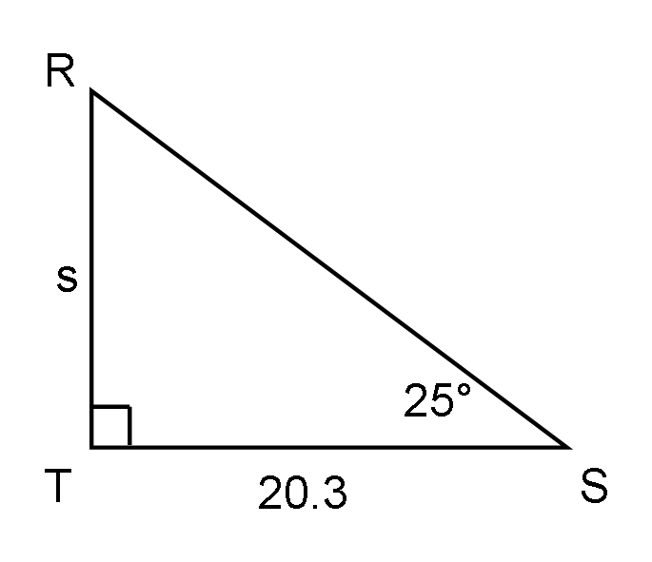

(A) 8.6 mm

(B) 9.5 mm

(C) 18.4 mm

(D) 43.5 mm

22. What is the length of side AB in rectangle ABCD, to the nearest tenth of a metre?

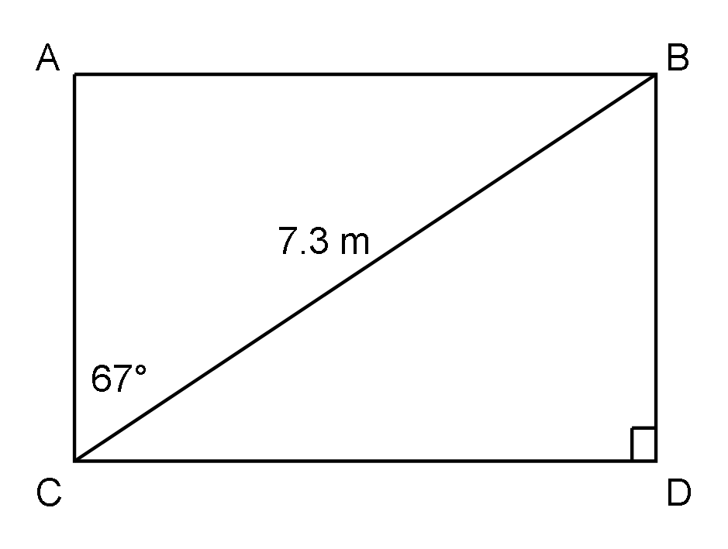

(A) 2.9 m

(B) 3.1 m

(C) 6.7 m

(D) 7.9 m

23. A surveyor made the measurements shown in the diagram. What is the distance from

R to S, to the nearest hundredth of a metre?

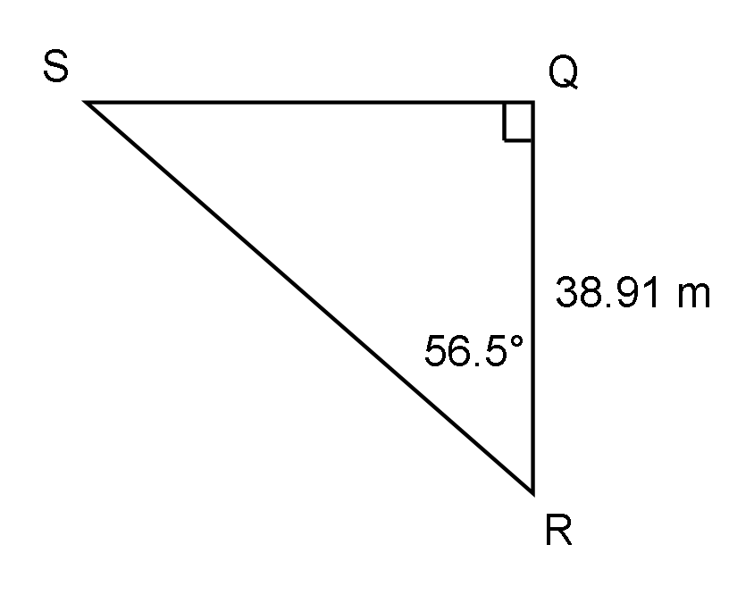

(A) 25.75 m

(B) 46.66 m

(C) 58.79 m

(D) 70.50 m

24. Mikhall walks 20 m away from the base of a tree. He turns around and measures the angle of

elevation to the top of the tree as 620. How tall is the tree to the nearest tenth of a metre?

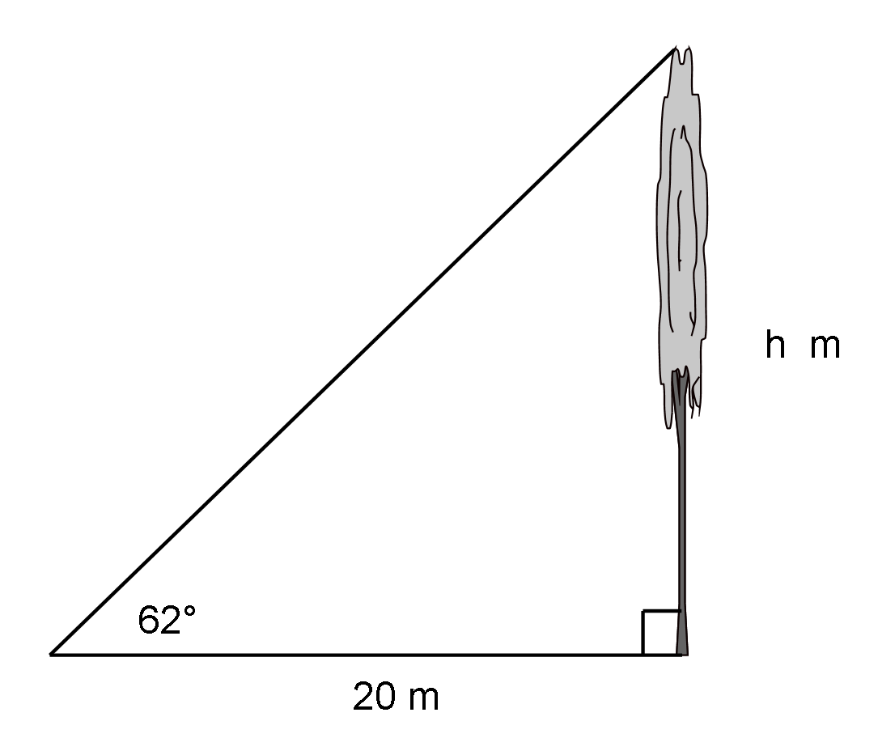

(A) 9.4 m

(B) 10.6 m

(C) 17.7 m

(D) 37.6 m

25. A tree breaks off 3m from its base such that the top of the tree just touch the ground. If the top

of the tree forms an angle of 26° with the ground, how long was the tree before it broke?

(A) 3.3 m

(B) 6.3 m

(C) 6.8 m

(D) 9.8 m

26. A 4 m ladder leans against a building. If the base of the ladder is 3 m from the wall, what is

the angle of inclination?

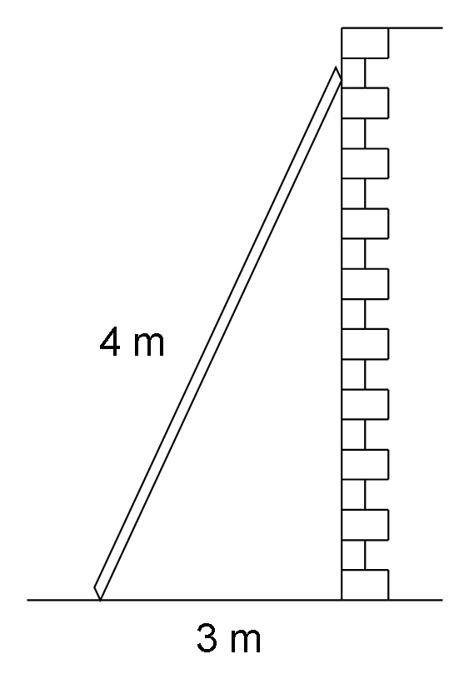

(A) 36.90

(B) 41.40

(C) 48.60

(D) 53.10

27. If , what is the value of x to the nearest tenth of a degree ?

(A) 1.00

(B) 29.00

(C) 33.60

(D) 56.40

28. Which of the following is a prime number?

(A) 1

(B) 4

(C) 11

(D) 27

29. What is the prime factorization of 180 in compact form?

(A) 

(B) 

(C) 

(D) 

30. What is the Greatest Common Factor for 28 and 98?

(A) 7

(B) 14

(C) 98

(D) 2744

31. What is the Least Common Multiple for 36 and 96?

(A) 12

(B) 36

(C) 96

(D) 288

32. Which of the following statements are true?

|  |  |
| --- | --- |
| I | A whole number is an integer. |
| II | A rational number is a real number. |
| III | A repeating decimal is an irrational number. |
| IV | A rational number can be expressed as a fraction. |

(A) I, II and III

(B) I, II and IV

(C) II, III and IV

(D) I, II, III, IV

33. Which number system does  belong to ?

(A) Q and R

(B) I, Q and R

(C) W, I, Q and R

(D) N, W, I, Q and R

34. Which of the following is the best approximation of ?

(A) Between -4 and -5

(B) Between -3 and -4

(C) Between 3 and 4

(D) Between 4 and 5

35. Which of the following is an irrational number?

(A) 

(B)

(C) 

(D) 

36. What is the index of  ?

(A) 2

(B) 3

(C) 7

(D) 

37. What is  as a mixed radical?

(A) 

(B) 

(C) 

(D) 

38. What is as an entire radical?

(A) 

(B) 

(C) 

(D) 

39. What is  in radical form?

(A) 

(B) 

(C) 

(D) 

40. Which of the following is equivalent to  ?

(A) 

(B) 

(C) 

(D) 

41. Which of the following is equivalent to ?

(A) 

(B) 

(C) 

(D) 

42. Evaluate : 

(A) 

(B) 

(C) 

(D) 

43. A square has an area of 64 cm2. What is the length of each side?

(A) 4 cm

(B) 8 cm

(C) 16 cm

(D) 32 cm

44. Evaluate: 

(A) 

(B) 

(C) 

(D) 

45. The volume of a cube is 91 125 cm3. What is the measure of each edge of the cube?

(A) 6 .71 cm

(B) 45 cm

(C) 301.87 cm

(D) 3375 cm

46. Evaluate: 

(A) 2

(B) 8

(C) 12

(D) 

47. Which expression is the largest?

(A) 

(B) 

(C) 

(D) 

**Section B - Constructed Response**

**Directions :** Answer all of the following questions showing all work.

1. Jack is installing trim around a window that measures 52 in. by 48 in.

A) How much trim will Jack need? (2%)

B) If trim costs $1.89 per foot, how much will it cost? (2%)

2. The base of a cone is glued to the circular face of a hemisphere. Calculate the volume of the

composite object formed, to the nearest square inch. (4%)

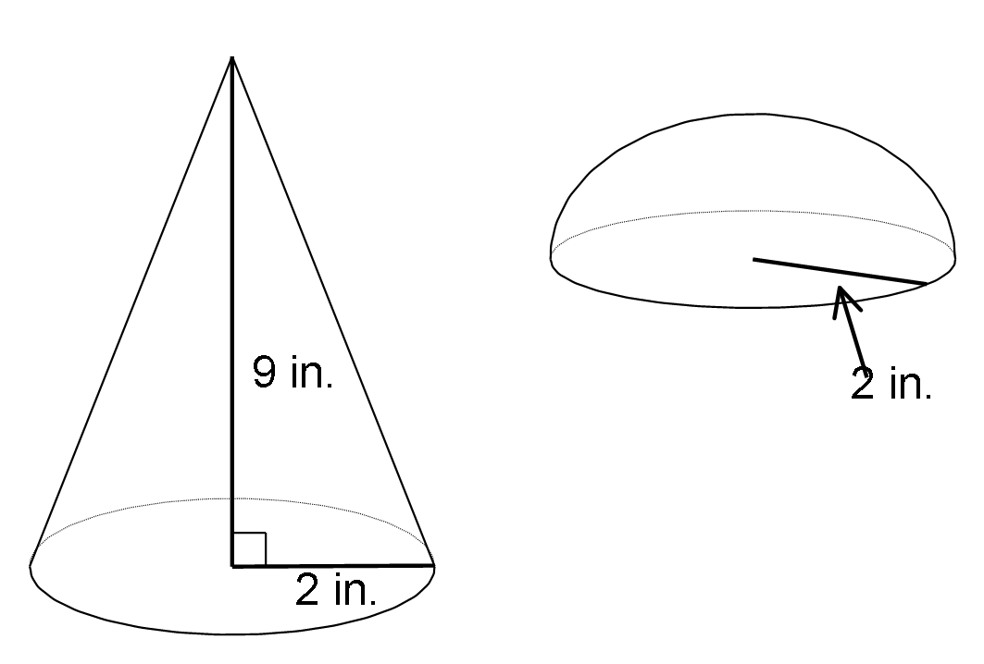

3. Spalding packages tennis balls in a box measuring 8 cm wide, 12 cm long and 4 cm high. If each box

contains 6 balls with a radius of 2 cm, how much air space is there in the box? (4%)

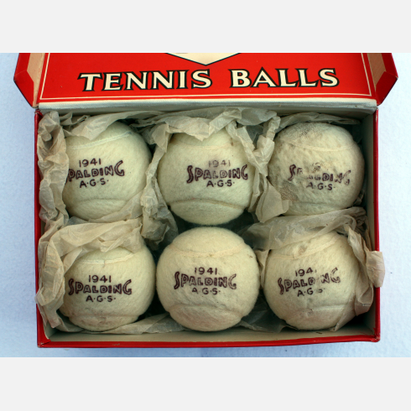

4. A farmer wishes to paint the exterior of his grain storage facility with dimensions as shown. If a can

of paint covers 460 ft2, how many cans of paint will the farmer need to purchase? (Note: the

bottom of the storage facility is **NOT** to be painted.) (4%)

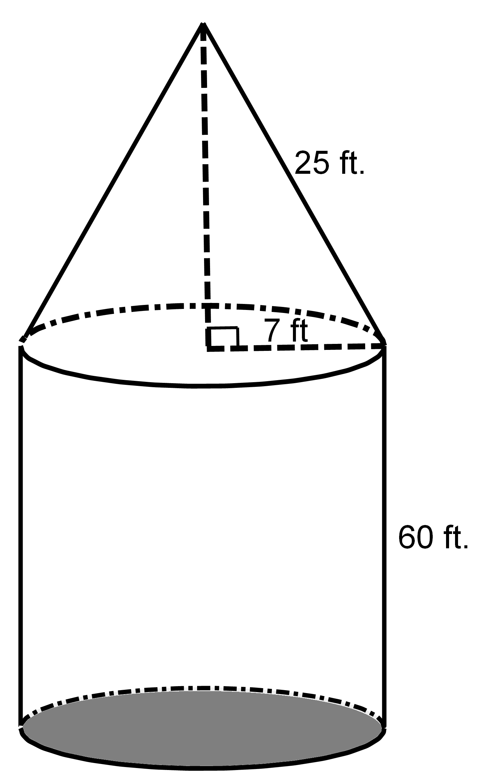

5. Solve . Give the measures to the nearest tenth. (4%)



6. From the top of a bank, the angle of inclination to the top of a hotel is 320. The angle of depression

to the base of the hotel is 670. If the height of the bank is 80 feet, how tall is the hotel to the

nearest tenth of a foot? (4%)

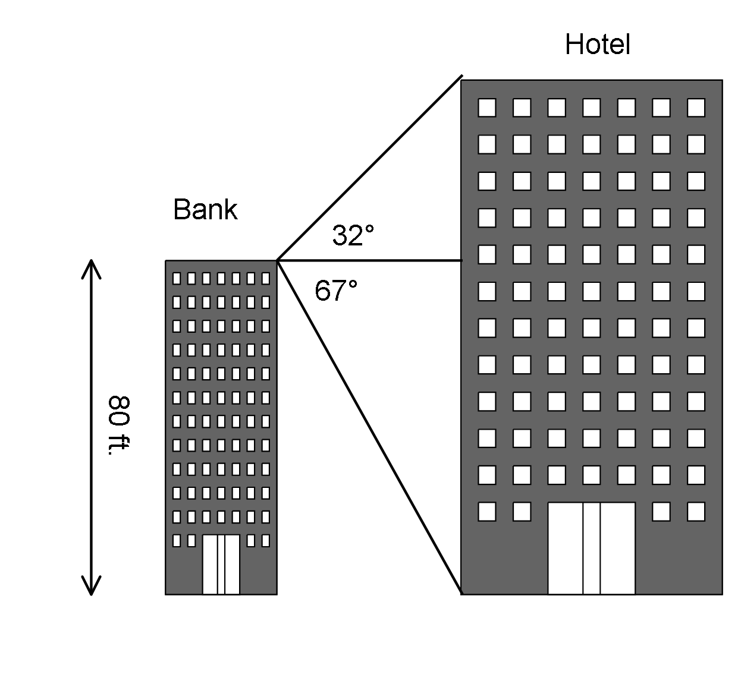

7. A lighthouse keeper is spotted from a fishing boat at an angle of elevation of 230. At the same time

a person on a sailboat spots the lighthouse keeper at an angle of elevation of 90. If the lighthouse

keeper is 33.5 m above the water, how far apart are the two vessels? (4%)

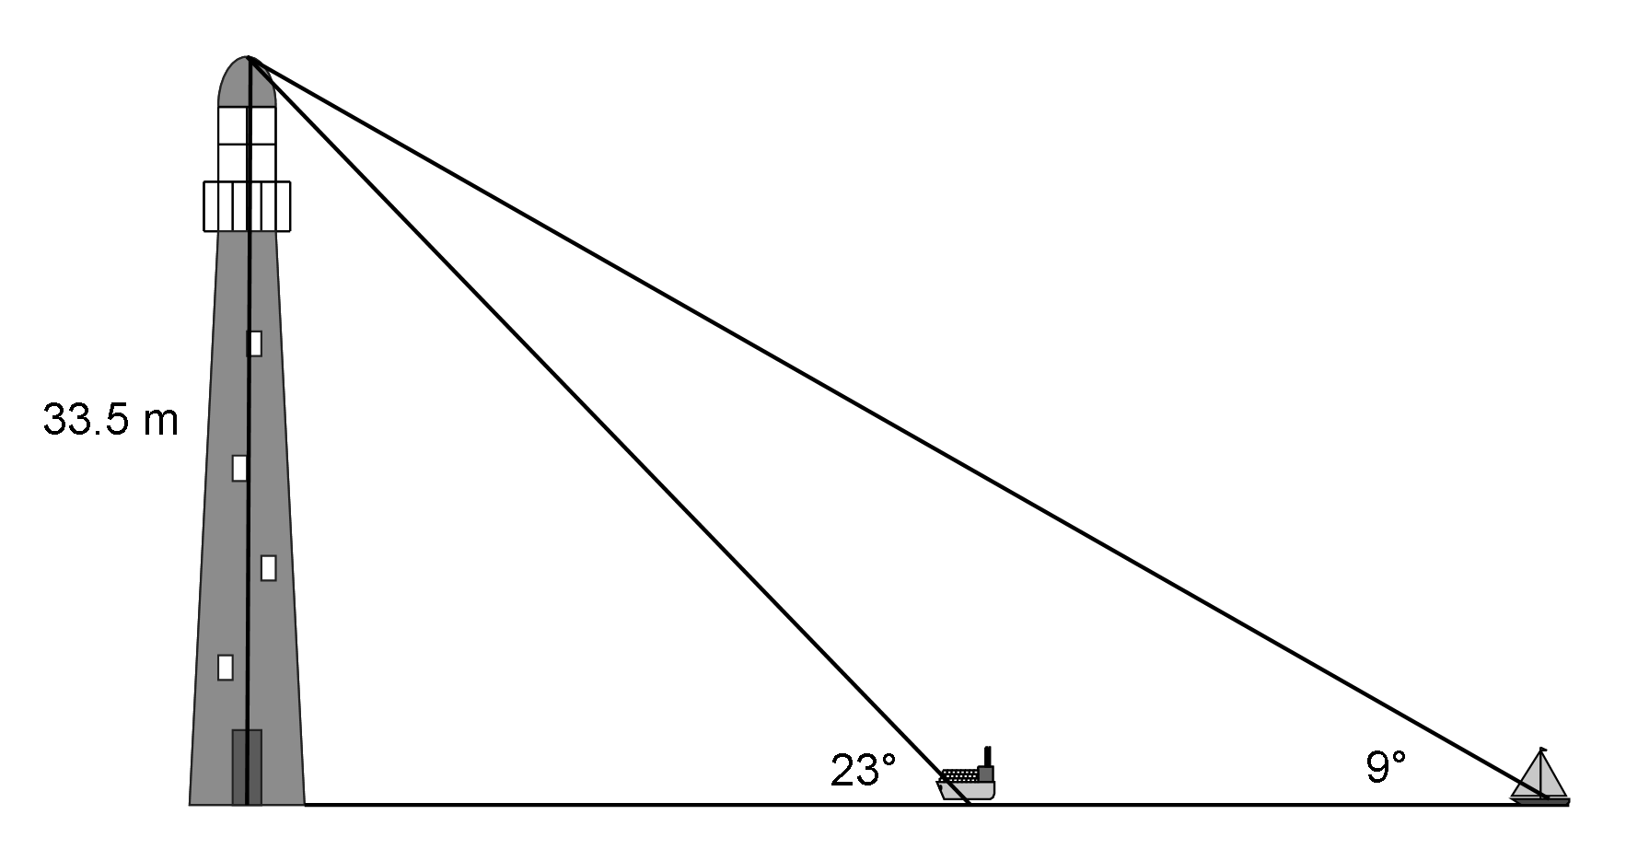

8. What is the length of side XY in the diagram below? (4%)

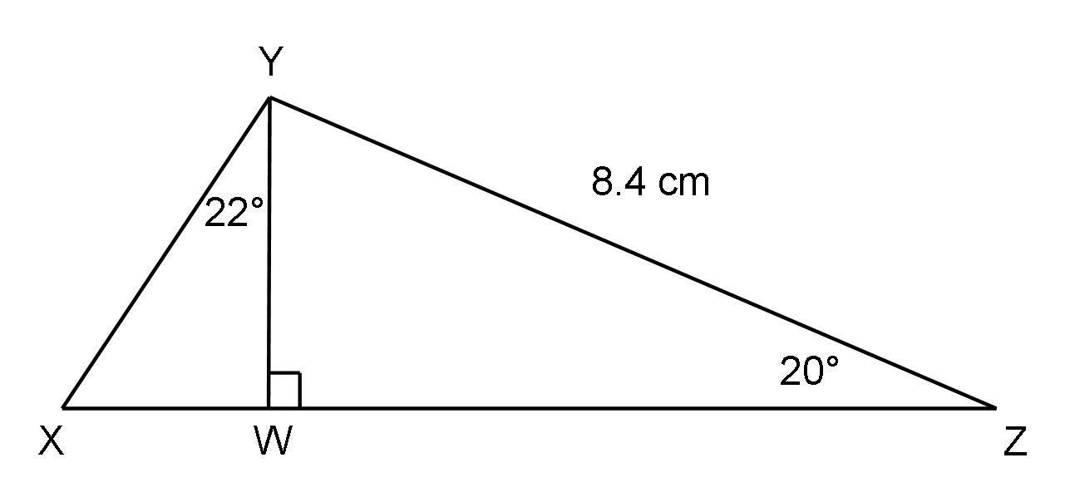

9. Three different construction companies are building a house. The painters show up every 6th

day, the dry wallers show up every 4th day and the plasterers show up every 10th day. After

how many days will all three companies be working on the house together? (4%)

10. Bob simplified  as shown: (3%)



Identify the error Bob made and write the correct solution.

11. Arrange from ***least to the greatest.*** (4%)

12. In find BC and write your answer as a mixed radical. (4%)

