Bishop White School
Math 3201 Test #1
Name:

PART I: Multiple Choice
Circle the letter that best completes the statement or answers the question.

1. What is the meaning of complement in set theory?

A. | all the elements in the universal set that are not identical
B. | a set of elements that work well with a given set
C. | all the elements of a universal set that do not belong to a subset of it
D. | all the elements that are the opposite of the elements in a given set

2. What is the meaning of disjoint in set theory?

A. | two or more sets having no elements in common
B. | two or more sets that do not match
C. | sets that are in different universal sets
D. | sets that contain no elements

3. What is the universal set?

A. | a set with an infinite number of elements
B. | a set of all the elements under consideration for a particular context
C. | a set with a countable number of elements
D. | a set that contains every possible element

4. Which pair of sets represents disjoint sets?

A. | N, the set of natural numbers, and I, the set of integers
B. | T, the set of all triangles, and C, the set of all circles
C. | N, the set of natural numbers, and P, the set of positive integers
D. | none of the above

5. Brett described the set as follows:
• M = {all of the foods he eats}
• D = {his favourite desserts}
• V = {his favourite vegetables}
• F = {his favourite fruits}

Which are the disjoint sets?

A. | M and D
B. | M and V
C. | M and F
D. | V and F

6. Which Venn diagram correctly represents the situation described?
Brendan described the set as follows:
• M = {all of the foods he eats}
• D = {his favourite desserts}
• V = {his favourite vegetables}
• F = {his favourite fruits}
Assume Brendan likes some fruit for dessert.

A. | 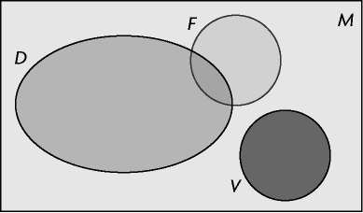
B. | 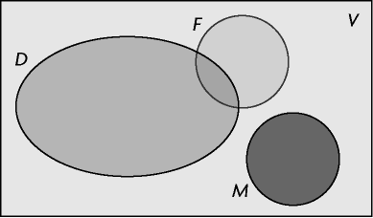
C. | 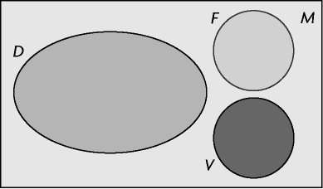
D. | 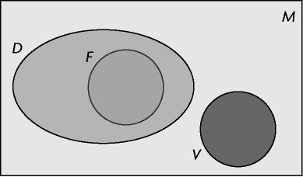

7. Given the following situation:
• the universal set U = {positive integers less than 20}
• X = {4, 5, 6, 7, 8}
• P = {prime numbers of U}
• O = {odd numbers of U}
Which is the complement of P?

A. | the even numbers of U
B. | the universal set excluding the set of X
C. | the positive integers greater than 20
D. | the non-prime numbers of U

8. There are 28 students in Mr. Connelly’s Grade 12 mathematics class.
The number of students in the yearbook club and the number of students on student council are shown in the Venn diagram. Use the diagram to answer the following questions.
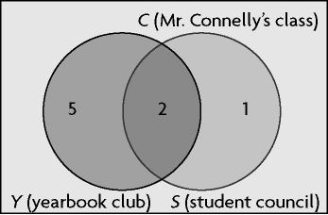

How many students are in the yearbook club but not on student council?

A. | 2
B. | 5
C. | 1
D. | 7

9. There are 28 students in Mr. Connelly’s Grade 12 mathematics class.
The number of students in the yearbook club and the number of students on student council are shown in the Venn diagram. Use the diagram to answer the following questions.

How many students are on the student council and the yearbook club?

A. | 2
B. | 5
C. | 1
D. | 7

10. Consider the following Venn diagram of herbivores and carnivores:
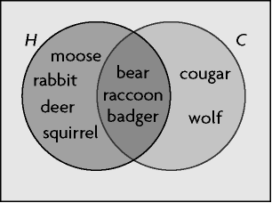

Determine H ∪ C.

A. | {moose, rabbit, deer, squirrel}
B. | {bear, raccoon, badger}
C. | {cougar, wolf}
D. | {moose, rabbit, deer, squirrel, bear, raccoon, badger, cougar, wolf}

11. Consider the following Venn diagram of herbivores and carnivores:

Determine n(H ∩ C).

A. | 2
B. | 9
C. | 4
D. | 3

12. Consider the following two sets:
• A = {1, 2, 3, 4, 5, 6, 7, 8, 9, 10, 11, 12}
• B = {–9, –6, –3, 0, 3, 6, 9, 12}
Which Venn diagram correctly represents these two sets?

A. | 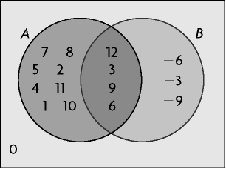
B. | 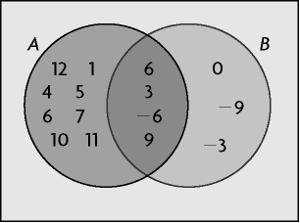
C. | 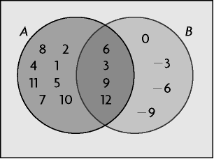
D. | 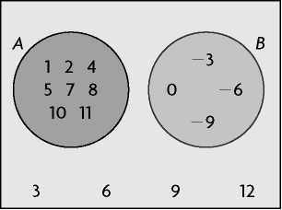

13. Consider the following two sets:
• A = {1, 2, 3, 4, 5, 6, 7, 8, 9, 10, 11, 12}
• B = {–9, –6, –3, 0, 3, 6, 9, 12}
Determine n(A ∪ B).

A. | 8
B. | 11
C. | 16
D. | 20

14. Consider the following two sets:
• A = {1, 2, 3, 4, 5, 6, 7, 8, 9, 10, 11, 12}
• B = {–9, –6, –3, 0, 3, 6, 9, 12}
Determine A ∩ B.

A. | {3, 6, 9, 12}
B. | {0, 3, 6, 9, 12}
C. | {1, 2, 4, 5, 7, 8, 10, 11}
D. | {–9, –6, 6, 9}

15. The three circles in the Venn diagram (P, Q, and R ) contain the same number of elements. Which set of values is true for p, q, and r?
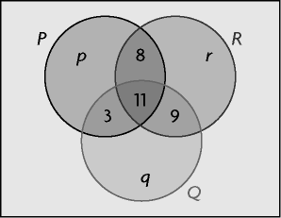

A. | p = 11, q = 11, r = 5
B. | p = 7, q = 8, r = 2
C. | p = 7, q = 6, r = 1
D. | p = 14, q = 13, r = 7

16. A summer camp offers canoeing, rock climbing, and archery. The following Venn diagram shows the types of activities the campers like.
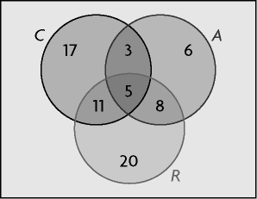

Use the diagram to determine n((R ∪ C) \ A).

A. | 64
B. | 48
C. | 37
D. | 59

17. A summer camp offers canoeing, rock climbing, and archery. The following Venn diagram shows the types of activities the campers like.

Use the diagram to determine n((A \ C) \ R).

A. | 8
B. | 22
C. | 6
D. | 5

18. A restaurant offers Chinese, Thai, and Korean food. The following Venn diagram shows the types of food the customers like.
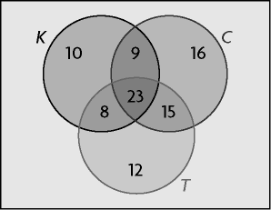

Use the diagram to determine n(C ∪ T).

A. | 53
B. | 15
C. | 40
D. | 83

19. Some table games use a board, dice, or cards, or a combination these. The following Venn diagram shows the number of games that use these tools.
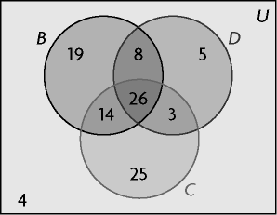

Use the diagram to determine n(U).

A. | 100
B. | 104
C. | 97
D. | 88

20. Some table games use a board, dice, or cards, or a combination these. The following Venn diagram shows the number of games that use these tools.

Use the diagram to determine the number of games that use exactly two of these tools.

A. | 13
B. | 51
C. | 25
D. | 74

Short Answer

1. What is the set notation for the set of all integers from –21 to –4 that are a multiple of 2?

2. Carlos surveyed 50 students about their favourite subjects in school. He recorded his results.
Favourite Subject | Number of Students
mathematics | 18
science | 15
neither mathematics nor science | 20

Determine how many students like mathematics and science.

3. Flightless birds include the ostrich, emu, penguin, and kiwi. Arctic birds include the snow goose, Arctic tern, osprey, penguin, and red-tailed hawk. Determine the union and intersection of these two sets.

4. Grade 12 students were surveyed about their extra curricular activities.
• 58% belonged to a sports team (S)
• 63% belonged to a band or choir (B)
• 47% belonged to a school club (C)
• 24% belonged to a sports team and a band or choir
• 21% belonged to a sports team and a school club
• 36% belonged to a band or choir and a school club
• 19% engaged in all three activities

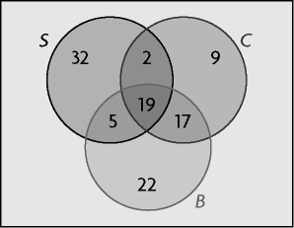

What percent of students only belong to a band or choir? Write your answer in set notation.

5. The city surveyed 3000 people about how they travel to work.
• 1978 took public transit (P)
• 1494 drove (D)
• 818 cycled (C)
• 731 took public transit and drove only
• 298 took public transit and cycled only
• 27 drove and cycled only
• 164 used all three modes of transportation
How many people use public transit only? Use a Venn diagram to show your answer.

6. A group of 50 tourists can choose between visiting the Aero Space Museum of Calgary, the Calgary zoo, or Glenbow Museum.
• 27 went to the Aero Space Museum, 29 went to the zoo, and 33 went to Glenbow Museum.
• 44 went to at least one museum but not the zoo.
• 9 went to Glenbow Museum only.
• 11 went to all three attractions.
How many tourists went to only two attractions? Use a Venn diagram in your answer.

