**Math 3201 – Unit 1 Test - Set Theory** Name:_____________

**Part 1: Multiple Choice - Place the correct answer in the space provided. (10)**

1) U = {hockey, basketball, golf, tennis, volleyball, soccer}. If

B = {sports that use a ball}, which element would be in  ? 1.____

1. Basketball (B) Golf (C) Hockey (D) Soccer

2) Which of the following would represent the shaded region? 2.____

1.  (B)  (C)  (D) 



3) Which of the following phrases describes an empty set? 3.____

(A) Common factors of 4 and 12

(B) Prime numbers that are even

(C) Multiples of 3 that are less than 12

(D) Factors of 10 that are divisible by 4

4) Set M consists of the multiples of 4 from 1 to 50. Which represents set notation? 4.____

1. M=
2. M=
3. M=
4. M=

5) Consider the following sets:

R={0, 1, 2, 3, 4, 5, 6}

S={2, 4, 6, 8}

T={1, 2, 3, 6}

Which of the following statements is true? 5.____

1. R ⊂ S (B) R ⊂ T (C) S ⊂ R (D) T ⊂ R

Use the following information to answer #6, #7 & #8

A = {natural numbers from 1 to 10} B = {factors of 12} C = {multiples of 11 less than 100}

6) What is the union of sets A and B, ? 6.____

7) What is A intersect B, 7.____

8) Set B and set C are an example of…. … sets 8.____

1. disjoint (B) empty (C) infinite (D) none of these

9) What does the ‘3’ represent in this Venn Diagram shown? 9.____

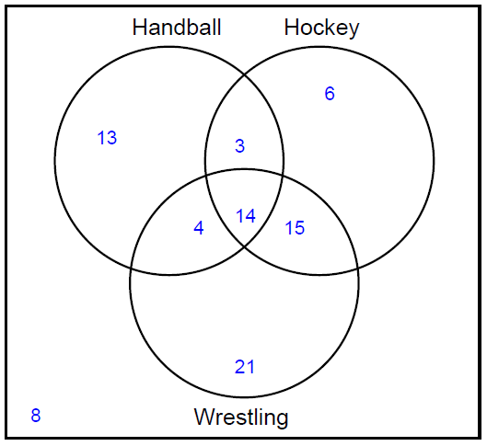

1. The number of people who like handball and hockey.
2. The number of people who like handball and hockey but not wrestling.
3. The number of people who like hockey and wrestling and handball.
4. The number of people who like hockey and wrestling but not handball.

10) Set T is students who like tennis, set B is students who like basketball and set S is

students who like swimming, which diagram indicates students who like tennis only? 10.___

1. 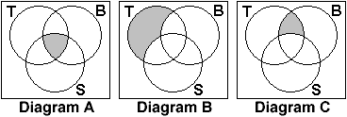A
2. B
3. C
4. None of these

**Part 2. Answer all questions in the space provided. Show all workings to receive full marks. (20)**

11. A survey was conducted to determine where people buy coffee.

82 people buy coffee at Tim Hortons.

65 people buy coffee at StarBucks.

17 people did not buy coffee at all.

If 130 people were surveyed, how many people buy coffee from ONLY Tim Hortons?

(3)

1. There are 36 students who study science.

* 14 study physics
* 18 study chemistry
* 24 study biology
* 5 study physics and chemistry
* 8 study physics and biology
* 10 study biology and chemistry
* 3 study all three subjects

(6)

Use a Venn diagram to answer the following questions:

1. Determine the number of students who study physics and biology only.
2. Determine the number of students who study at least two subjects.
3. Determine the number of students who study biology only.
4. A grade three teacher asked her class of 28 students about the type of pet they owned. The results were as follows:

28 children have a dog, a cat or a bird

13 children have a dog

13 children have a cat

13 children have a bird

4 children have a dog and cat only

3 children have a dog and bird only

2 children have a cat and bird only

(6)

1. Algebraically, determine how many children have a dog, cat and bird?

B) How many children have only one pet?

14. In a school of 120 students

5 students took English, Physics, and Chemistry

15 students took Physics and English

8 students took Physics and Chemistry

10 students took English and Chemistry

99 students took English **or** Chemistry

45 took Chemistry

30 students took Physics

James summarized the data using the Venn Diagram shown below:



Identify the regions in James’ Venn diagram that have errors and describe the errors that James made. Provide a correct Venn diagram with the correct entries.

(5)