Mathematics 3201
Sample Mid-Year Exam #1, 2014-15
Item Breakdown/Solutions

PART I:

# | Ans | 2M | 2A | L3 | Guide | Outcome |  | # | Ans | 2M | 2A | L3 | Guide | Outcome
1 | C | X |  |  | p.22 | LR2 |  | 19 | C | X |  |  | p.92 | P3
2 | D | X |  |  | p.26 | LR2 |  | 20 | A | X |  |  | p.84 | P6
3 | D | X |  |  | p.24 | LR2 |  | 21 | B |  | X |  | 88/90 | P2
4 | B |  | X |  | p.26 | LR2 |  | 22 | A |  | X |  | 84 | P5
5 | B |  | X |  | p.35 | LR2 |  | 23 | C |  | X |  | 84/94 | P3/P6
6 | B |  |  | X | 28/30 | LR2 |  | 24 | C |  | X |  | p.80 | P1
7 | A |  | X |  | p.34 | LR2 |  | 25 | D |  |  | X | p.84 | P6
8 | B | X |  |  | p.52 | P4 |  | 26 | B | X |  |  | p.100 | RF1
9 | B |  | X |  | p.52 | P4 |  | 27 | C | X |  |  | p.100 | RF1
10 | D | X |  |  | p.56 | P4 |  | 28 | D | X |  |  | p.102 | RF1
11 | C | X |  |  | p.52 | P4 |  | 29 | D |  | X |  | p.104 | RF1
12 | A | X |  |  | p.56 | P4 |  | 30 | C | X |  |  | p.104 | RF1
13 | A |  | X |  | p.60 | P5 |  | 31 | D |  | X |  | p.106 | RF2
14 | A |  | X |  | p.68 | P5 |  | 32 | B |  | X |  | p.106 | RF2
15 | A |  | X |  | p.70 | P6 |  | 33 | B | X |  |  | p.108 | RF2
16 | C |  | X |  | p.68 | P5 |  | 34 | D |  | X |  | p.108 | RF2
17 | A | X |  |  | p.72 | P6 |  | 35 | A |  |  | X | p.110 | RF3
18 | C |  | X |  | 80/82 | P1

PART II:

Item | Value | L2A | L3 | Guide | Outcome |  | Item | Value | L2A | L3 | Guide | Outcome
36a | 3 | X |  | p.34 | LR2 |  | 38b | 3 | X |  | 88/90 | P2
36bi | 1 |  | X | p.36 | LR2 |  | 38c | 3 |  | X | p.84 | P6
36bii | 2 | X |  | p.36 | LR2 |  | 39ai | 1 |  | X | p.106 | RF2
37a | 2 | X |  | p.68 | P5 |  | 39aii | 3 | X |  | p.106 | RF2
37b | 3 | X |  | p.60 | P5 |  | 39b | 2 | X |  | p.106 | RF2
37c | 3 |  | X | p.70 | P6 |  | 39c | 4 | X |  | p.114 | RF3
37d | 2 |  | X | p.70 | P6
38a | 3 | X |  | p.84 | P5

PART II - Total Value: 35 marks

Answer ALL items in the space provided. Show ALL workings.

Value
3 36(a). There are 79 children who play sports at the recreation centre.
- 20 play volleyball
- 35 play basketball
- 50 play hockey
- 15 play only volleyball and basketball
- 5 play only basketball and hockey
- 2 play all three

Draw a Venn diagram to illustrate this information and use it to determine how many children just play hockey.

Volleyball
Basketball

13
5 - x
17

2
x
3

45 - x

0
Hockey

Venn Diagram (0.5 mark)

$\left(5-x\right)+x+\left(45-x\right)+2+13+3+17+0=79$ (1 mark)
$$85-x=79 (0.5 mark)$$
$$-x=-6$$
$$x=6 (0.5 mark)$$
The # of children who play hockey only is 45 - 6 = 39 (0.5 mark)

Value
36(b). A student was asked the following question:
“40 people were surveyed. 26 people like soup, 3 people like both soup and submarine sandwiches, and 4 people like neither. How many people like submarine sandwhiches only?”

The student’s solution to the question is shown below:
Subs
Soup
4

x
3
26

$$x+3+26+4=40$$
$$33+x=40$$
$x=7 ;$7 people like submarine sandwiches only.

1 i) Identify the error in the student’s solution.

The 26, should be 23. Forgot to account for overlap (1 mark)

2 ii) Algebraically determine the correct solution.
Subs
Chips
4

x
3
23

$x+3+23+4=40$ (1 mark)
$$30+x=40 (0.5 mark)$$
$$x=10 (0.5 mark)$$
10 people like Submarine sandwiches only.

2 37(a). How many different arrangements are there using the letters in the word CRANBERRIES ? Show your workings.

$$\frac{11!}{3!2!} \\ =\frac{11×10×9×8×7×6×5×4×3×2×1}{6×2} \\ =3 326 400$$ | (0.5 mark)  (0.5 mark)  (0.5 mark)  (0.5 mark)

Value
3 37(b). Algebraically solve for n: ${}_{n+2}C_{2}=21$

$$\frac{\left(n+2\right)!}{2!\left[\left(n+2\right)-2\right]!}=21 \\ \frac{\left(n+2\right)!}{2!n!}=21 \\ \frac{\left(n+2\right)\left(n+1\right)n!}{2×n!}=21 \\ n^{2}+3n+2=42 \\ n^{2}+3n-40=0 \\ \left(n+8\right)\left(n-5\right)=0 \\ n=-8 or n=5$$ | First two steps (1 mark)  (0.5 mark)  (0.5 mark)  (0.5 mark)  (0.5 mark)

3 37(c). There are 5 boys and 6 girls in a club. 5 club members will be selected for a field trip. How many ways can the teacher select 5 members if there must be at most 2 boys?

(${}_{5}C_{0}$)(${}_{6}C_{5})+\left({}_{5}C_{1}\right)\left({}_{6}C_{4}\right)+({}_{5}C_{2})({}_{6}C_{3})$  $$=\left(1\right)\left(6\right)+\left(5\right)\left(15\right)+\left(10\right)\left(20\right) \\ =6+75+200 \\ =281$$ | (1.5 marks)  (0. 5 mark)  (0.5 mark)  (0.5 mark)

2 37(d). How many numbers greater than 400 are possible using the digits 2, 3, 4, and 5 if repetition is not allowed? Show your workings.

3 digits 4 digits  $$\left(2\right)\left(3\right)\left(2\right) +\left(4\right)\left(3\right)\left(2\right)\left(1\right) \\ =12+24 \\ =36$$ | (1.5 marks)  (0.5 mark)
3 38(a). Andrew cannot remember the correct order of the six digits in his ID number.
He does remember that his number contains the digits 5, 6, 4, 3, 2, and 9.
What is the probability that the first three digits of his number are all odd?

$$The first 3 digits of his number are odd and the last 3 are even. There are {}_{ 3}P_{3} to$$
$$arrange the first 3 odd digits \left(0.5 mark\right)and{}_{ 3}P_{3} ways to arrange the last 3 even digits(0.5 mark). There$$
$$are {}_{ 6}P_{6} ways to arrange the 6 digits (0.5 mark). Therefore:$$
$$P\left(first three digits are odd\right)= \frac{{}_{ 3}P_{3}×{}_{ 3}P_{3}}{{}_{ 6}P_{3}} (1 mark)$$
$$=\frac{6×6}{6×5×4×3×2×1}=\frac{1}{20} (0.5 mark)$$

Value
3 38(b). A computer store advertised its annual half-price sale in the newspaper and
on television. A survey of 200 customers indicated that 60 read about the sale in the newspaper, 50 watched the sale advertised on television, and 30 saw the sale through both sources. What is the probability that a randomly selected customer did not see the advertisement in either form?

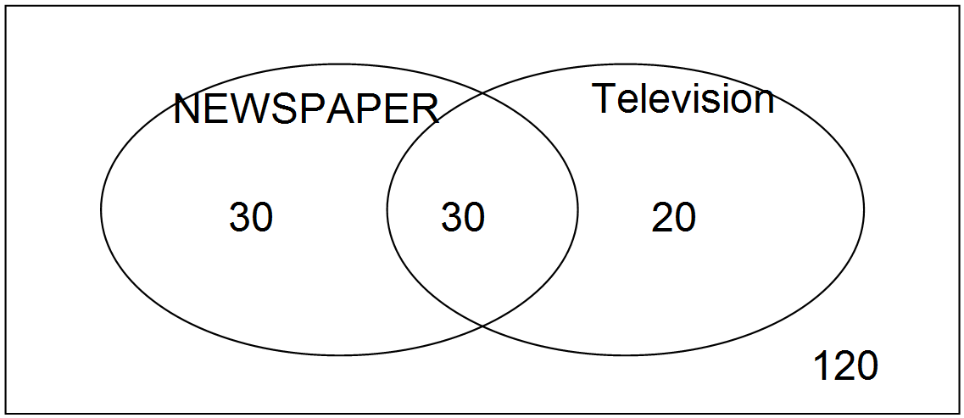
$60-30=30 \# of newspaper only$ (0.5 mark)
$50-30=20 \# of TV only$ (0.5 mark)
$$Thus, 80 who saw ad in at least one form (0.5 mark)$$
$200-80=120 who did^{'}t see it in either form$ (0.5 mark)
$Therefore P\left( did not see\right)=\frac{120}{200}=\frac{3}{5}=0.6$ (1 mark)

OR $60+50-30=80 are the number of customers who saw it in at least one form (1.5 marks)$
$200-80=120 who did^{'}t see it in either form$ (0.5 mark)
$Therefore P\left( did not see\right)=\frac{120}{200}=\frac{3}{5}=0.6$ (1 mark)

3 38(c). There are 14 girls and 6 boys on the student council at a school. Five students from the student council are to be randomly selected to participate in a local town debate. What is the probability that at least 3 of the students selected are girls?

$\frac{\left({}_{ 14}C_{3}×{}_{ 6}C_{2}\right)+\left({}_{ 14}C_{4}×{}_{ 6}C_{1}\right)+\left({}_{ 14}C_{5}×{}_{ 6}C_{0}\right)}{{}_{ 20}C_{5}}=\frac{\left(\frac{14!}{3!11!}\right)\left(\frac{6!}{2!4!}\right)+\left(\frac{14!}{4!10!}\right)\left(\frac{6!}{1!5!}\right)+\left(\frac{14!}{5!9!}\right)(1)}{\frac{20!}{5!15!}}$ (2 marks)

$=\frac{\left(364\right)\left(15\right)+\left(1001\right)\left(6\right)+\left(2002\right)\left(1\right)}{15504}=\frac{5460+6006+2002}{15504}=\frac{13468}{15504}\sim 0.$869 (1 mark)

39(a). Arnold simplified an expression as follows:

$$\frac{2x}{x^{2}-4}+\frac{7}{2x-4}$$

$=\frac{2x}{\left(x+2\right)\left(x-2\right)}+\frac{7}{2\left(x-2\right)}$ Step 1
$=\frac{2x}{\left(x+2\right)\left(x-2\right)}+\frac{7}{2\left(x-2\right)}$ Step 2
$=\frac{x}{\left(x+2\right)\left(x-2\right)}+\frac{7\left(x+2\right)}{\left(x-2\right)\left(x+2\right)}$ Step 3
$=\frac{x+7x+14}{\left(x+2\right)\left(x-2\right)}$ Step 4
$=\frac{8x+14}{(x+2)(x-2)}$ Step 5

1 (i) Identify the step in which the error occurred and explain the mistake.

The error occurred in Step 2. He could not divide off the 2. (1 mark)

Value
3 (ii) Correct the errors and simplify.

$=\frac{2x}{\left(x+2\right)\left(x-2\right)}+\frac{7}{2\left(x-2\right)}$ (0.5 mark)
$=\frac{2x(2)}{\left(x+2\right)\left(x-2\right)(2)}+\frac{7(x+2)}{2\left(x-2\right)(x+2)}$ (1 mark)
$=\frac{4x}{2\left(x+2\right)\left(x-2\right)}+\frac{7\left(x+2\right)}{2\left(x-2\right)\left(x+2\right)}$ (0.5 mark)
$=\frac{4x+7x+14}{2\left(x+2\right)\left(x-2\right)}$ (0.5 mark)
$=\frac{11x+14}{2(x+2)(x-2)}$ (0.5 mark)

2 39(b). Simplify: $\frac{x+5}{7x+14}÷\frac{x^{2}-25}{10(x+2)} ,$ $x≠-5, -2, 5$

$=\frac{x+5}{7(x+2)}÷\frac{\left(x-5\right)\left(x+5\right)}{10(x+2)}$ (1 mark)
$=\frac{x+5}{7(x+2)}∙\frac{10(x+2)}{(x-5)(x+5)}$ (0.5 mark)
$=\frac{10}{7(x-5)}$ (0.5 mark)

4 39(c). A school group is going on a field trip. The total cost is $900. If 10 more students sign up, the price per student will decrease by $15. If $x$ represents the number of students and the situation is modelled by the equation
$\frac{900}{x}-\frac{900}{x+10}$ $=15$, algebraically determine how many students are going on the field trip.

$\frac{900x(x+10)}{x}-\frac{900x\left(x+10\right)}{x+10}=15x(x+10)$ LCD = $x\left(x+10\right)$ (0.5 mark)
$\frac{900x(x+10)}{x}-\frac{900x\left(x+10\right)}{x+10}=15{(x}^{2}+10x)$ (0.5 mark)
$900\left(x+10\right)-900x=15x^{2}+150x$ (1 mark)
$900x+9000-900x=15x^{2}+150x$ (1 mark)
$15x^{2}+150x-9000=0$
$15\left(x^{2}+10x-600\right)=0$ (0.5 mark)
$$15\left(x-20\right)\left(x+30\right)=0$$
$$x-20=0;x+30=0$$
$$x=20;x≠-30$$
$-30$ is an extraneous root (Note :deduct 0.5 marks if not stated)
20 students (0.5 mark)

