**Mathematics 3200**

**Unit 1 Test**

**Name**: ______________________________________

**Part A**: Place the letter corresponding to the correct answer to each of the following in the blank at the

right.

1. Which of the following is **not** a polynomial function? 1. ____

(A)  (B) 

(C)  (D) 

2. What is the restriction on x when  is divided by  ? 2. ____

(A)  (B) 

(C)  (D) 

3. Given a polynomial function  where , which is a factor? 3. ____

(A) -5 (B) 5

(C)  (D) 

4. What is the maximum number of real roots that a cubic function can have? 4. ____

(A) 1 (B) 2

(C) 3 (D) infinitely many

5. What is the remainder when is divided by  ? 5. ____

(A) -15 (B) -12

(C) -10 (D) -4

6. Determine the value of ***k*** if is a factor of . 6. ____

(A) -14 (B) -1

(C) 1 (D) 14

7. Given the graph below, which is true for the polynomial function? 7. ____

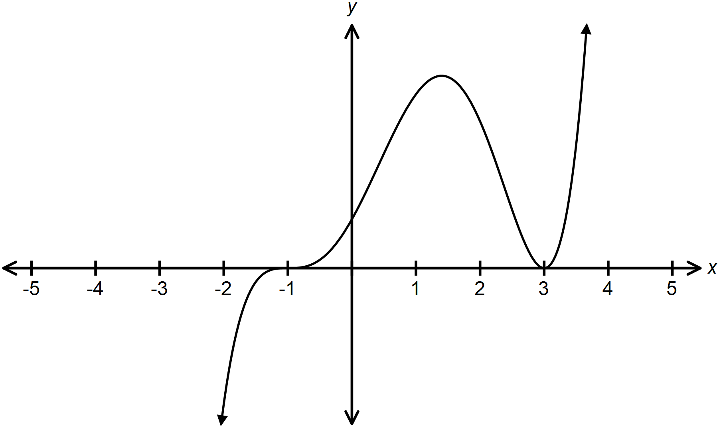

|  |  |  |
| --- | --- | --- |
|  | Degree | Value of leading Coefficient |
| (A) | 3 | negative |
| (B) | 3 | positive |
| (C) | 5 | negative |
| (D) | 5 | positive |

8. What are the possible integral zeros for ? 8. ____

(A)  (B) 

(C)  (D) 

9. Which polynomial function best describes the graph below? 9. ____

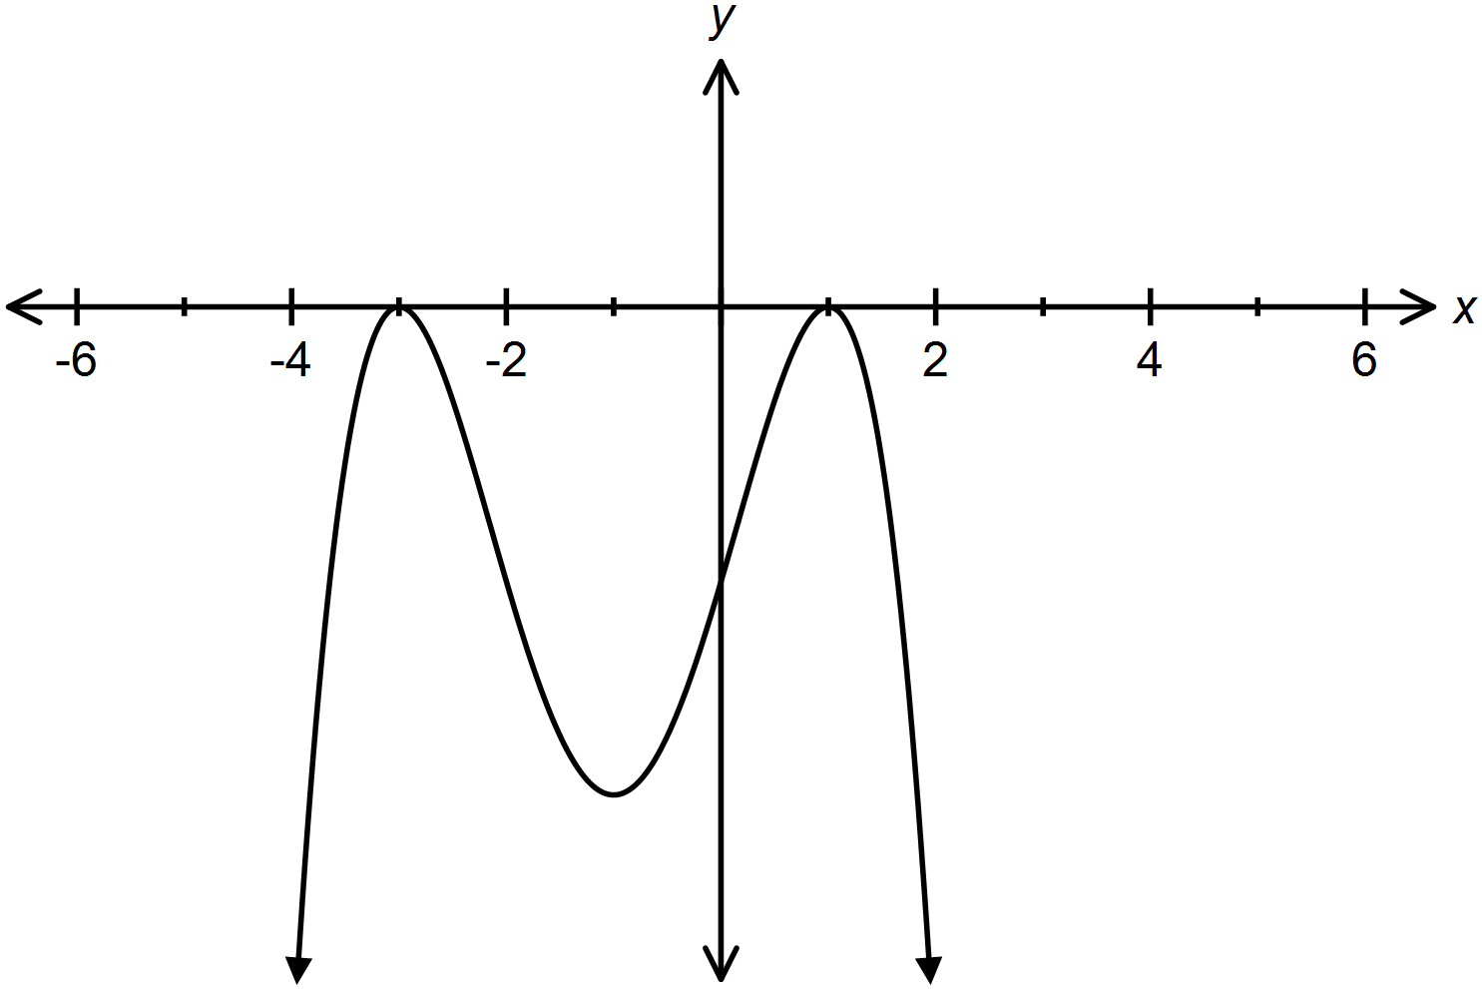

(A)  (B) 

(C)  (D) 

10. Which of the following graphs has a multiplicity of 2 at x = -1, a single root at x = 4 10. ___

and a negative leading coefficient.

(A) (B)

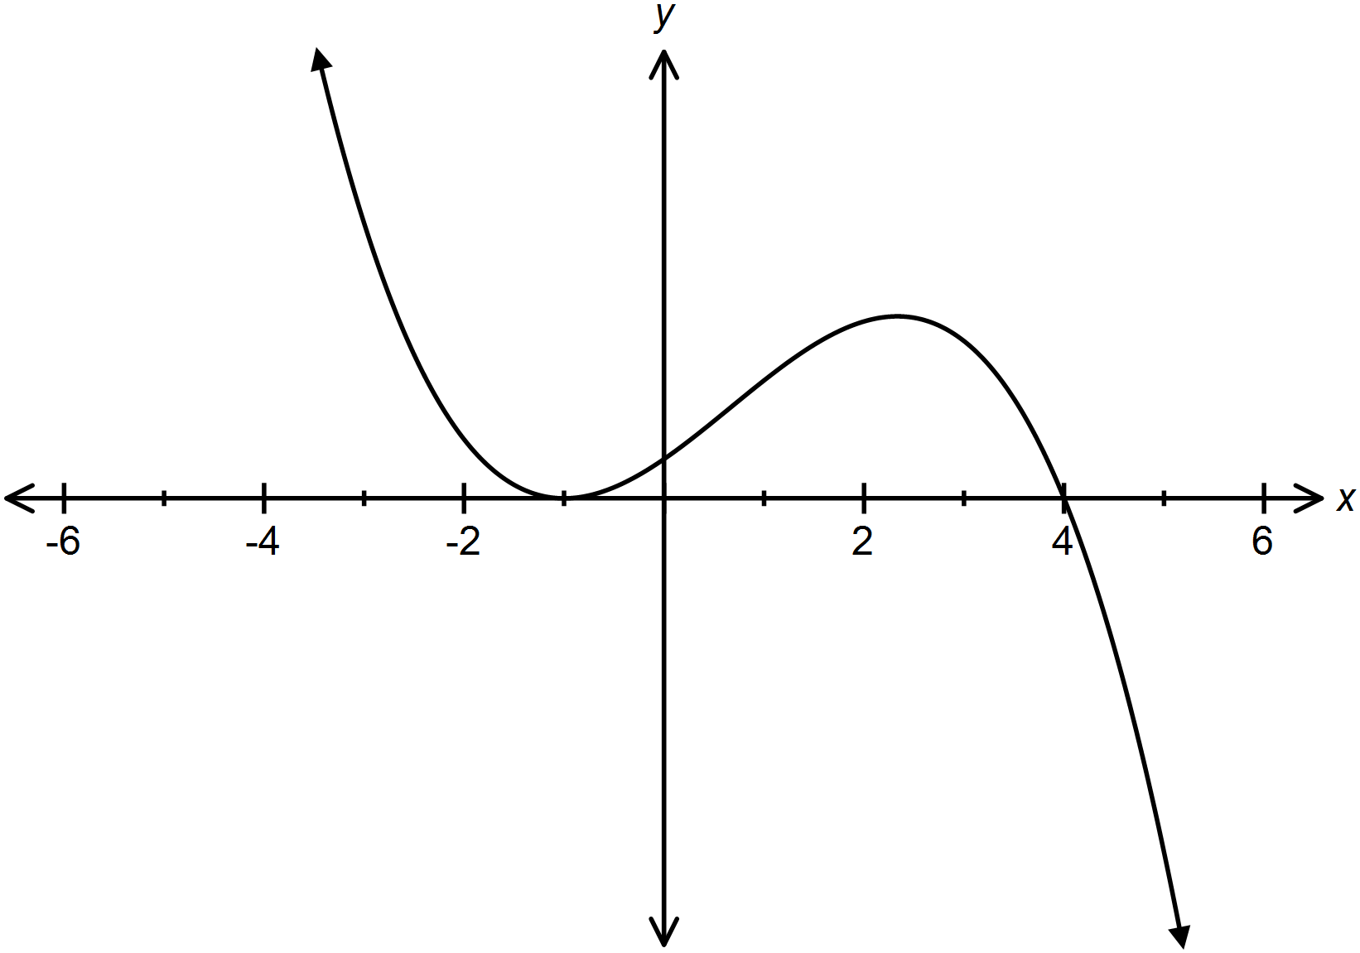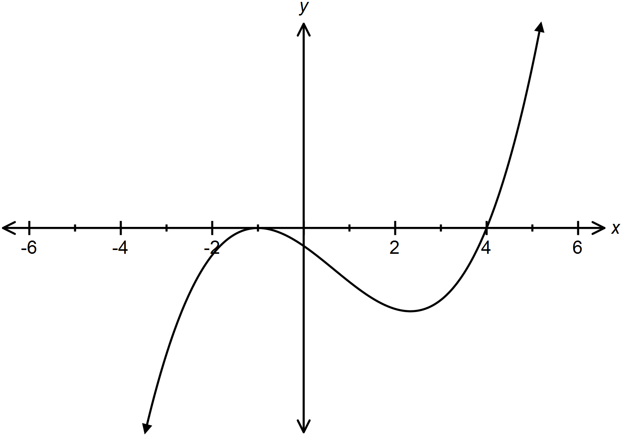

(C) (D)

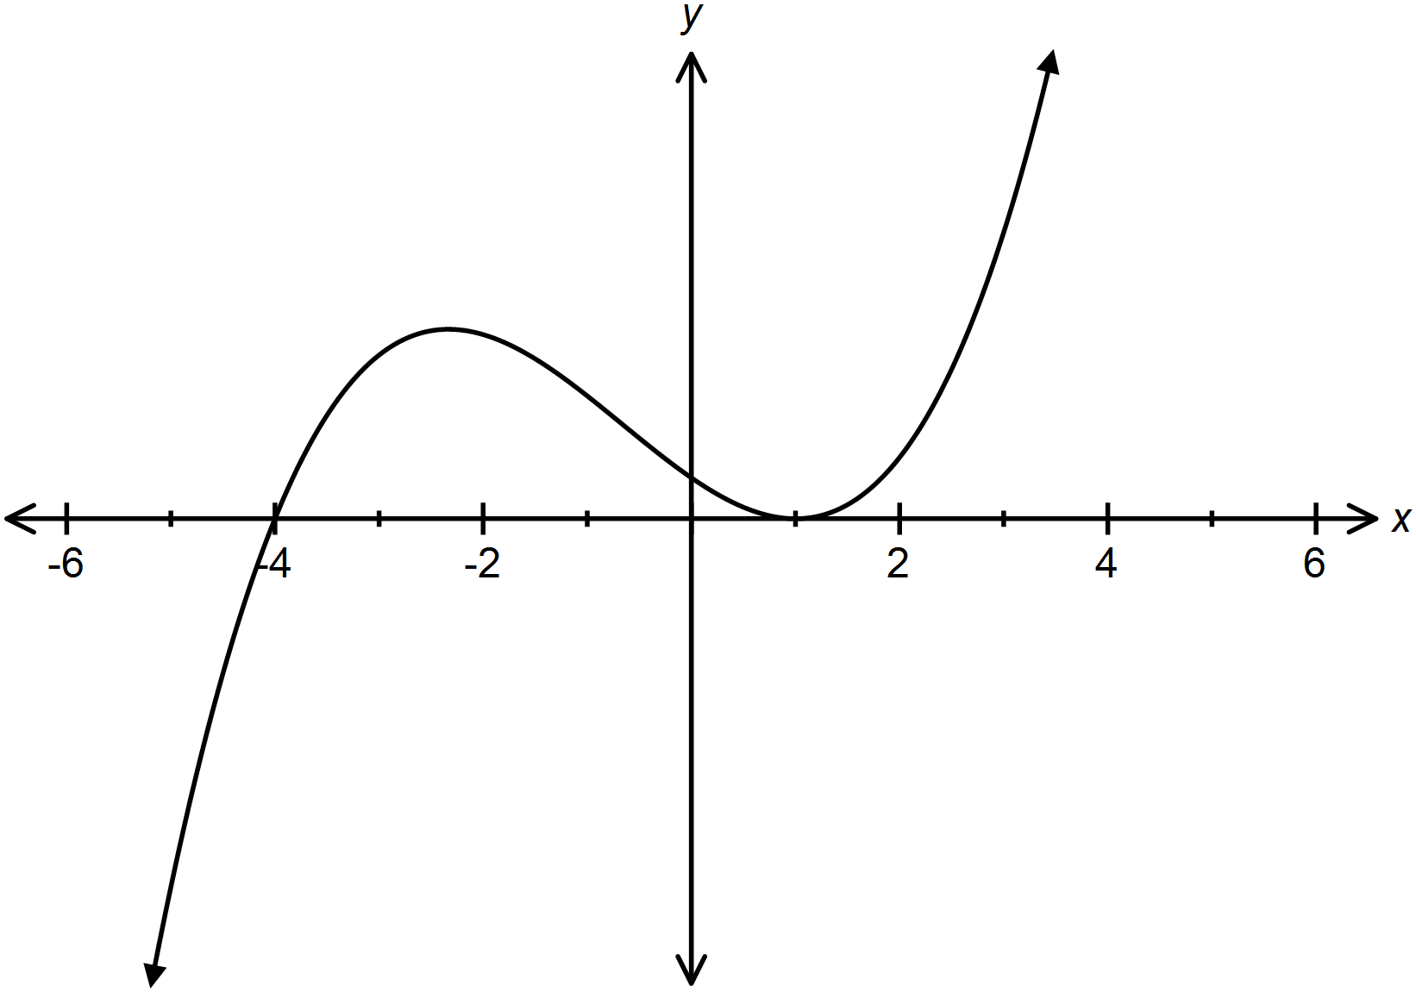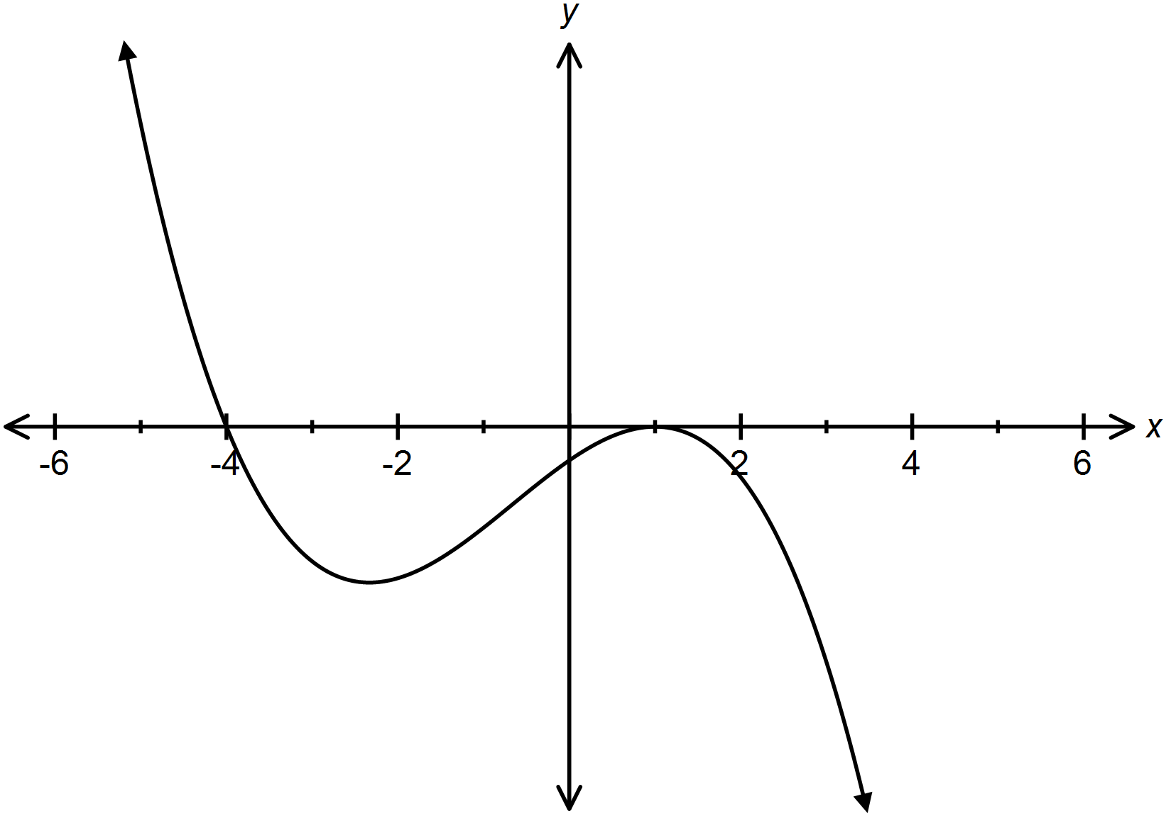

11. What are the x intercepts of the graph of the function ? 11. ___

(A)  (B) 

(C)  (D) 

12. Which polynomial equation has a single root at  and a double root at ? 12. ___

(A)  (B) 

(C)  (D) 

13. Which of the following is a factor of the function ? 13. ___

(A)  (B) 

(C)  (D) 

14. If  is divided by , which of the following is true? 14. ___

(A) 

(B) 

(C) 

(D) 

15. Given the table below, when is  ? 15. ___

|  |  |  |  |  |
| --- | --- | --- | --- | --- |
|  | X < -1 | -1 < x < 2 | 2 < x < 3 | X > 3 |
| x– 2 |  |  |  |  |
| x + 1 |  |  |  |  |
| x - 3 |  |  |  |  |
| P(x) |  |  |  |  |

(A)  (B) 

(C)  (D) 

16. What is the range of the function graphed below ? 16. ___

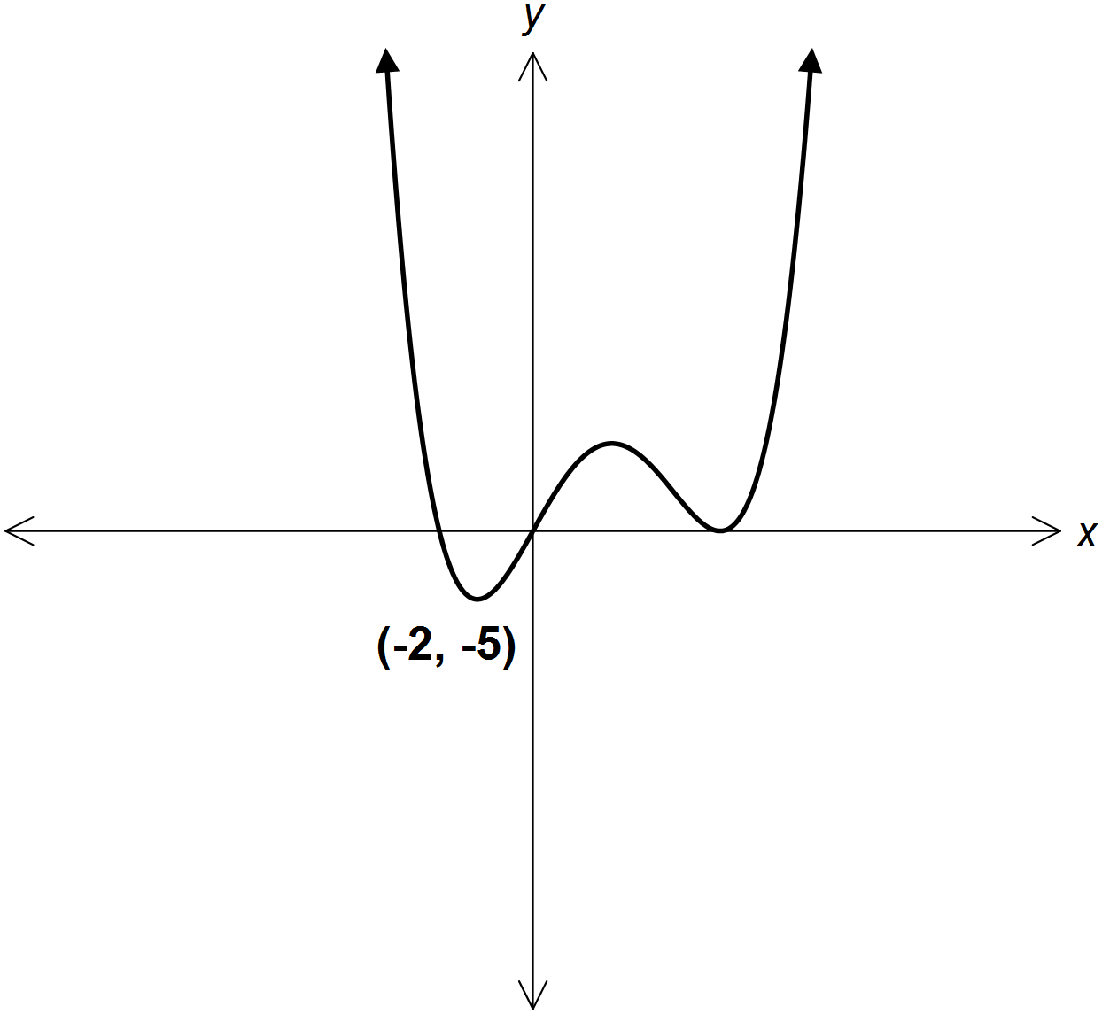

(A)  (B) 

(C)  (D) 

**Part B:** Answer each question and show all workings.

1. Factor completely.

2. Solve  leaving roots in exact simplest form.

3. The dimensions of a rectangular solid are shown.

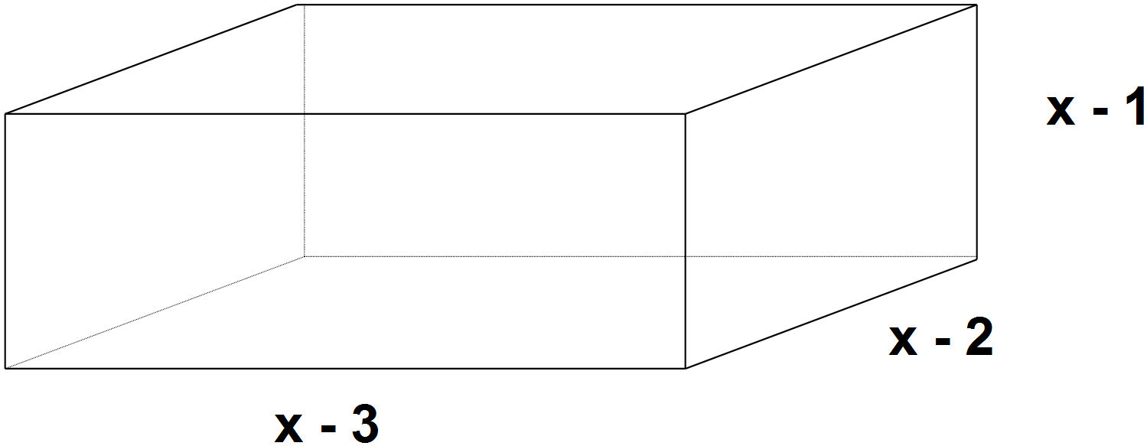

(a) Write an expression for the volume in the form 

(b) What are the inadmissible values for x?

(c) If the volume of the solid is 60 cm2, what is the dimension of the solid?

4. Sketch the graph of  clearly labeling the x intercept(s) and y intercept.

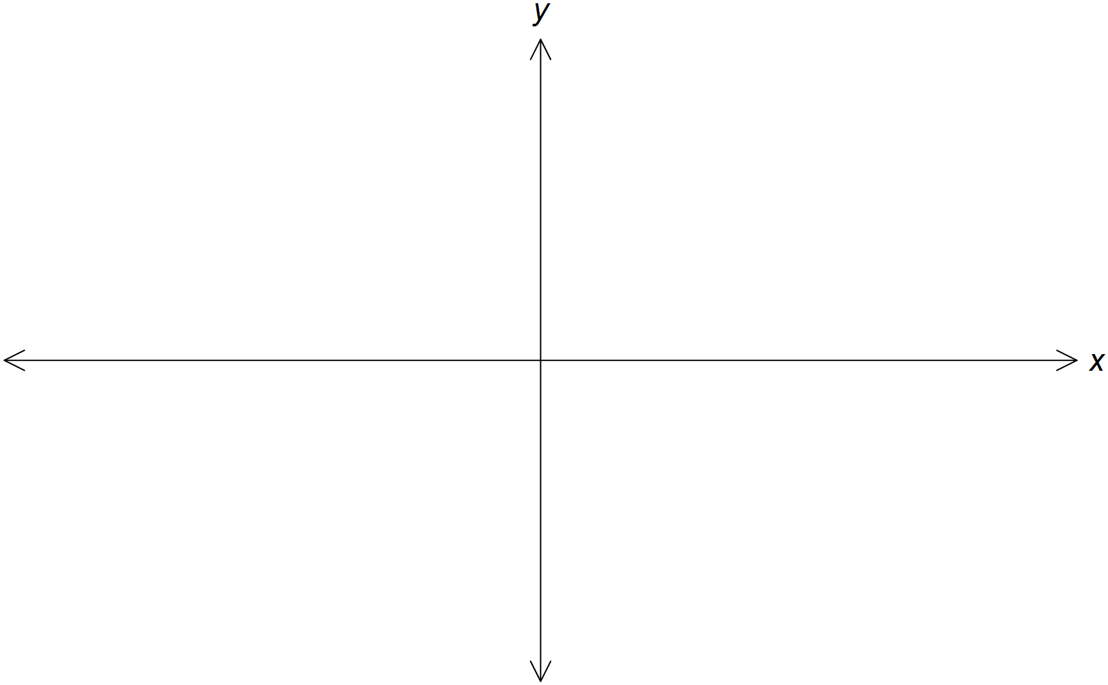

5. Write the equation for the graph of the polynomial function below.

