**Mathematics 3200**

**Test Unit 2**

**Name:** ___________________________________________

**Part A : Place the letter corresponding to the correct answer to each of the following on the blank at**

**the right.**

1. Which is true for the function  when compared to ? 1. ____

|  |  |  |
| --- | --- | --- |
|  | **Horizontal Translation** | **Vertical Translation** |
| A) | 8 Left | 3 Down |
| B) | 4 Left | 3 Down |
| C) | 4 Right | 3 Up |
| D) | 8 Right | 3 Up |

2. Given the graph of , what is the range? 2. ____

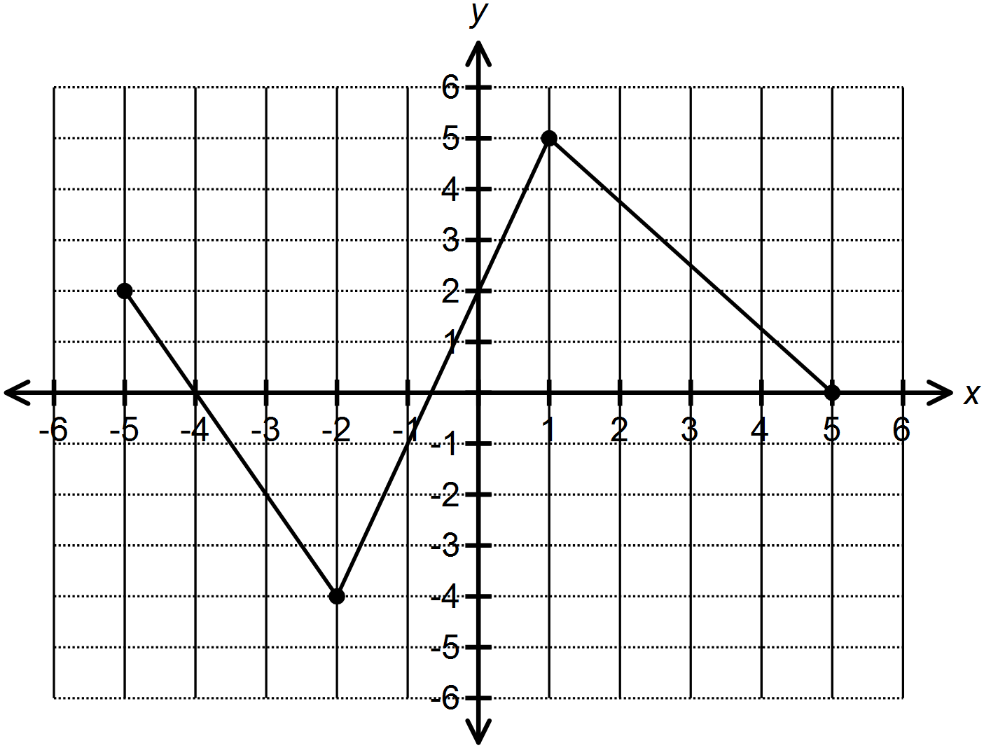

(A)  (B) 

(C)  (D) 

3. Given the graph of below, what is the domain of  ? 3. ____

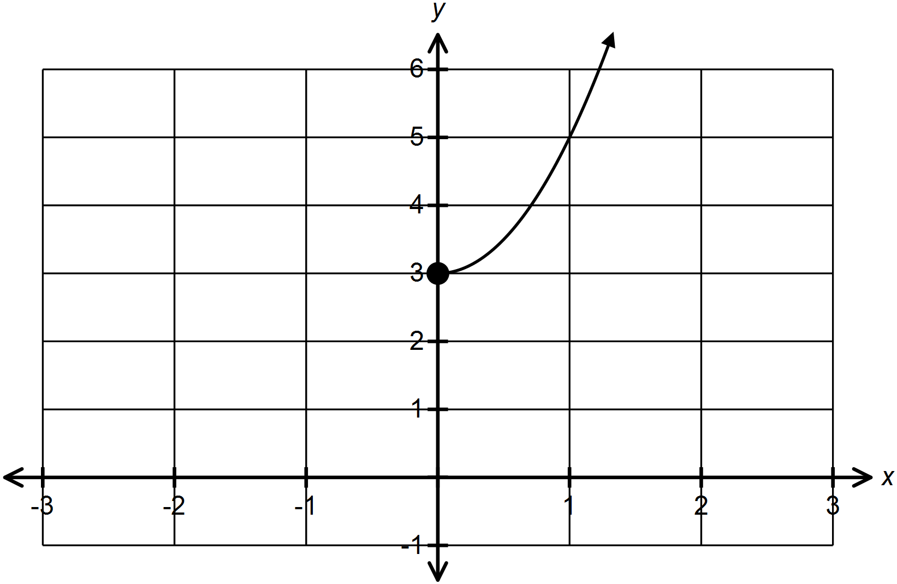

(A)  (B) 

(C)  (D) 

4. What is the vertical stretch factor of  when compared to ? 4. ____

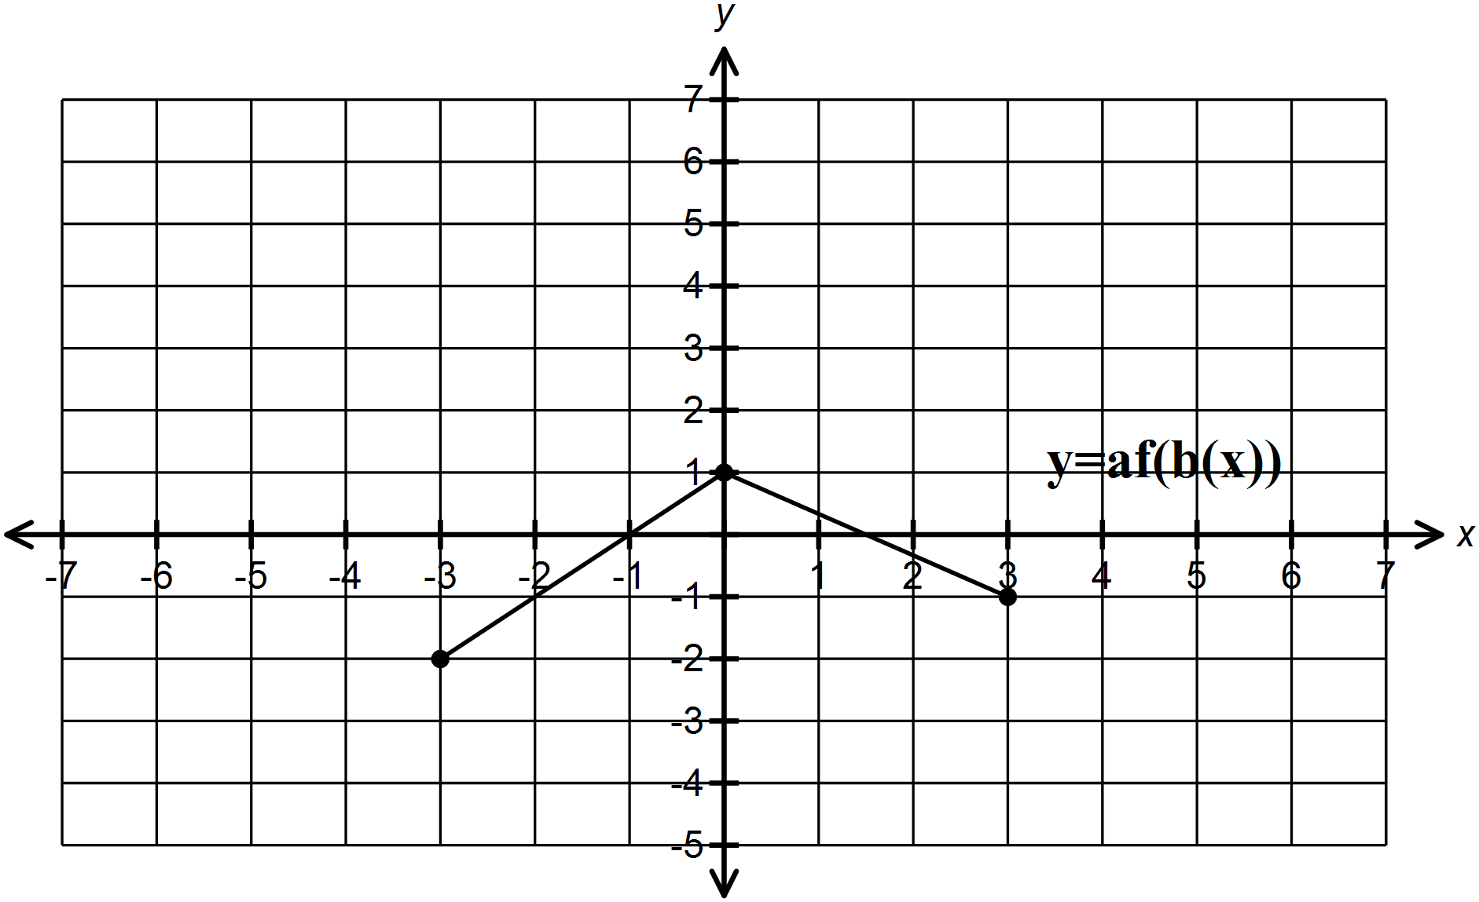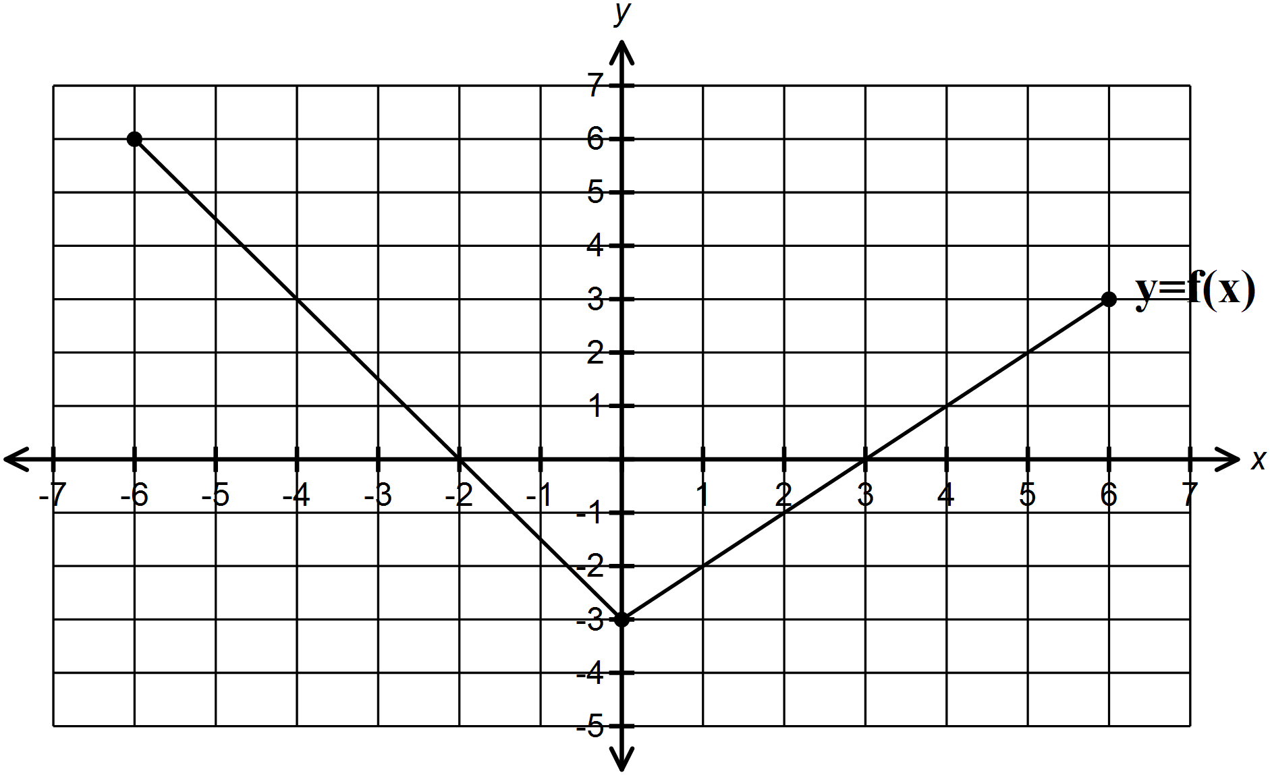

(A)  (B) 

(C)  (D) 

5. What is the correct order of transformations for the graph of  when to 5. ____

compared to ?

(A) Stretched vertically by a factor of 2 about the x axis

Stretched horizontally by a factor of 3 about the y axis

Reflected in the y axis

Horizontal translation of 1 unit right

(B) Horizontal translation of 1 unit right

Stretched vertically by a factor of 2 about the x axis

Stretched horizontally by a factor of  about the y axis

Reflected in the y axis

(C) Stretched vertically by a factor of 2 about the x axis

Stretched horizontally by a factor of  about the y axis

Reflected in the y axis

Horizontal translation of 1 unit right

(D) Stretched vertically by a factor of  about the x axis

Stretched horizontally by a factor of  about the y axis

Reflected in the x axis

Horizontal translation of 1 unit right

6. Which mapping notation transforms into  ? 6. ____

(A)  (B) 

(C)  (D) 

7. Given the function , what is  ? 7. ____

(A)  (B) 

(C)  (D) 

8. The point is on the graph of , what is the image point for the 8. ____

transformation  ?

(A)  (B) 

(C)  (D) 

9. Given the function , which of the following restriction must be applied 9. ____

to so that  is a function?

(A)  (B) 

(C)  (D) 

10. Given the function , what is ? 10. ___

(A)  (B) 

(C)  (D) 

11. Which of the following functions has an inverse that is a function ? 11. ___

(A) (B)

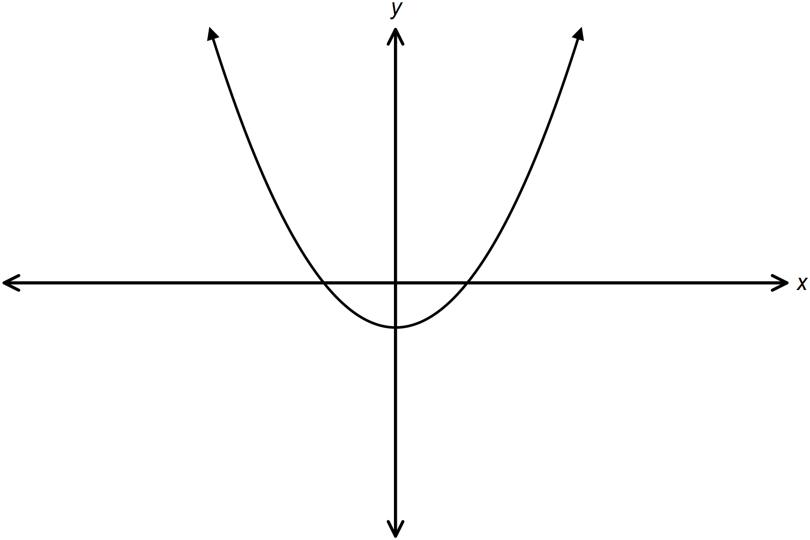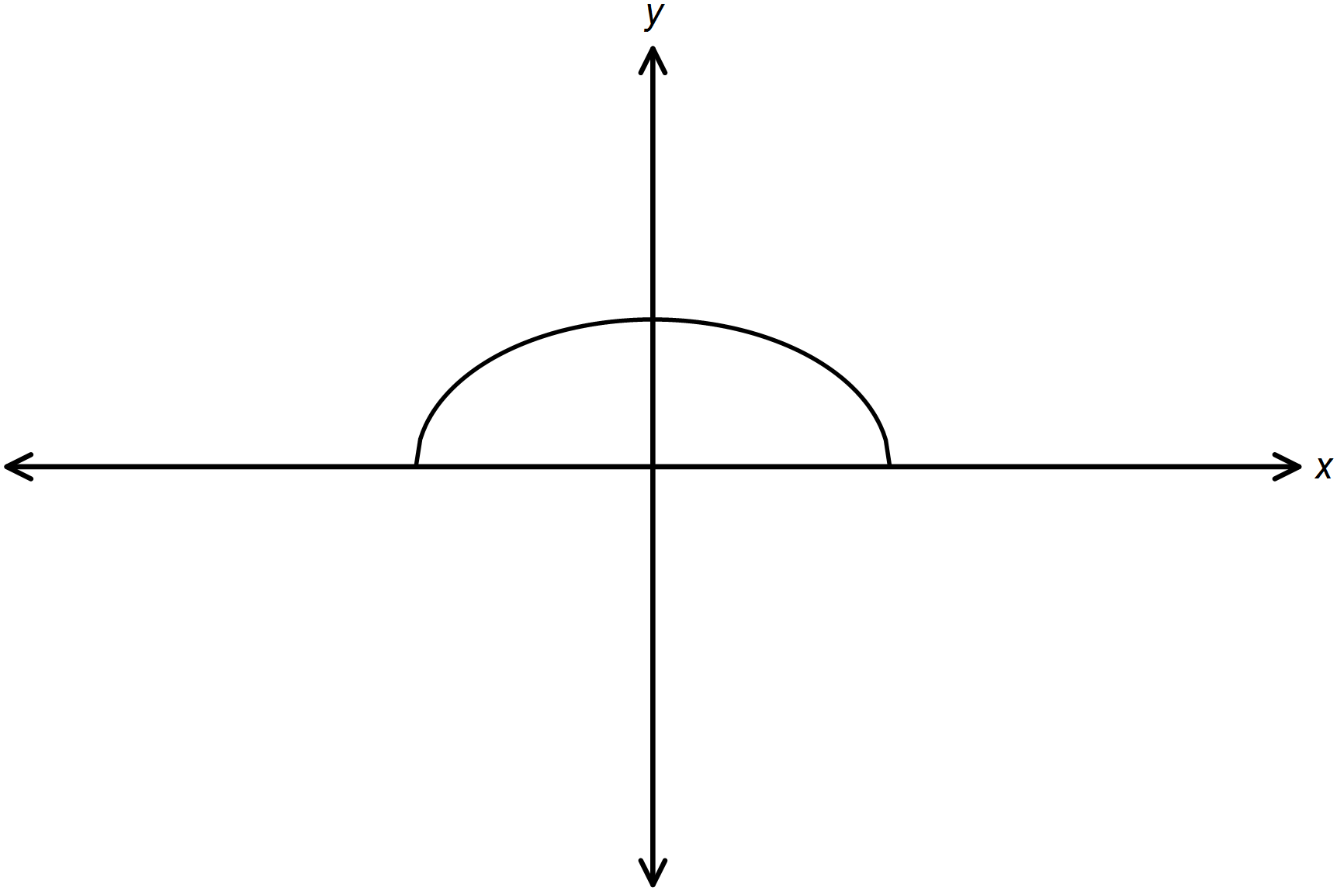

(C) (D)

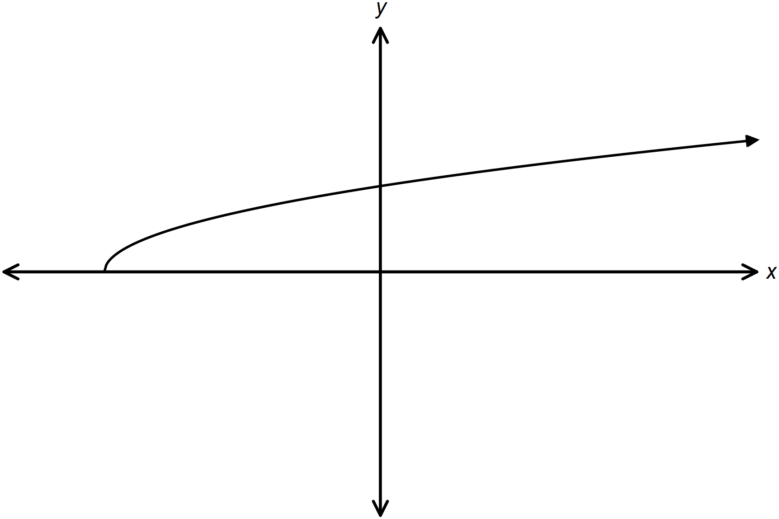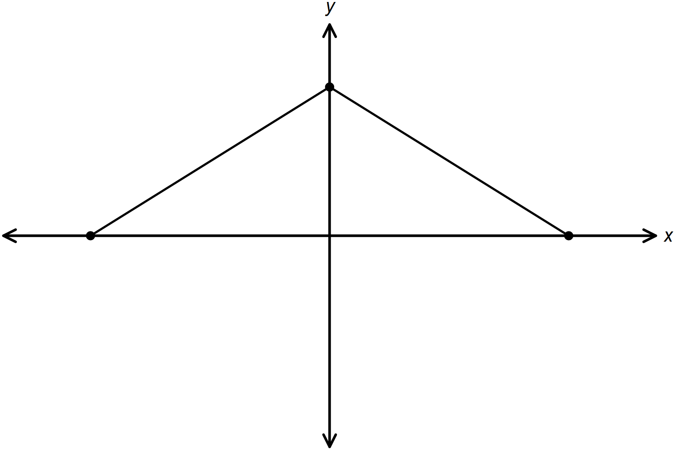

12. What are zeros of the function  after the transformation of ? 12. ___

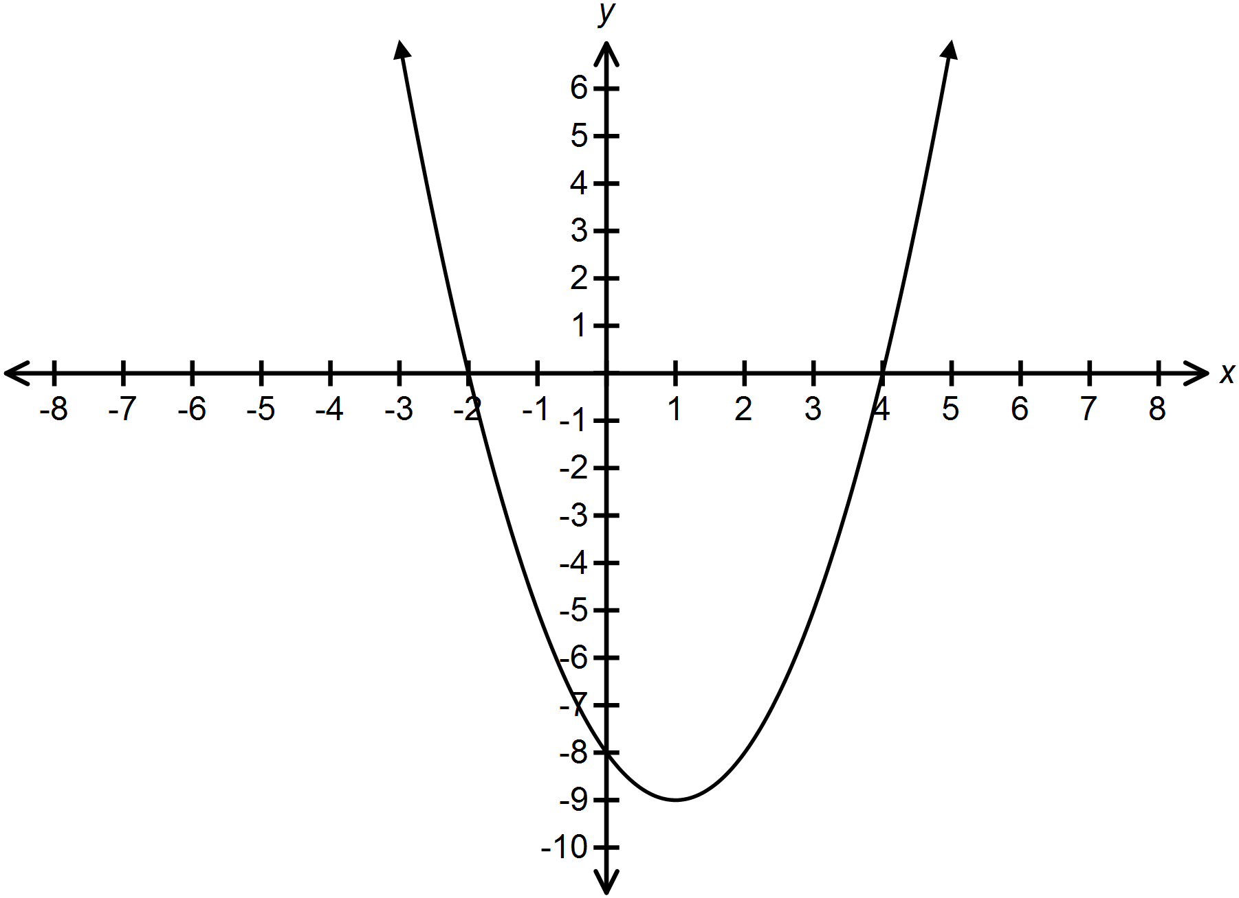



(A)  (B) 

(C)  (D) 

13. Which function best represents  when compared to ? 13. ___

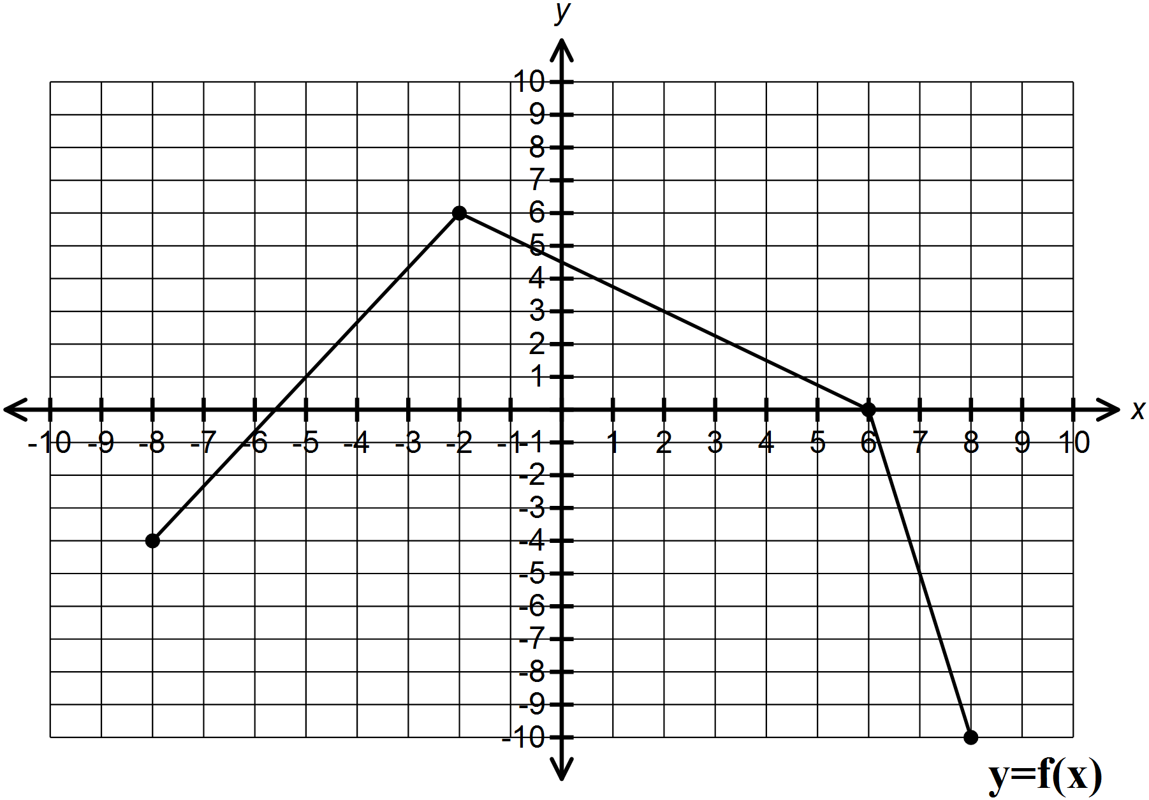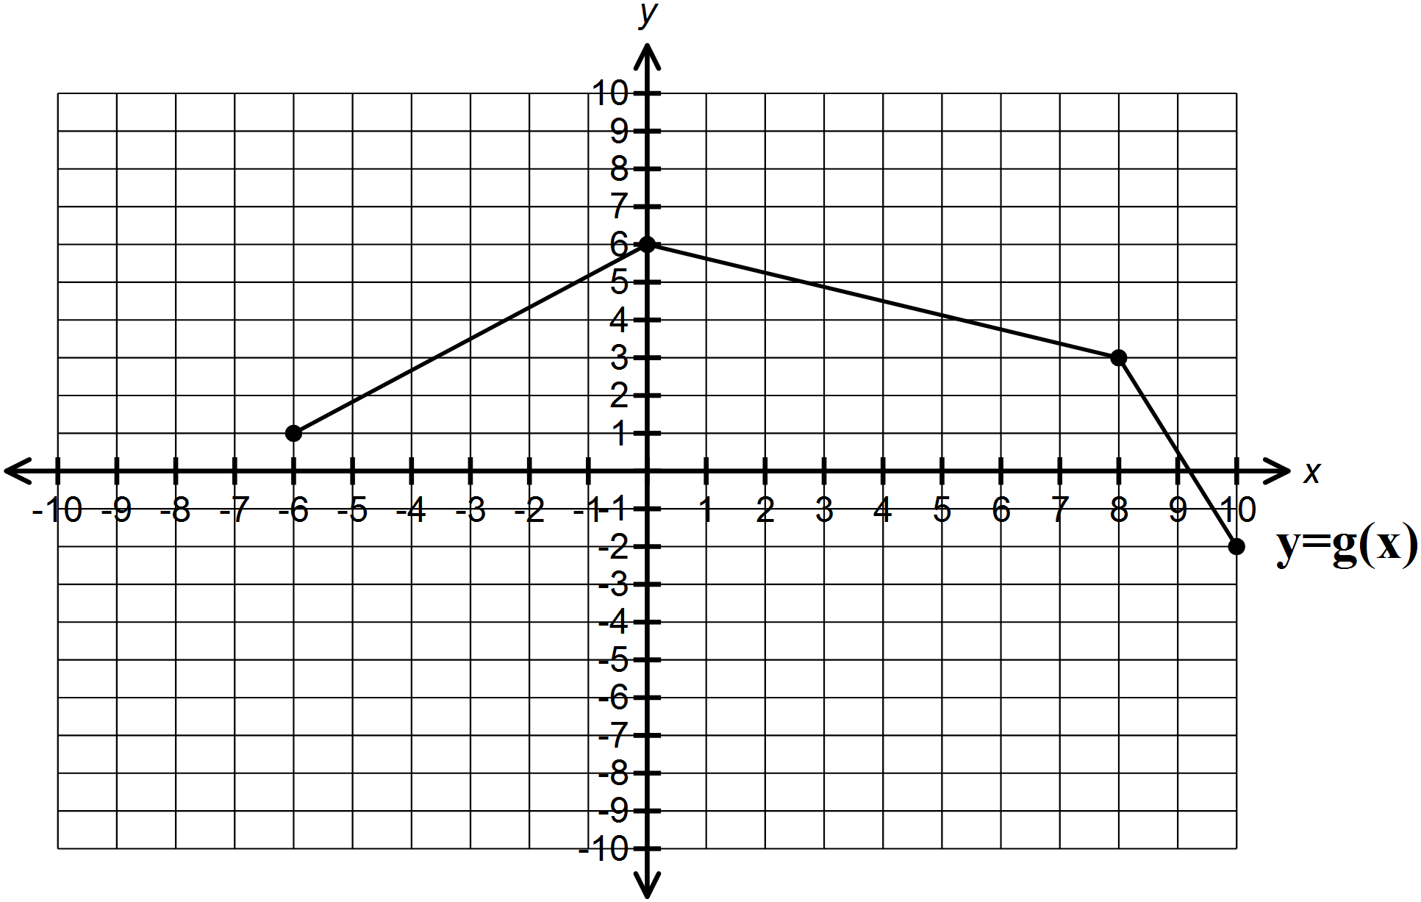

(A)  (B) 

(C)  (D) 

14. Which of the following is the graph of the inverse of ? 14. ___

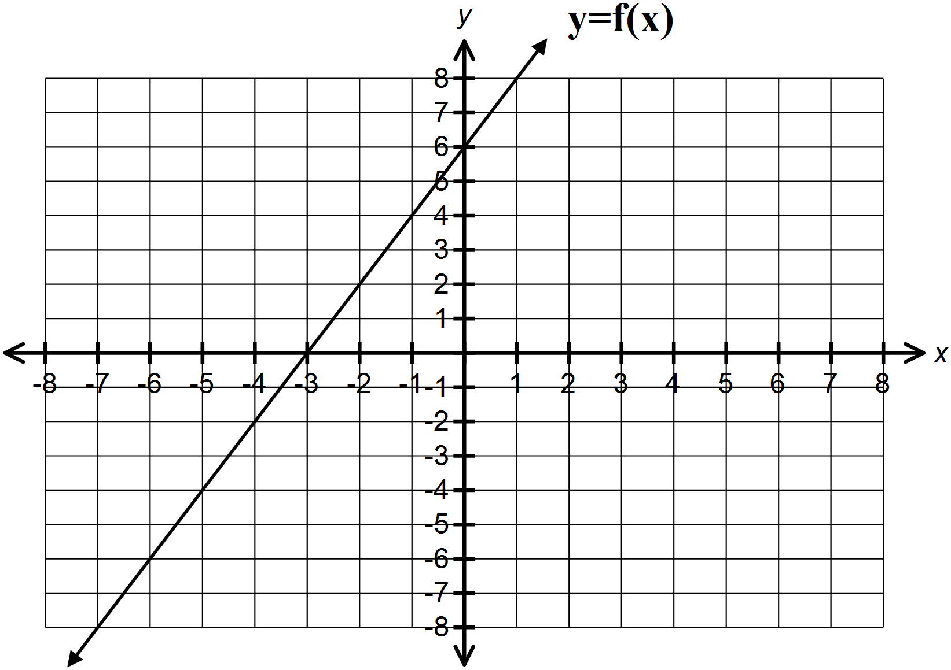

(A) (B)

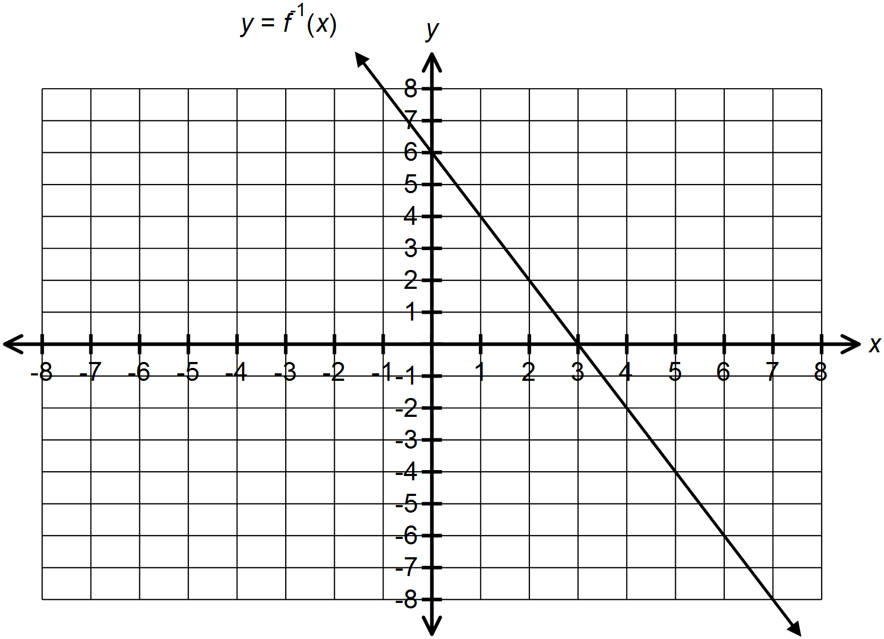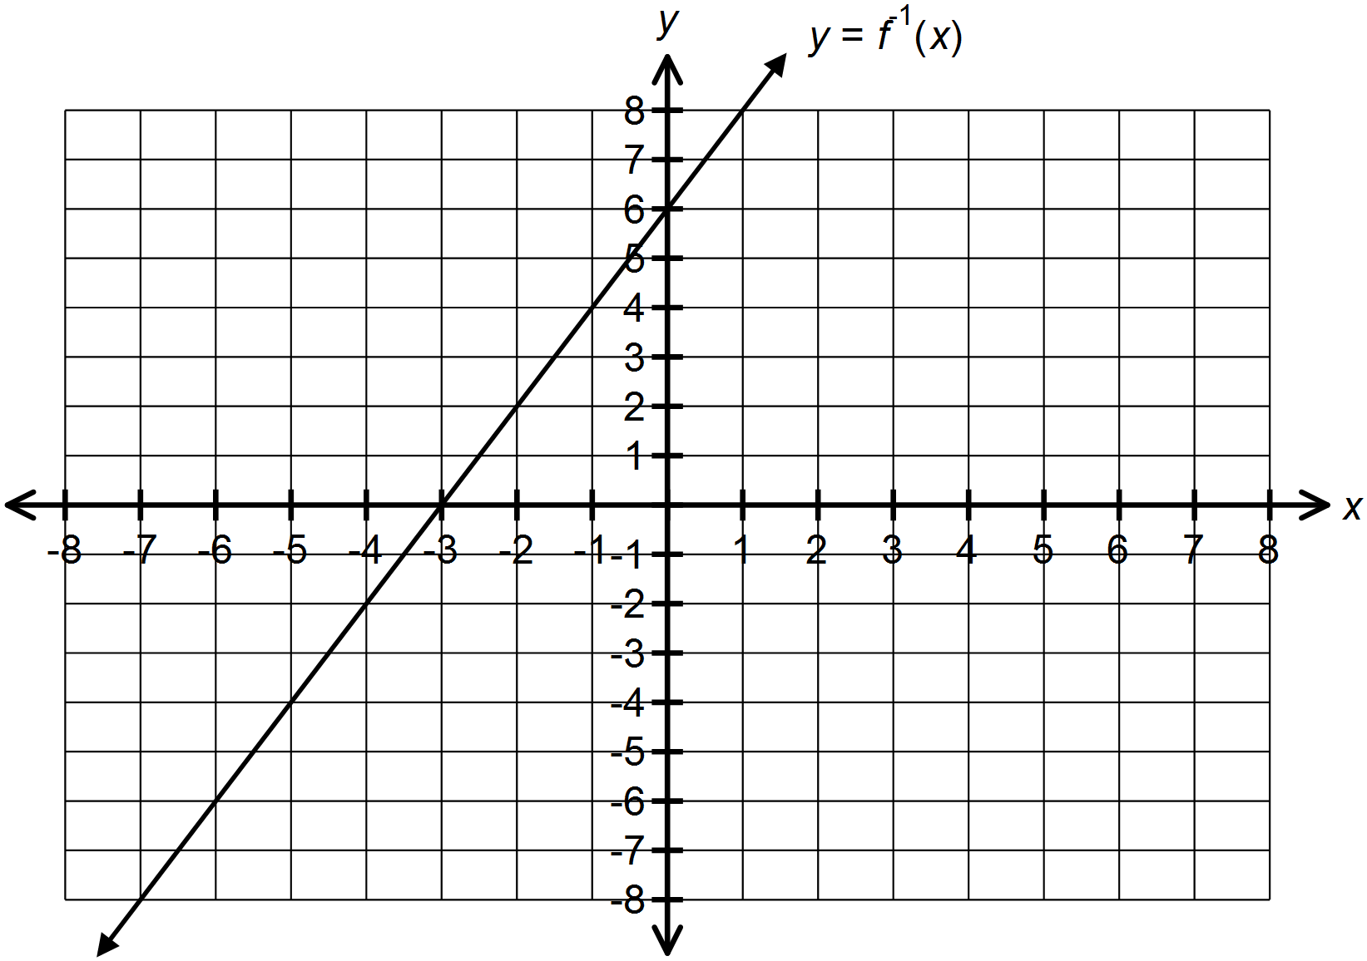

(C) (D)

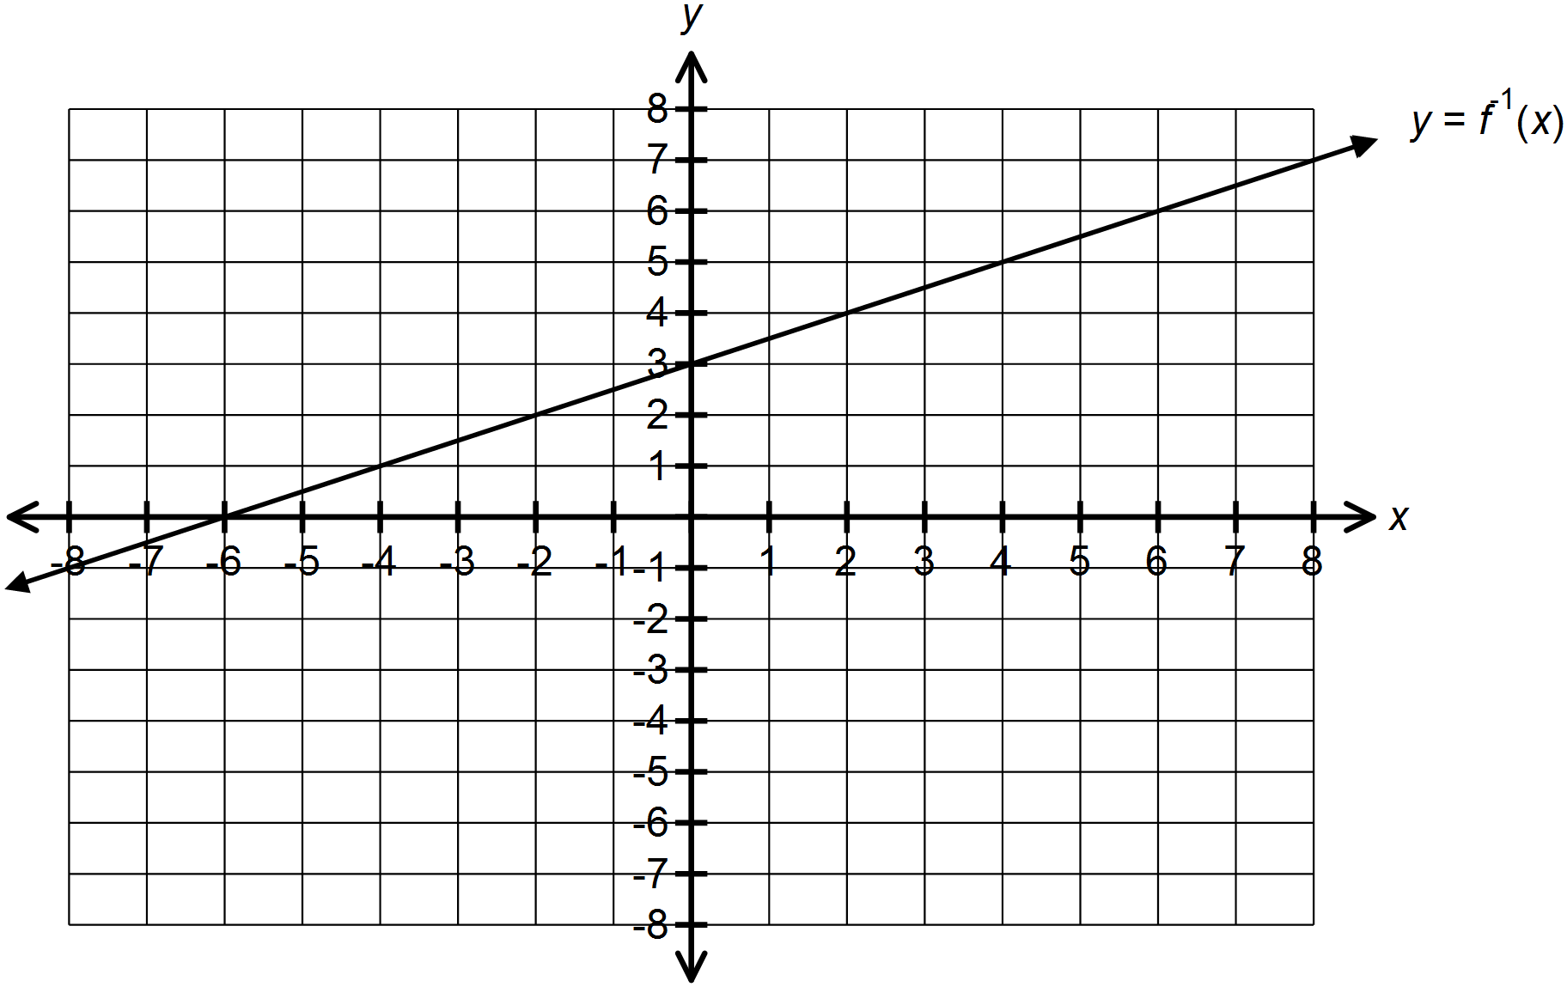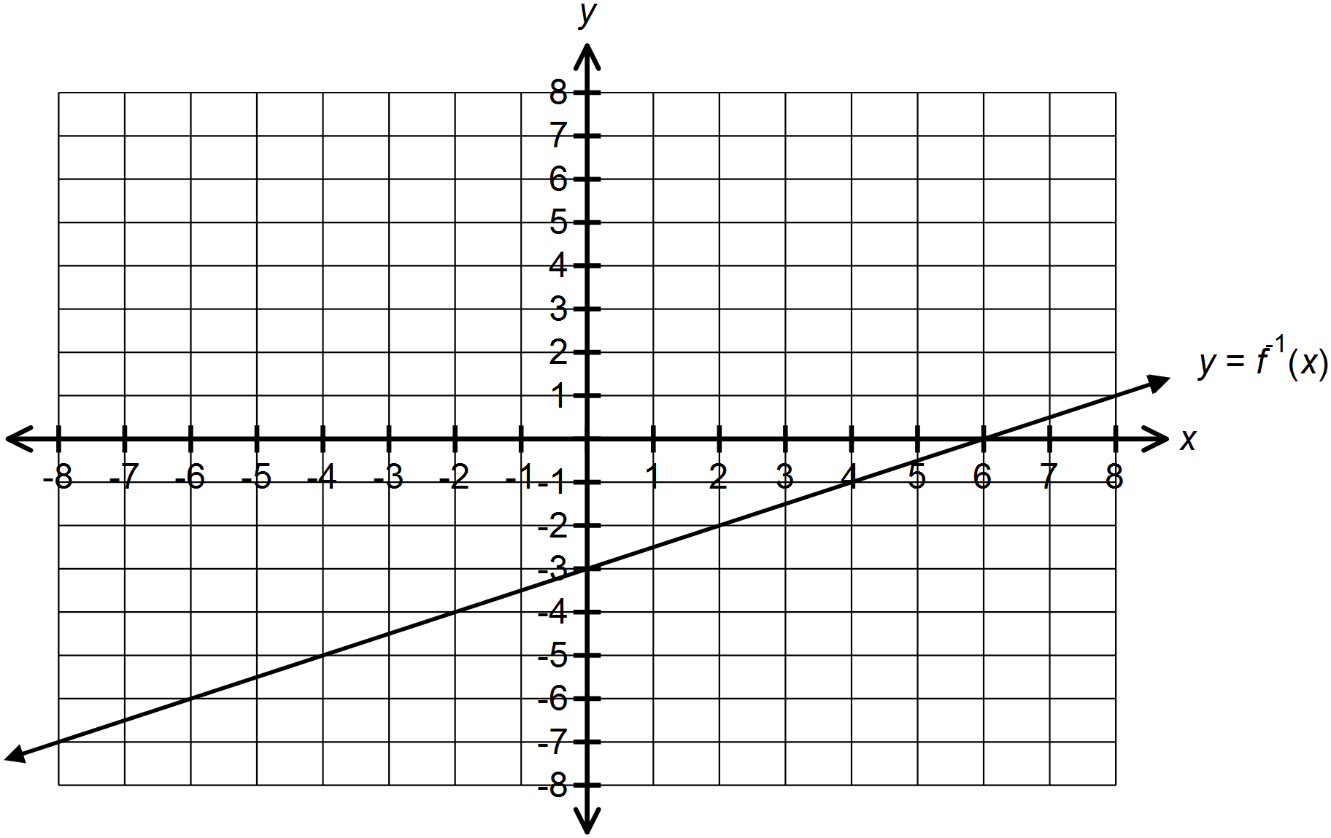

15. Which is true for the function when compared to ? 15. ___

|  |  |  |
| --- | --- | --- |
| (A)  (B)  (C)  (D) | **Horizontal Stretch Factor** | **Vertical Stretch Factor** |
|  | -3 |
|  | 3 |
| 4 | -3 |
| 4 |  |

**Part B: Answer all questions and show your workings.**

1. Given the graph of the function shown, Sketch the graph of .

**(4 marks)**

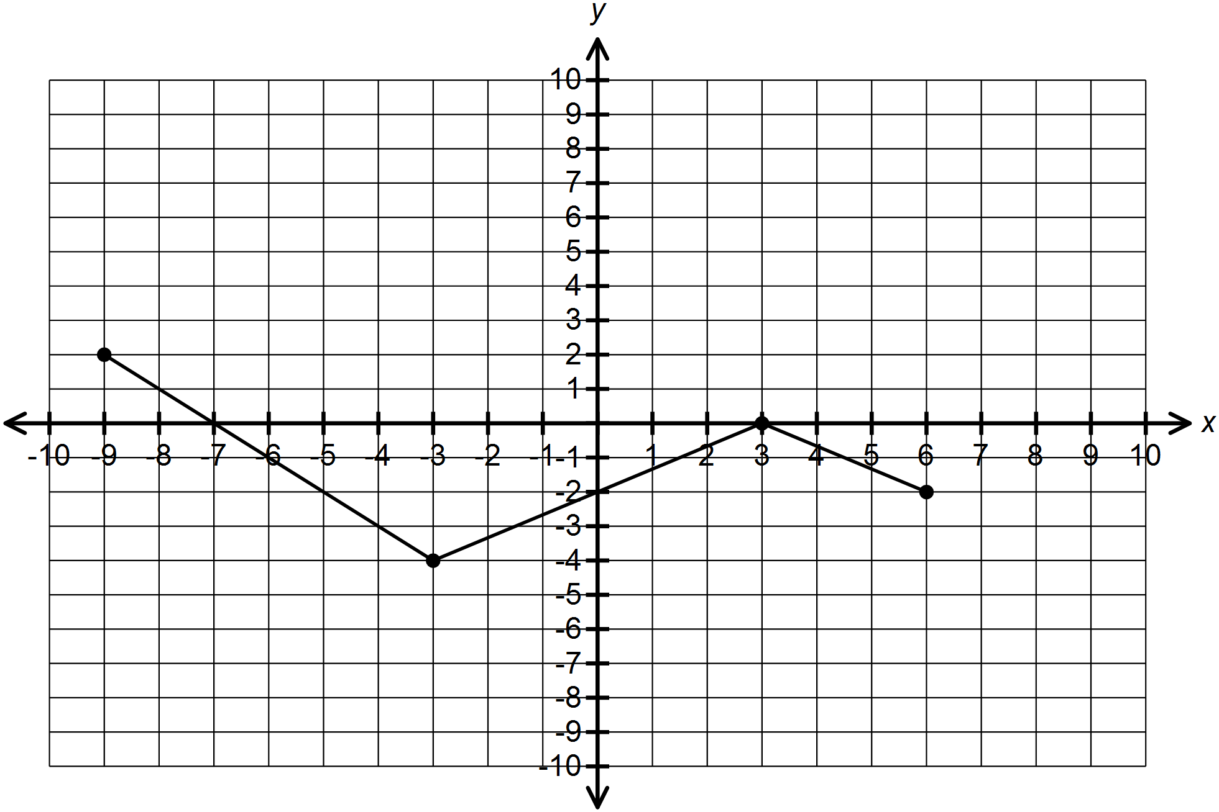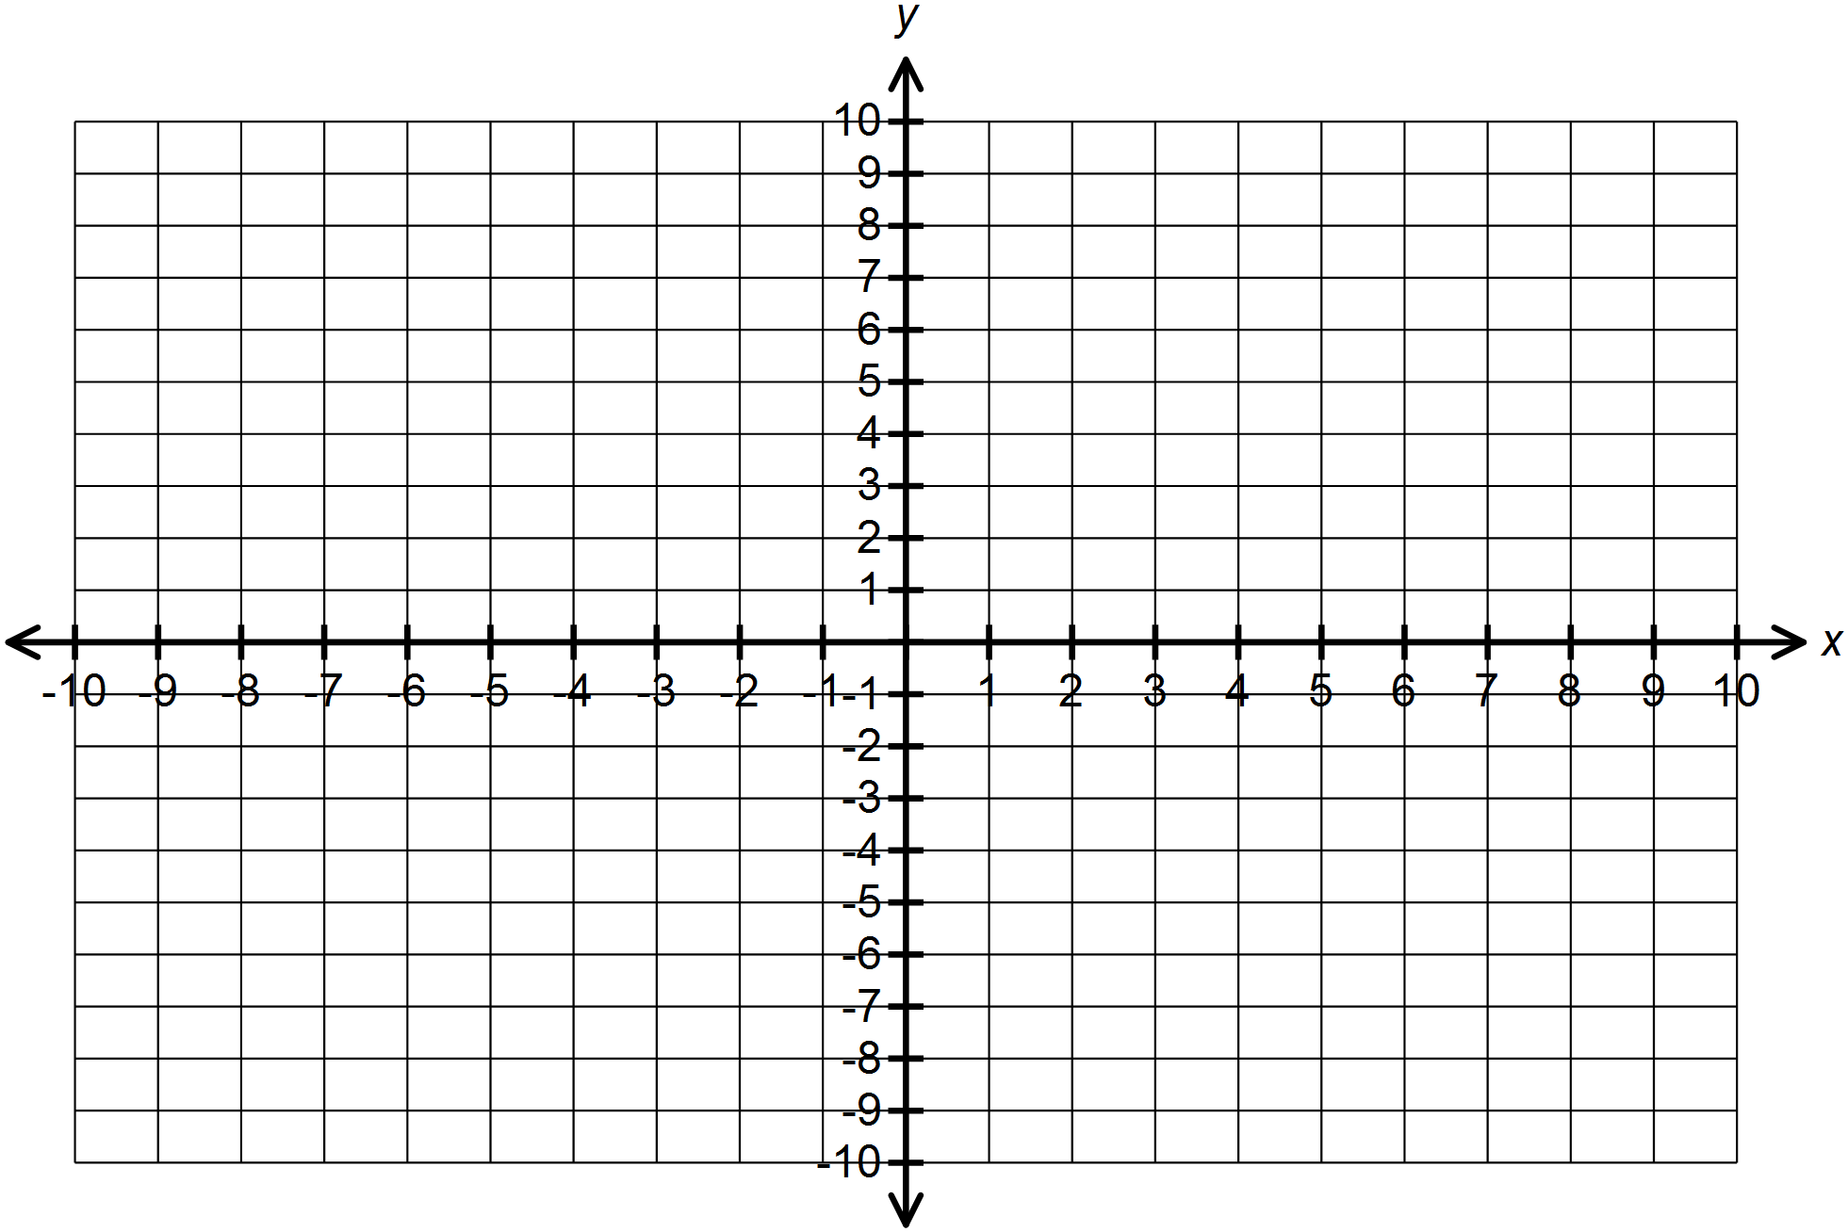

2. The graph of with points  is transformed so that

. Plot the points and determine the equation of the image

function in the form . **(4 marks)**

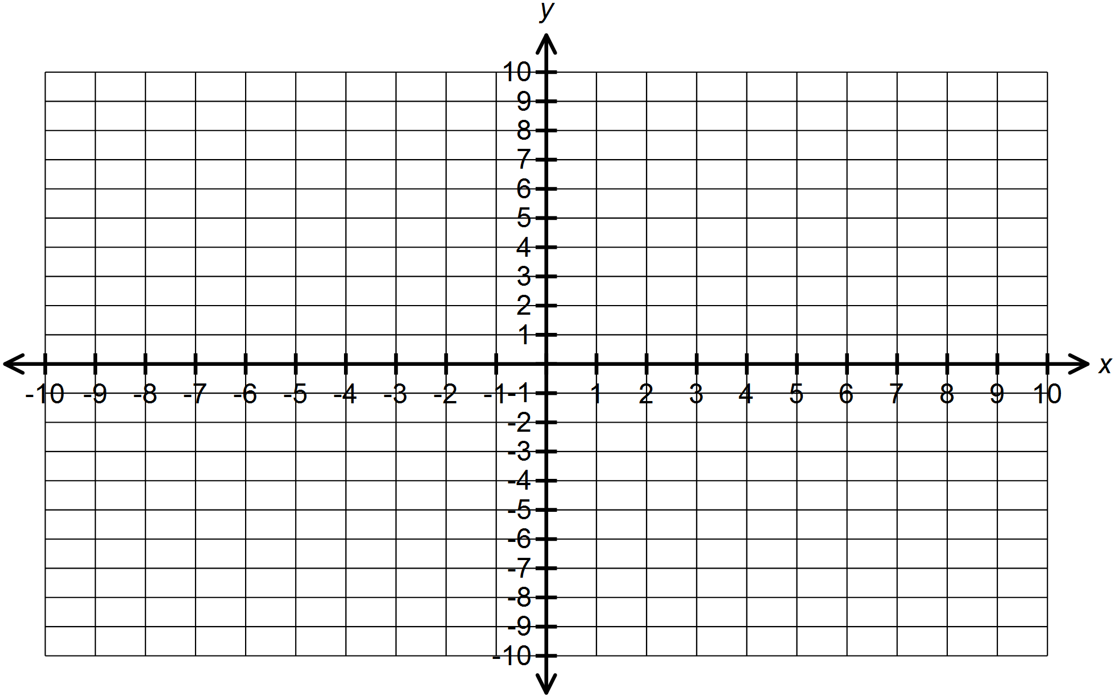

3. Determine the equation of when compared to . **(3 marks)**

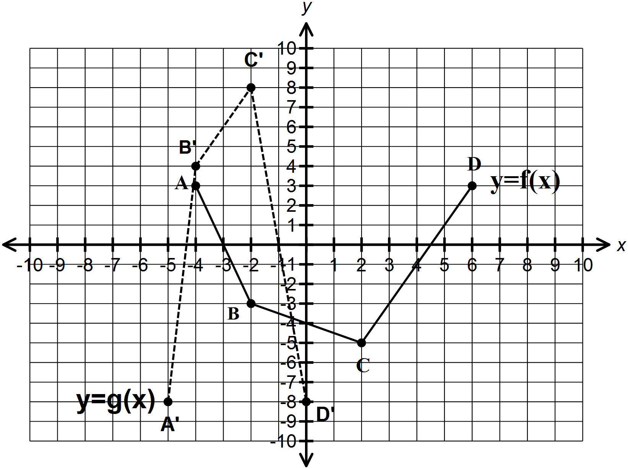

4. Given the graph of the function below, sketch the graph of the inverse of

. **(4 marks)**

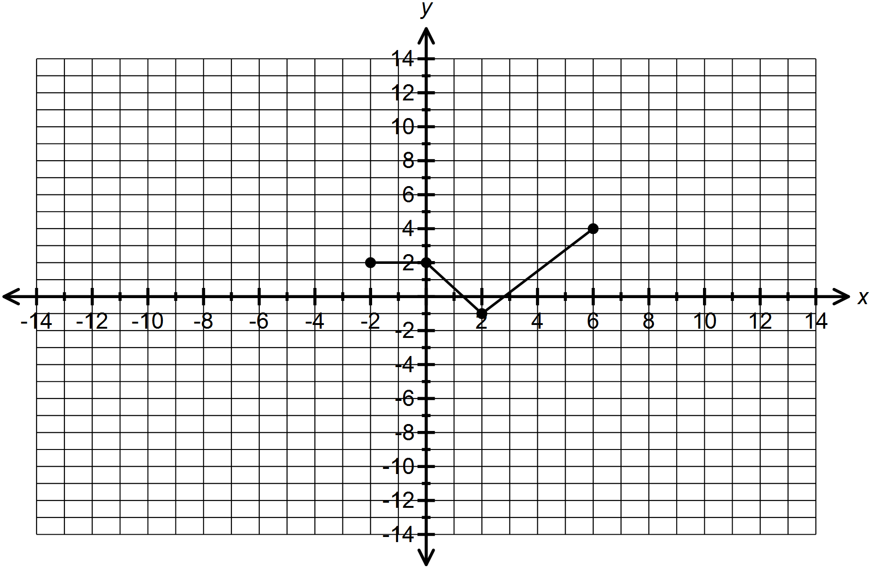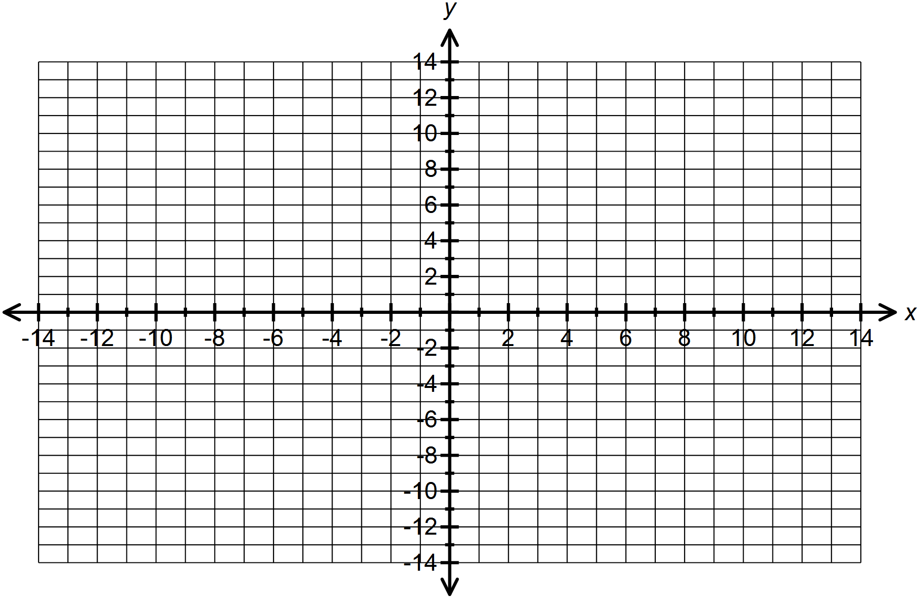

5. (a) If , what restriction could be placed on so that ? **(2 marks)**

(b) Find  with the restricted domain for the equation in part (a). **(3 marks)**