**Mathematics 3200**

**Test 3 (Radical Functions)**

**Part A :** Place the letter in the blank at the right that corresponds to the correct answer to each of the

following.

1. Which of the following functions transforms  , 3 units to the right and 6 units up? 1. ____

(A)  (B) 

(C)  (D) 

2. Which function best represents the graph below ? 2. ____

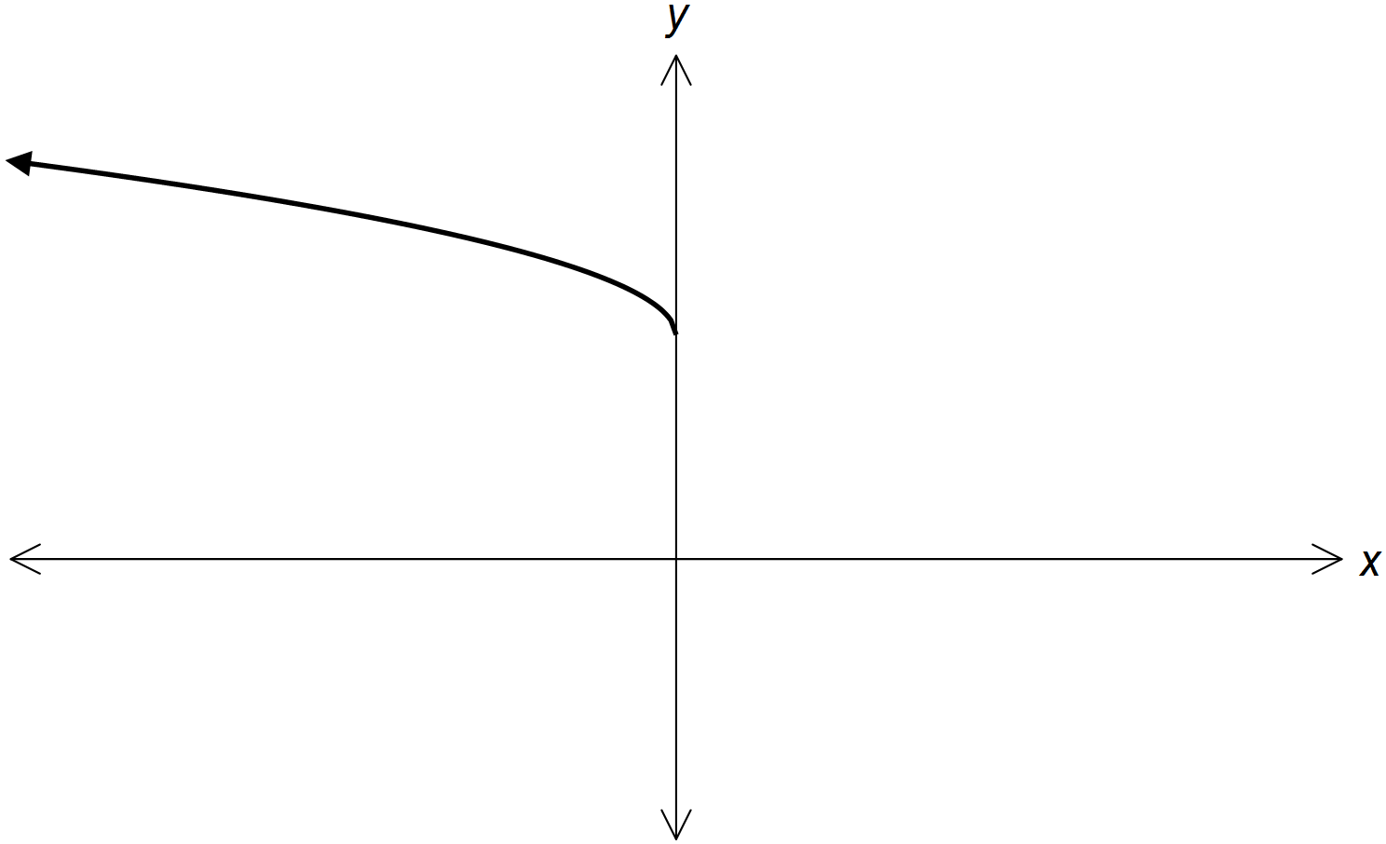

(A)  (B) 

(C)  (D) 

3. Which is true for the function when compared to ? 3. ____

|  |  |  |
| --- | --- | --- |
|  | **Horizontal Stretch Factor** | **Vertical Stretch Factor** |
| (A) |  |  |
| (B) |  |  |
| (C) |  |  |
| (D) |  |  |

4. The point  is on the graph of  , what is the image point under the 4. ____

transformation ?

(A)  (B) 

(C)  (D) 

5. What are the invariant points for the graph of  and  ? 5. ____

(A)  (B) 

(C)  (D) 

6. If , what is the domain of  ? 6. ____

(A)  (B) 

(C)  (D) 

7. If , which of the following is true for  ? 7. ____

|  |  |  |
| --- | --- | --- |
|  | Domain | Range |
| (A) |  |  |
| (B) |  |  |
| (C) |  |  |
| (D) |  |  |

8. If  , what translation is performed on  to get the graph of g(x)? 8. ____

(A) 10 units right (B) 10 units left

(C) 2 units left (D) 2 units right

9. What are all the invariant points for the graph of and ? 9. ____

(A)  (B) 

(C)  (D) 

10. The graph of the function is stretched horizontally by a factor of 2 and translated 10. ___

3 units left. What is the domain of the transformed function?

(A)  (B) 

(C)  (D) 

**Part B :** Answer each question and show all workings.

1. If  sketch the graph ofand  using a table of values. Label the invariant

point(s).

|  |  |  |  |  |
| --- | --- | --- | --- | --- |
| X |  |  | X |  |
| 2 |  |  |  |
| 1 |  |  |  |
| -2 |  |  |  |
| -7 |  |  |  |

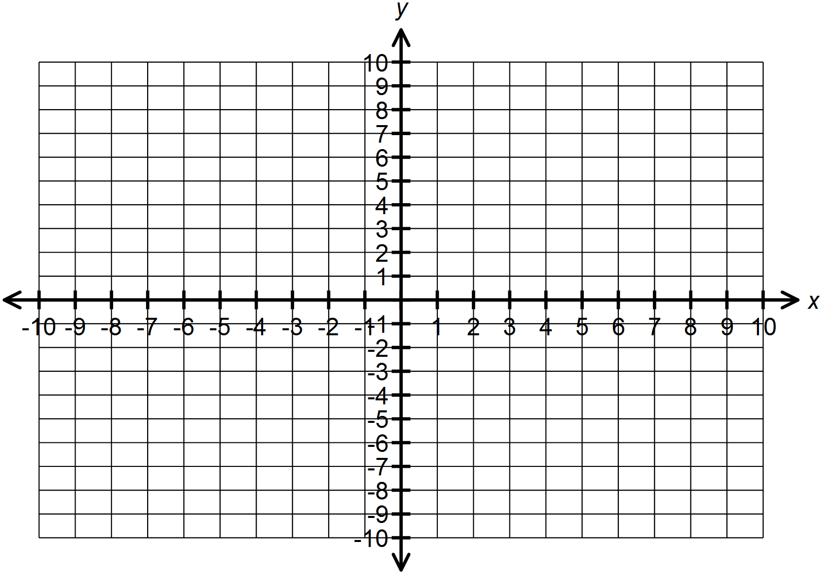

2. If  sketch the graph of and  using a table of values. Label the invariant

points.

|  |  |  |  |  |
| --- | --- | --- | --- | --- |
| X |  |  | X |  |
|  |  |  |  |
|  |  |  |  |
|  |  |  |  |
|  |  |  |  |  |
|  |  |  |  |  |



3. Solve graphically 

|  |  |  |  |  |
| --- | --- | --- | --- | --- |
| X | Y |  | X | Y |
|  |  |  |  |
|  |  |  |  |
|  |  |  |  |
|  |  |  |  |
|  |  |  |  |
|  |  |  |  |
|  |  |  |  |



4. Solve 

|  |  |  |  |  |
| --- | --- | --- | --- | --- |
| X | Y |  | X | Y |
|  |  |  |  |
|  |  |  |  |
|  |  |  |  |
|  |  |  |  |
|  |  |  |  |
|  |  |  |  |
|  |  |  |  |

