**Mathematics 3201**

**Test (Unit 3) Probability**

**Name: _____________________________________________**

|  |
| --- |
| **FORMULAES** |
|  |

**Part A :** Place the letter corresponding to the correct answer to each of the following in the appropriate

blank at the right.

1. A soccer player has 17 attempts on net and 6 goals are scored. What are the odds in favor 1. ____

of the player scoring a goal on the next attempt?

(A)  (B) 

(C)  (D) 

2. There are 7 marbles in a bowl : **2 White, 3 Green,** and **2 Blue**. If 2 marbles are randomly 2. ____

selected, what is the probability of a green marble **NOT**  being selected if the first marble

selected is not replaced?

(A)  (B) 

(C)  (D) 

3. A and B are mutually exclusive events. The probability of A or B occurring, , is 3. ____

56%. If the probability of A occurring, , is 17%, what is the probability of B not

occurring, ?

(A) 27% (B) 39%

(C) 61% (D) 73%

4. A student has a six sided die with each side numbered one through six and a coin with 4. ____

heads on one side and tails on the other. What is the probability of rolling a number greater

than 4 with the die and tossing heads with the coin?

(A)  (B) 

(C)  (D) 

5. The odds in favor of you choosing a lucky ticket at a raffle is . What is the probability 5. ____

of you not choosing a lucky ticket to win a prize at the raffle?

(A)  (B) 

(C)  (D) 

6. Mark and Abby are students in line with three other students. What is the probability 6. ____

Mark and Abby are standing together?

(A)  (B) 

(C)  (D) 

7. A market study found that 30% of the residents in Mathville fished for Atlantic salmon and 7. ____

60% hunted white partridge. If 10% did both, what is the probability that a resident of

Mathville didn’t fish for Atlantic salmon or hunted white partridge?

(A) 10% (B) 20%

(C) 50% (D) 80%

8. Dan has a 50% probability of making the school hockey team and a 80% probability of 8. ____

making the provincial swimming team. What is his probability of making both?

(A)  (B) 

(C)  (D) 

9. In the Venn Diagram below set A contains 150 elements and set B contains 25 elements. 9. ____

If 325 elements are not in either A or B, what is the probability of A or B, ?

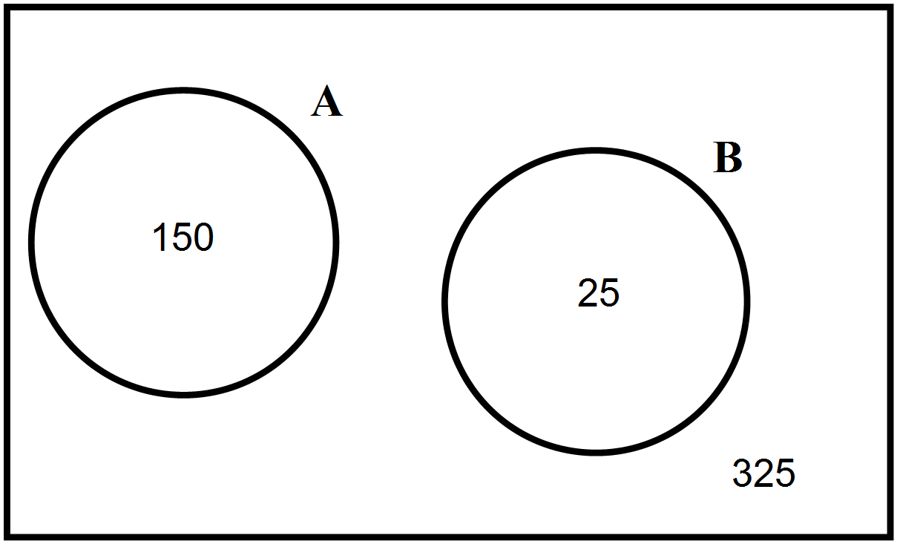

(A) (B) 

(C)  (D) 

10. A deck of 40 cards consists of 4 different colored sets: red, blue, green and yellow. Each 10. ___

set is numbered from 0 to 9 as shown below. If two cards are randomly picked from the

deck, what is the probability that the first card is blue or green and the second card is also

blue or green if the first card is not replaced?

|  |  |  |  |
| --- | --- | --- | --- |
|  | Card Colour | Cards |  |
|  | red |  |  |
|  | blue |  |  |
|  | green |  |  |
|  | yellow |  |  |

(A)  (B) 

(C) (D)

11. A committee of three people will be randomly chosen from a group of nine people; 11. ___

5 females and 4 males. Which represents the probability of selecting a committee that has

at least one male and at least one female member?

(A)  (B) 

(C)  (D) 

12. The Student Council at Mealy Mountain is having a Christmas contest. If a student spins 12. ___

a one or five they win. What are the odds of a student winning a prize?

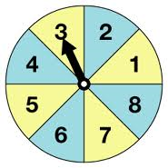

(A)  (B) 

(C)  (D) 

**Part B** **:** Answer all questions and show your workings.

1. If a 5 digit number is generated at random from the digits **2**, **3**, **4**, **5**, **6** with no repetition. What is

the probability that a number will end with a **5**? **(3 marks)**

2. There are 7 women and 5 men interested in becoming members of a committee consisting of

4 people. If the committee is selected at random:

(A) what is the probability of having a committee of all men? **(3 marks)**

(B) what is the probability of having the same number of men and women on this committee?

**(3 marks)**

3. A person will be randomly selected from a group to draw a marble from a bag. The odds of selecting

a female from the group is 7:8 and the odds of drawing a red marble from the bag are 1:3. What is

the probability of a non-red marble being drawn from the bag by a male from the group? **(3 marks)**

4. A company has two factories that make computer chips. Suppose 70% of the chips come from

Factory 1 and 30% come from factory 2. In Factory 1 25% of the chips are defective and 10% are

defective in Factory 2. Complete the tree diagram and determine the probability that chips are

not defective from both factories? **(3 marks)**

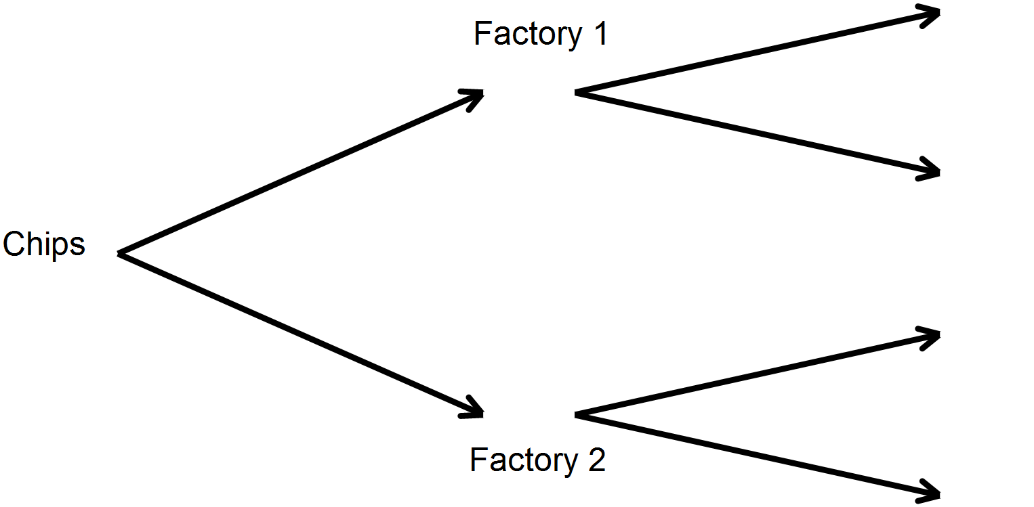

5. Mealy Mountain Collegiate is raising money for a trip to Math Numberland. They sell 500 tickets on

two prizes: **1st Prize TI Nspire Calculator autographed by Mr. Math**

**2nd Prize Box of 10 Mechanical Pencils**

If Mr. Physics has 10 tickets, what is the probability of him winning one of the prizes if the first ticket

drawn is replaced? **(3 marks)**