**Mathematics 3201**

**Unit 1 Test**

**Name: ____________________________________**

**Part A**: Place the letter corresponding to the correct answer in the blank at the right.

1. The list of multiples of 8 from 1 to 16000 are listed in set M below. 1. ____



Which of the following represents set M?

(A)  (B) 

(C)  (D) 

2. In the Venn diagram below, what is  ? 2. ____

U = {A, B, D, E, J, K, L, O, R, T}

X = {Different letters in **LABRADOR**}

Y= {Difference letters in **ALBERTA**}

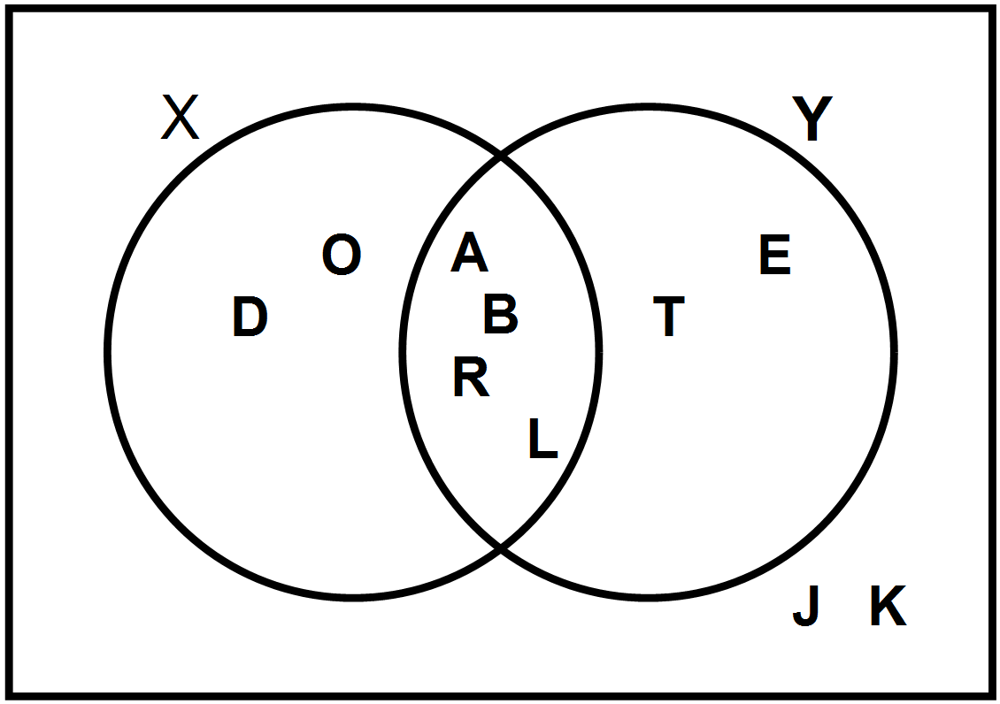

(A)  (B) 

(C)  (D) 

3. The following sets represents some carnivores(C) and herbivores(H). What is ? 3. ____

C = {badger, bear, deer, moose, rabbit, raccoon, squirrel}

H = {badger, bear, cougar, raccoon, wolf}

(A) {cougar, wolf }

(B) {badger, bear, raccoon}

(C) { deer, moose, rabbit, squirrel}

(D) {badger, bear, cougar, deer, moose, rabbit, raccoon, squirrel, wolf}

4. Which of the following Venn diagrams represents disjoint sets for A and B? 4. ____

(A) (B)

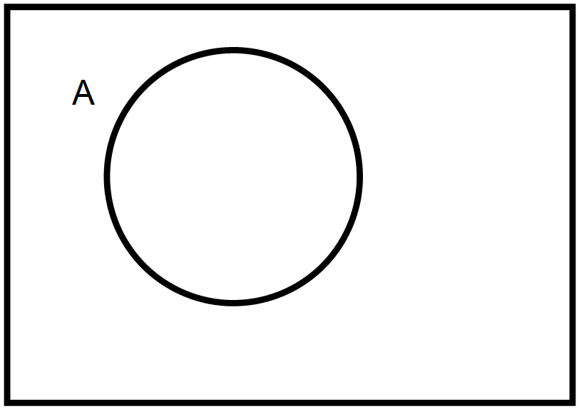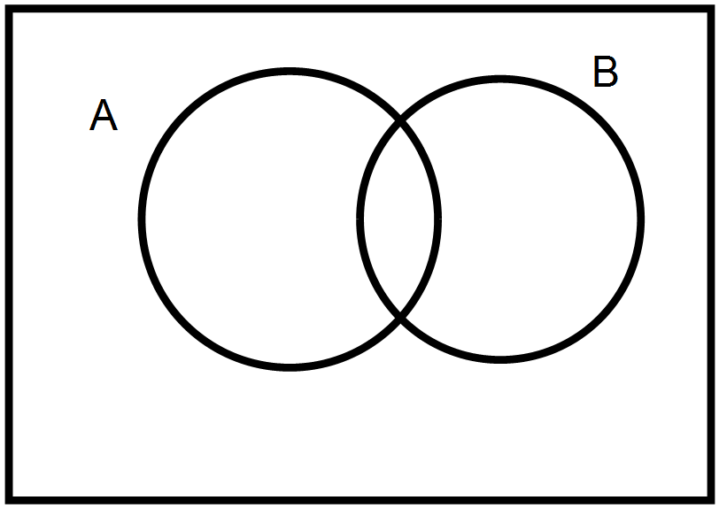

(C) (D)

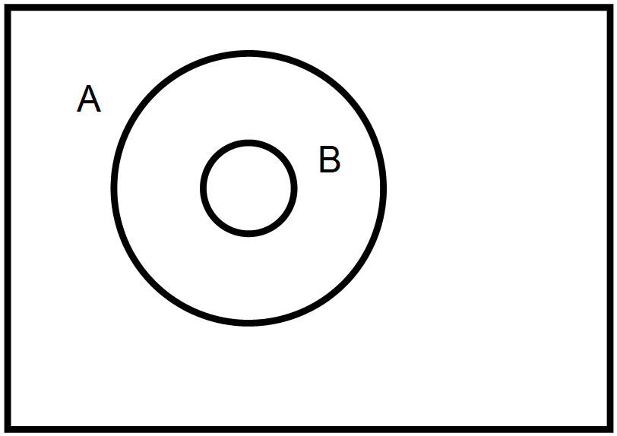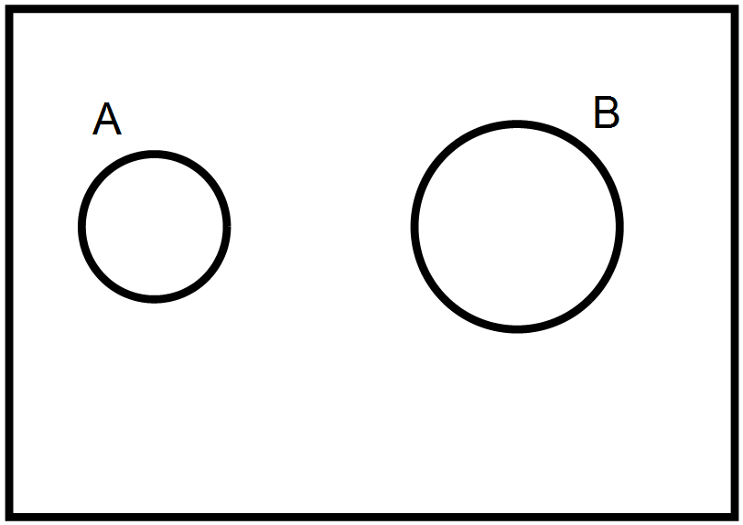

5. Given the following two sets, what is ? 5. ____



(A) 3 (B) 8

(C) 16 (D) 19

6. A restaurant offers Chinese(C), Thai(T), and Korean(K) food. The Venn diagram shows the 6. ____

types of food the customer like.



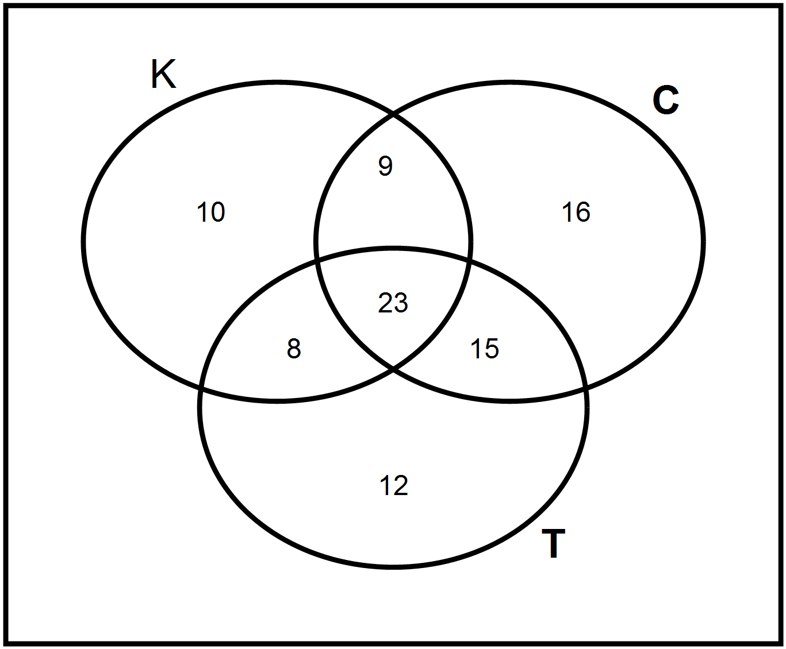

What is  ?

(A) 47 (B) 55

(C) 71 (D) 93

7. In the Venn diagrams below which shaded region represents  ? 7. ____

(A) (B)

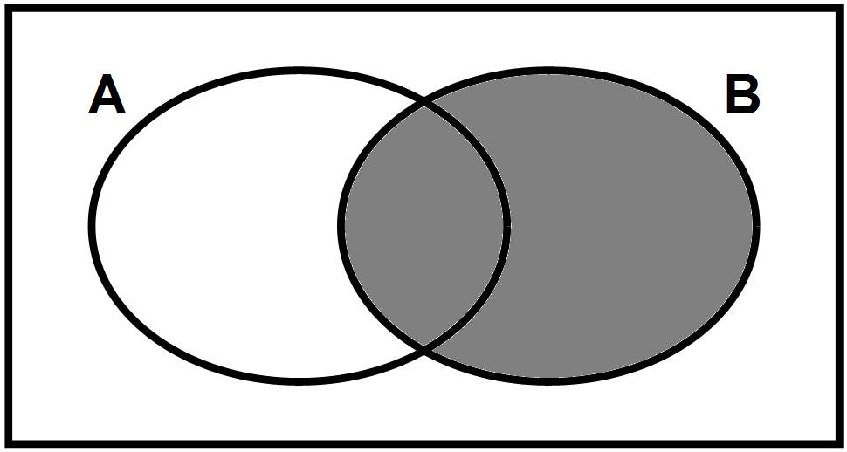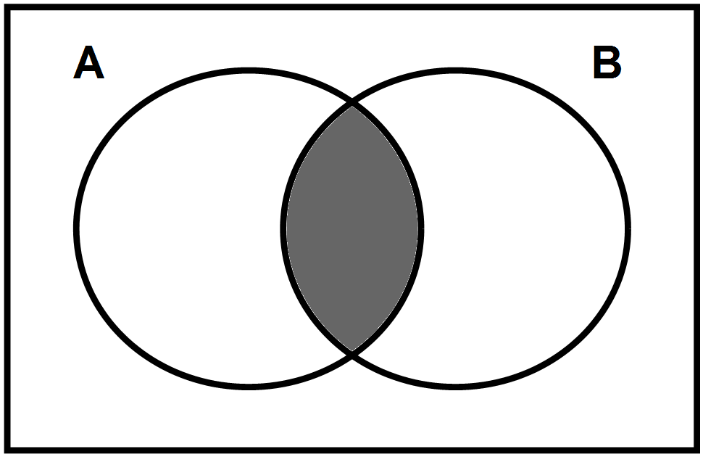

(C) (D)

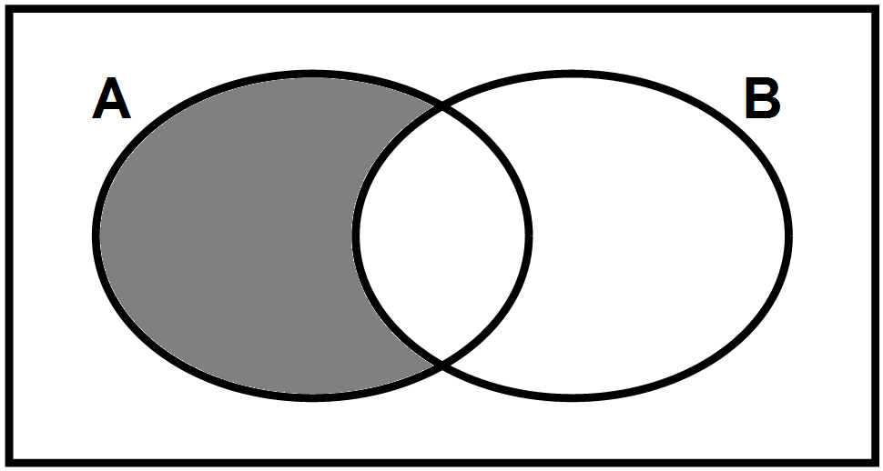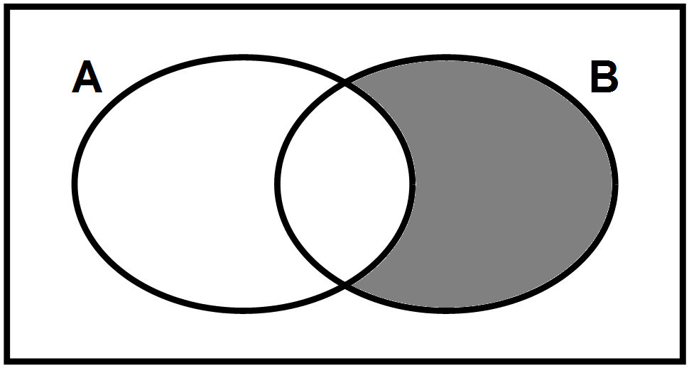

8. If  and , what is , the universal set? 8. ____

(A) 17 (B) 38

(C) 60 (D) 77

9. Given the universal set . Which of the following 9. ____

is a subset of U ?

(A)  (B) 

(C)  (D) 

10. Marcel asked students if they liked chicken or burgers. 10. ___

17 liked only burgers

25 liked only chicken

12 liked both types of food

16 liked neither chicken or burgers

How many students did Marcel ask?

(A) 46 (B) 54

(C) 70 (D) 82

11. In the diagram below determine . 11. ___

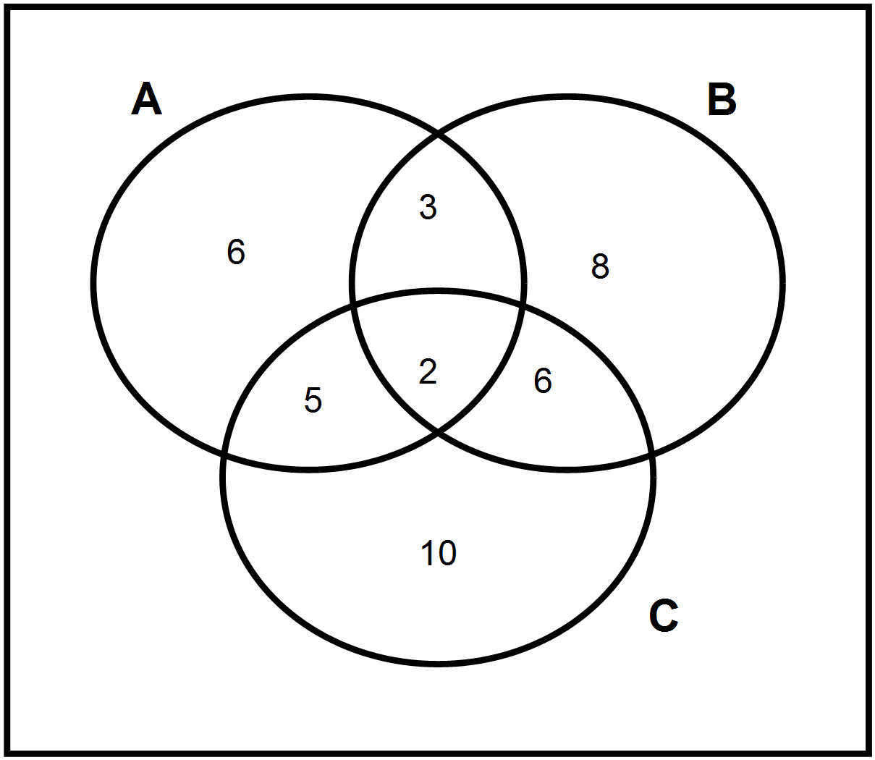

(A) 3 (B) 17

(C) 20 (D) 30

12. If  and what is ? 12. ___

(A)  (B) 

(C) (D) 

**Part B:** Answer all questions and show your workings.

1. Mr. Mathematics went fishing this summer in Newfoundland, Labrador and British Columbia. Each set

below represents the fish caught in each province.

Fish caught in Labrador(L) = {Arctic Char, Cod, Salmon, Smelt, Trout}

Fish caught in Newfoundland(N) = { Capelin, Cod, Herring, lobster, Mackerel, Salmon, Trout}

Fish caught in British Columbia(B) = { Cod, Halibut, Herring, Salmon, Walleye, Crab}

(a) Complete a Venn diagram to show these three sets

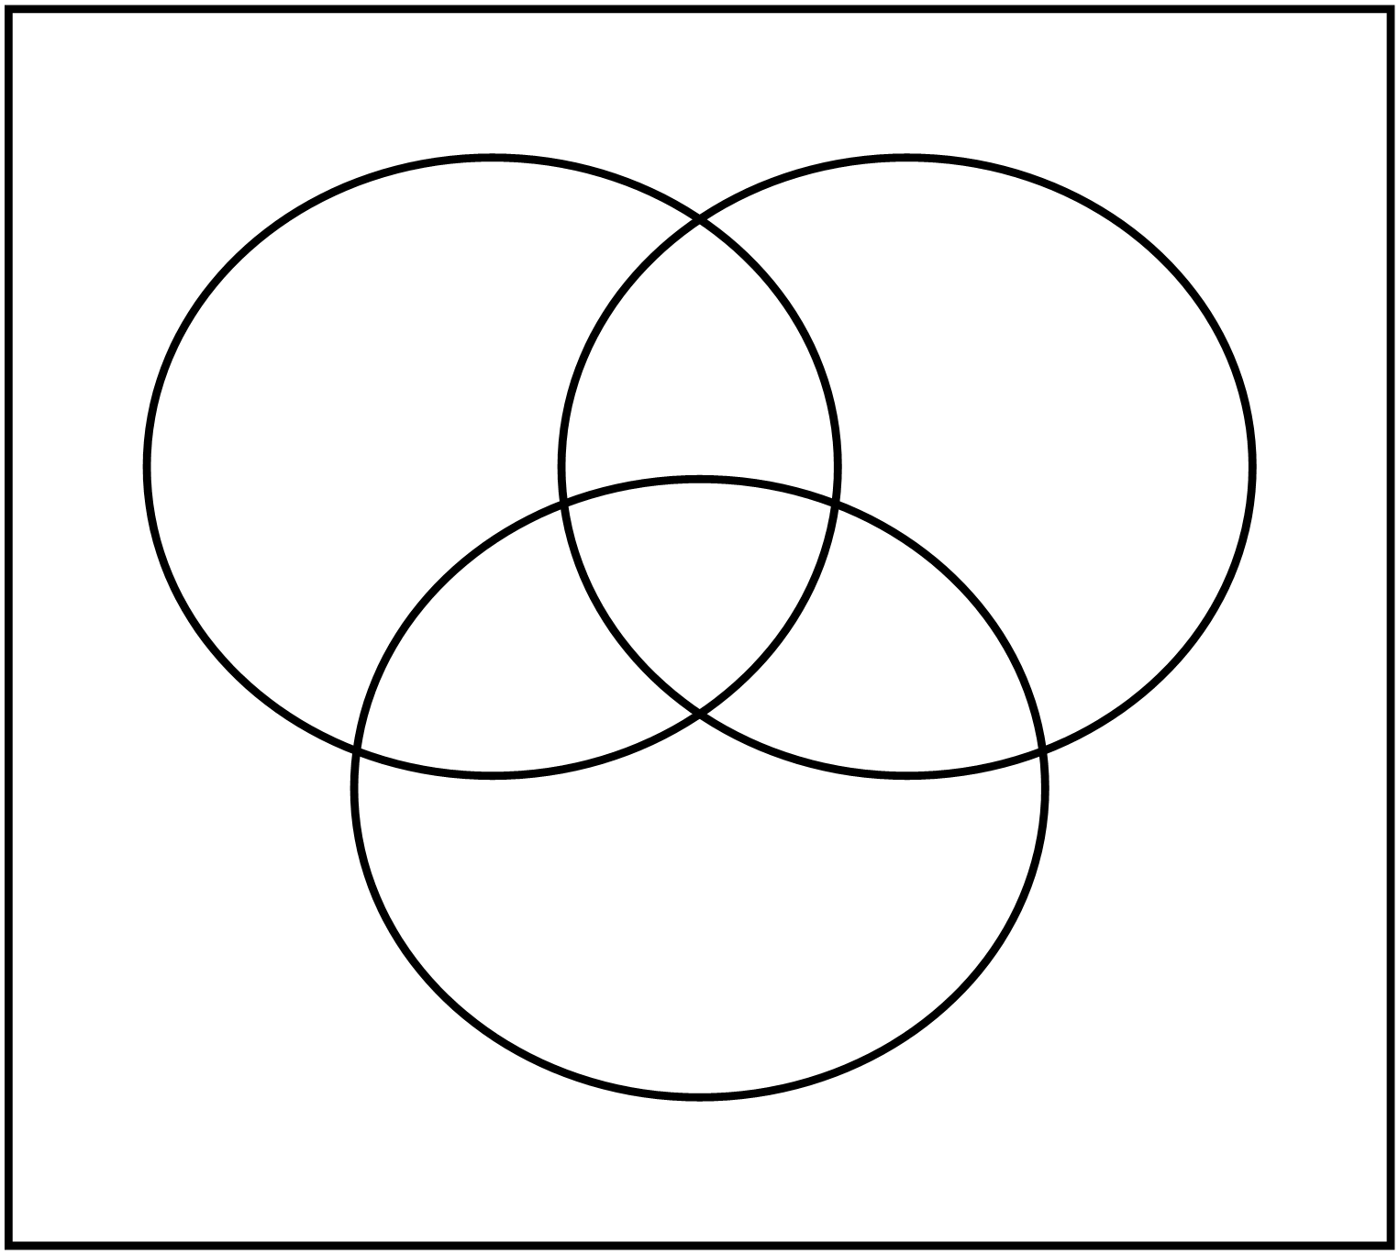

(b) Determine  (c) 

(d) Determine 

2. Paul asked 30 people who saw a movie based on a popular book if they liked the book or movie best.

3 people did not like the book or movie

15 liked the movie

22 liked the book

Draw a Venn diagram and determine how many liked both the movie and book.

3. A total of 140 students went to a conference of future careers.

60 went to electricity

57 went to plumbing

64 went to carpentry

14 went to electricity and plumbing but not carpentry

22 went to plumbing and carpentry but not electricity

14 went to electricity and carpentry but not plumbing

19 didn’t go to any

Draw a Venn diagram and determine how many went to all three?

4. There were 40 members of a sports club surveyed.

23 played ball hockey

24 played tennis

18 played golf

14 played tennis and ball hockey

8 played tennis and golf

2 play all three

Draw a Venn diagram and determine the number of people who play only ball hockey and golf.