**Mathematics 3201**

**Test Unit 2**

**Name: _____________________________________________**

|  |  |  |
| --- | --- | --- |
| **FORMULAES** | | |
|  |  |  |

**Part A :** Place the letter corresponding to the correct answer to each of the following in the appropriate

blank at the right.

1. Consider the word **THE**, how many ways can the letters be arranged? 1. ____

(A) 1 (B) 2

(C) 3 (D) 6

2. A student incorrectly wrote . To produce a correct solution what should be 2. ____

applied to 60?

(A) add 2 (B) divide by 2

(C) multiply by 2 (D) subtract 2

3. A hotel offers free breakfast to its guests. One morning the hotel has 3 different kinds of 3. ____

juice, 4 different kinds of cereal, and 2 different kinds of pastries available. If a guest can

choose one kind of juice, one kind of cereal and one type of pastry, how many different

possible breakfasts can be ordered?

(A) 1 (B) 9

(C) 24 (D) 288

4. Which of the following expressions is defined? 4. ____

(A)  (B) 

(C)  (D) 

5. What is  in simplest form? 5. ____

(A) 1 (B) 12

(C) 56 (D) 840

6. How many ways can the letters in the word **TATTOO** be arranged? 6. ____

(A) 1 (B) 60

(C) 120 (D) 720

7. There are 25 students in Math 3201 class. If 6 students are chosen to be dismissed early, 7. ____

how many ways can they be placed in a line to exit the classroom?

(A)  (B) 

(C)  (D) 

8. In the grid below a person must travel from A to B by only heading East (E) or South (S). 8. ____

One example of a route is shown represent three moves East followed by two moves

South (EEESS). Under these rules, which represents the total number of possible routes

that can be taken to get from A to B?

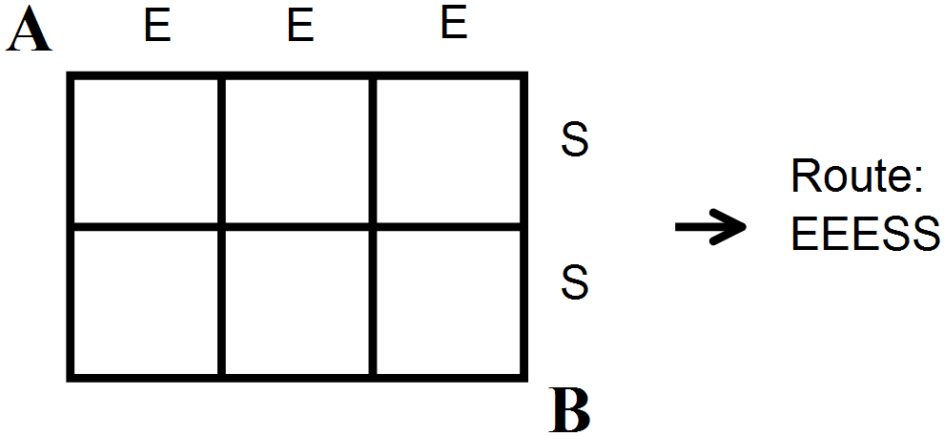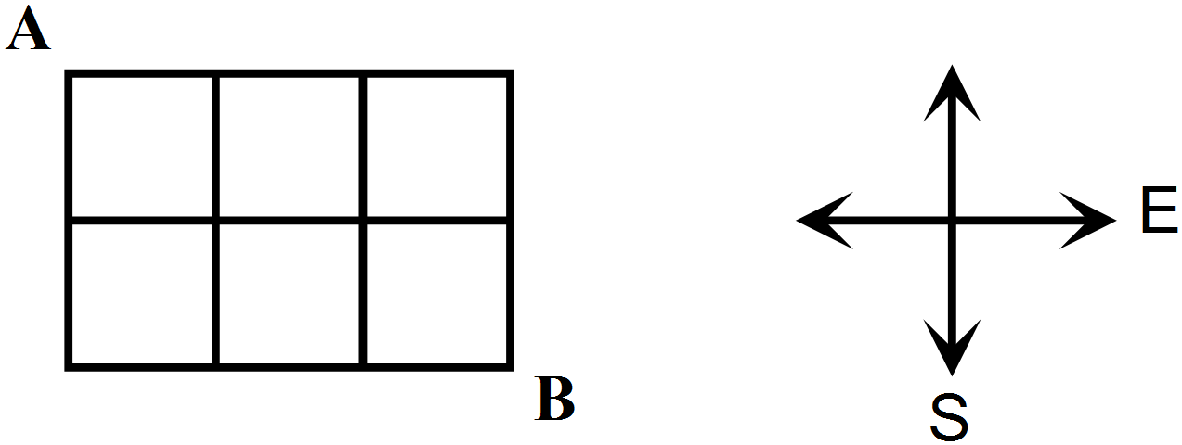

Example:

(A)  (B) 

(C)  (D) 

9. Simplify  9. ____

(A)  (B) 

(C)  (D) 

10. Evaluate  10. ___

(A) 2 (B) 4

(C) 252 (D) 30 240

11. Henry has 83 CD’s in his collection. In how many ways can he select 10 of these CD’s ? 11. ___

(A)  (B) 

(C)  (D) 

12. How many ways can a president, a vice president, and secretary be selected from a class 12. ___

of 22 students?

(A)  (B) 

(C)  (D) 

13. A grocery store manager is trying to arrange the following in the produce aisle: **Avacados,** 13. ___

**Pumpkin, Eggplant, Squash, and Watermelon**. If there are no restrictions, how many

ways can he present his products?

[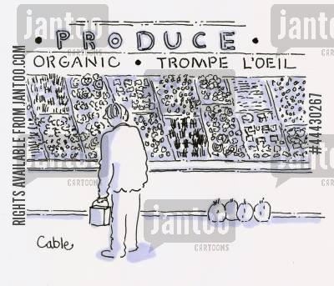](http://www.google.ca/url?sa=i&rct=j&q=&esrc=s&frm=1&source=images&cd=&cad=rja&docid=WmnviP8ZokvpsM&tbnid=_qt_U0Eb-bI4UM:&ved=0CAUQjRw&url=http://www.jantoo.com/cartoons/keywords/grocery-shopping&ei=Y4ZqUuPgH9CLkAe_74B4&bvm=bv.55123115,d.eW0&psig=AFQjCNFbS33v85sc4H5Q-sWiNGV5mm8Q7w&ust=1382799248125387)

(A) 5 (B) 45

(C) 72 (D) 120

14. There are 12 people in a line for a movie. If Crystal, Steven, and Jason are friends and stand 14. ___

together, what is the number of possible arrangements for the entire line? (All 12 people.)

(A)  (B) 

(C)  (D) 

**Part B** **:** Answer all questions and show your workings.

1. There are 15 runners participating in the Trapper’s Marathon. If all runners finish, how many ways

are there for the runners to finish first, second, third and fourth ? **(2 marks)**

2. There are 8 boys and 12 girls graduating from Mathematical Collegiate this year. How many ways

can a teacher :

a) select a committee of 6 people? **(2 marks)**

b) select a committee of 4 boys and 4 girls? **(2 marks)**

c) select a committee of 8 students with at **least** 6 students being boys? **(3 marks)**

3. Solve  for n where  **(3 marks)**

4. The girls soccer team has 12 players and 2 coaches where 4 players are in Level III, 6 players are in

Level II and 2 players are in Level I. A photographer from the Labradorian wants to take their picture

for the front page of the newspaper. If they line up for a picture with a coach at each end, the

Level III girls are together, Level II girls are together and Level I girls are together, how many different

ways can the photographer place them in a line for the picture? **(3 marks)**

5. In how many ways can a salesperson arrange five different models of a ski-doo and 3 different

models of a quad if the quads are arranged together. **(2 marks)**

6. If a 5 digit number is generated at random from the digits 2, 3, 4, 7 and 8, how many numbers

can be generated if:

i) each digit is used only once and the number begins with 8? **(2 marks)**

ii) each digit can be used more than once? **(2 marks)**

7. (a*) Big Math Consulting* has 5 parking spaces in front of their office but has 10 employees. How many

ways can *Big Ma*th choose which employees get a parking place? **(2 marks)**

[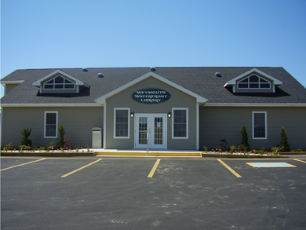](http://www.google.ca/url?sa=i&rct=j&q=&esrc=s&frm=1&source=images&cd=&cad=rja&docid=P8uSovtc6wK8NM&tbnid=fFWz6PcjtrePKM:&ved=0CAUQjRw&url=http://www.infrastructure.gc.ca/kid-enfant/how-comment/weymouth-eng.html&ei=WY1qUsqrEZHIkAf5yYEw&bvm=bv.55123115,d.eW0&psig=AFQjCNHugTDH4yQiJpK8VVvfZQ8SGV2m6w&ust=1382801074059431)

(b) If *Big Math Consulting’s* secretary and accountant are lucky enough to get parking places but

wants two places together, how many ways can *Big Math* assign the parking places to the

5 employees? **(2 marks)**